AUTO WORKERS’ AND MOTOR INDUSTRY PROVIDENT FUNDS

FUND INVESTMENT PERFORMANCE AND THE COVID-19 PANDEMIC

On 24 March 2020 I communicated to all the funds’ members informing them that the funds are cognisant of the economic difficulties facing members, employers and society generally as a result of the Covid-19 pandemic and the poor performance of world markets and that we are taking steps in the Funds to protect members’ retirement savings as far as possible during these difficult times.

As I am sure you know by now, there has been tremendous market turmoil in the past two months, with unprecedented levels of volatility and reactions, in the form of economic stimulus, in order to protect our financial system.

It is important that as Funds we keep you updated on how we have addressed this market turmoil and what our performance looks like during this period. I am glad to report that our investment consultants, Riscura, are satisfied that our funds have performed better than most others during this period. Members should therefore take comfort in knowing that our Trustees have acted swiftly, decisively and correctly during this period to members’ benefit.

As members of the Auto Workers’ Provident Fund and Motor Industry Provident Fund, your retirement fund contributions are invested in a defined contribution arrangement, which means that it is invested in the markets (shares, bonds, private equity, and similar investments) and whatever returns the markets give, you as a member receive – so, if the markets go up your retirement savings increase as well but if they go down you also see a decrease in your retirement fund credit in the fund.

As you will know by now, in the last three months financial markets have been very volatile and have fallen significantly due to long-standing underlying structural economic issues which were brought to the fore by the Covid-19 pandemic. Some developed markets like the USA and Europe have fallen over 20% and emerging markets such as South Africa have also seen significant drops in financial markets, replicating those of developed markets. Our funds are invested in the global market and they experience similar impacts when these occur. As you would expect, our funds are not immune to such drops and have felt negative returns recently as a result of market performance, which has also negatively affected your fund credit.

As a member though, you must note that financial markets work in cycles, so they experience years of good growth and also periods when markets experience poor growth. It is hard to predict these cycles, so it is widely accepted that as a long-term investor, retirement fund members should not move in and out of markets just because of a temporary market fall – what generally happens is that this type of investor loses out when the market picks up again and falls into the trap of exiting the market at the wrong times, buying when expensive and thus losing out. Historically, it has been shown that markets recover well and quickly after experiencing a downturn, but it is difficult to predict when the upturn will start.

Our Funds have restructured their investment portfolios to bring them in line with market trends as identified by our investment consultants, so are well positioned to take advantage of the expected upturn. Our investment strategy also aims to minimise investment risks by diversifying into different asset classes, regions and asset managers, so we carefully consider the investment advice we receive and make decisions which will add value to our members’ retirement savings in the long term. So, while we have experienced losses, the extent of these losses has been limited through this new investment strategy, which we believe will yield significant long-term benefits for our members.

The one thing a member should not do at the moment is panic. So, considering withdrawal from our funds should be avoided. This is because your investment losses become locked-in and you miss the upside when it comes, so withdrawal should not be considered as an option.
For those members who are at or close to retirement and who have seen a drop in their retirement benefit, they should consider remaining in the fund for as long as possible if they can, so as to take advantage of the market recovery. Please consult with your financial adviser in these circumstances so that you can make an informed decision.

Our investment consultants, Riscura have provided the following investment performance figures for our funds, which are up to 31 April 2020 –

PERFORMANCE TABLES TO 30 APRIL 2020

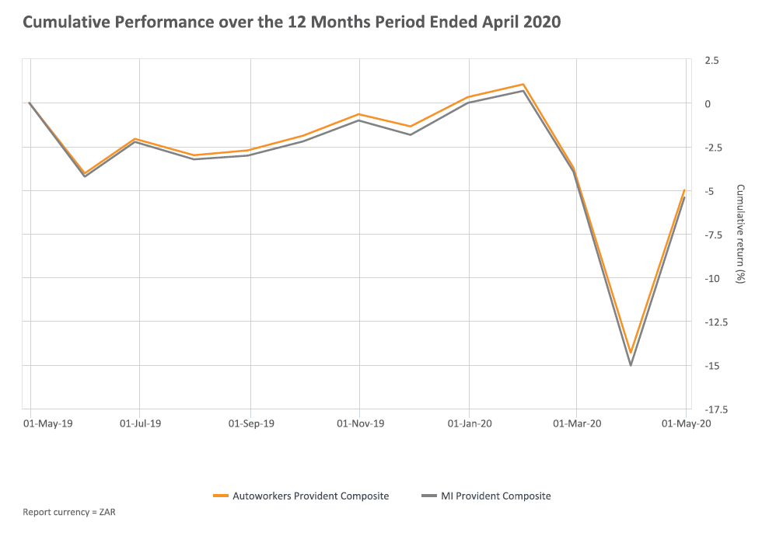

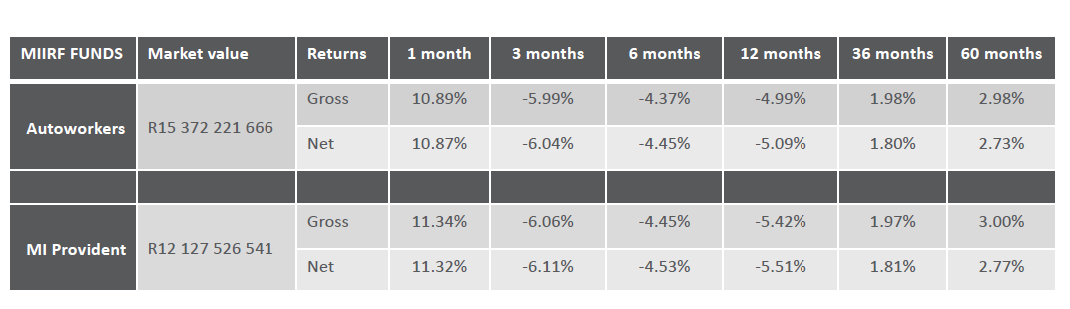

As you see, there is indeed no need to panic – while fund values saw a drop of approximately 15% during the pre-lockdown period between February and March 2020, our funds have started to recover well from this recent market collapse and achieved over 10% positive returns during the month of April 2020. It therefore makes sense to remain calm and optimistic that we will make up the poor performance in the coming months.

We will provide you with further investment updates in the next few months.

Please stay safe.

Yours faithfully

Anesh Soonder
Chairperson

