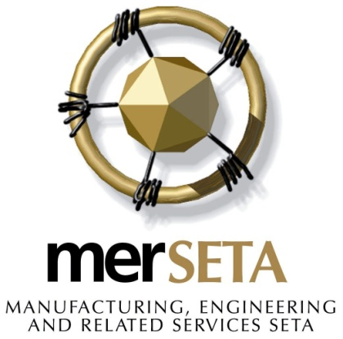

DRAFT

SECTOR SKILLS PLAN

Update

2021/ 2022

**15 July 2020**

# Official sign off

Final Submission of required SSP Documents as per DHET Guidelines for Draft SSP 2021/2022

It is hereby certified that this Draft version of the Sector Skills Plan takes into account all the relevant policies, legislation and other mandates for which merSETA is responsible and accurately reflects the stipulated submission requirements as communicated by the Department of Higher Education and Training (DHET).

This submission comprises merSETA Cover Letter, Continuous Improvement Plan and Final SSP which was developed in accordance with the SSP Framework produced by DHET.

Ms S. Nomvete

**Strategy and Research Executive** Signature: ………………………………….

Mr W. Adams

**Acting Chief Executive Officer** Signature: ………………………………….

Ms K. Moloto Signature: ………………………………….

**Chairperson of the merSETA**

**Accounting Authority**

**15 July 2020**

# COVER LETTER

**15 July 2020**

**To: Department of Higher Education and Training, Directorate: SETA Support**

**SSP Cover Letter: merSETA SSP 2021/22**

**To whom it may concern,**

The Manufacturing, Engineering and Related Services Sector Education Training Authority (merSETA) has prepared this draft submission of the Sector Skills Plan (SSP) comprising this cover letter and the merSETA Continuous Improvement Plan (CIP) in response to the requirements as set out by the Department of Higher Education and Training (DHET) in the SSP Guidelines: Requirements for SSP Submission 2021/2022.

This letter serves to outline the processes that have culminated in the submission of the merSETA SSP.

**Updates and New Information**:

The analysis undertaken for the SSP report draws on a range of information sources.

These sources include:

* The merSETA’s Workplace Skills Plans. The WSP data includes employer information, Hard to fill vacancy (HTFV) information, Skills Gaps information, training information and employment information.
* The WSP 2020 collected employee information at individual level which means that the data are no longer aggregated on OFO. The data in the SSP reflects over 5000 levy paying companies.
* WSP data have more stringent data quality controls in place and utilises codes from OFO 2019.
* Data and information from primary research studies and data reports developed internally, these are documented in the research process methods section of the SSP.
* Data from secondary sources such as Statistics South Africa, the Higher Education

Management Information System (HEMIS) and industry associations including the

National Association of Automobile Manufacturers of South Africa (NAAMSA), MIBCO, SEIFSA, Plastics SA and others have been included.

* Research reports from national research institutions, government institutions, higher education institutions, industry publications and the media has also been utilised.

The following outlines the tasks that will be further refined for the Final submission in August 2020:

| **Task to be completed** | **Comment** |
| --- | --- |
| 1. Econometric Analysis and Interviews in light of COVID-19 | In process |
| 1. Final Priority Skills List | The skills list will be refined by considering analysis of information from the COVID-19 pandemic as well sector consultations |
| 1. Chamber reports on COVID-19 to augment Chamber information with respect to economics and skills development | In process |
| 1. Stakeholder Feedback Incorporated | In process |
| 1. Updates as per anticipated DHET feedback session to be scheduled in August 2020 | To be confirmed in Final SSP submission |

Furthermore, this SSP was presented to the merSETA Governance & Strategy Committee on 9 July 2020. All recommendations from this committee have been incorporated into the SSP and the committee has recommended the SSP for approval by the Accounting Authority. Final approval of the draft SSP will be sought when the AA meets on 24 July 2020.

Kind regards

______________________________

Mr Wayne Adams

**Acting Chief Executive Officer: merSETA**

______________________________

Ms Kate Moloto

**Chairperson of the merSETA Accounting Authority**

# Executive Summary

This SSP has been written at a very unique time in the history of South Africa and the world. The COVID-19 Pandemic is a major disruptor on what was already a sector in distress.

A key observation over the past 4 months has been the shift in the economy in line with demands for 4IR in terms of business processes, the new norm in terms of remote working and the threat of mass unemployment. Businesses have had to adapt in a very short period of time, adjusting from almost total suspension of production in lockdown level 5 to production under new health and safety regulations in line with social distancing under lockdown level 3.

In terms of key drivers for the mer sector, the merSETA has noted opportunities for reindustrialisation to revitalise the manufacturing sector, even in a time of COVID-19. Supporting local business development and diversity of manufacturing activities in line with changing customer needs and expectations will put South Africa on steady ground in the future. Automation, digitalisation, environmental sustainability and associated new business models remain key skills drivers. Future skills must be researched more closely for the mer sector. In particular, the skills requirements in a post COIVD-19 economy must be researched.

To meet industry needs, skills interventions must be tailored and implemented using the best and latest technologies related to digital platforms and simulations. A key perspective highlighted in the sector profile of the SSP is the need for bespoke skills interventions for people with disabilities, women, youth, cooperatives, small and micro businesses located in conditions of poverty and who have barriers to access. The social economy is highlighted as a key section of society that is expected to expand due to COVID-19 and it is imperative that the merSETA designs innovative interventions to assist these groups through skills development and bespoke partnerships with PSET institutions.

Monitoring and evaluation is crucial to the success of all SETA interventions and projects.The merSETA has put in place effective mechanisms to ensure it meets its mandate. However, there are still some improvements required to fill the gaps in the system particularly with respect to institutionalising M&E. This will entail reviewing and putting in place effective mechanisms and tools for monitoring, measuring and evaluating outcomes and impact. In addition, effective evaluation of programmes, planning processes, research, systems and organisational processes is required. This will place merSETA in good stead in terms of its mandate and improving its service delivery.

In order to minimise the impact of the pandemic on its current learners, the merSETA has put in place mechanisms to strengthen its partnerships and ensure that learner support is enhanced. Furthermore, it is mobilising its efforts to support enterprises through its partnership with the UIF to expedite TERS funding and reignite the retrenchment assistance programme (RAP) to assist workers who have become unemployed. Having identified the social economy as a key area of focus in its strategy, the merSETA is also putting in place plans to assist entrepreneurs and local businesses to access premises to conduct their business in TVET Colleges and other private training spaces who can offer up their workshops and premises on a part-time basis.

In addition the pandemic has highlighted the need to enhance efforts in line with a technologically enhanced education provision system using e-learning platforms, simulation and expanding the notion of learning factories in lieu of workplaces for workplace based learning.

Overall COVID-19 has expedited efforts to assist the mer sector in the short term, but the SSP highlights that long term planning and monitoring is also required. Enhanced efforts are required to meet the needs of an industry in flux and to focus on the skills required assist the sector in regaining its prominence in the economy.

Table of Contents

Official sign off II

COVER LETTER i

Executive Summary iii

1. SECTOR PROFILE 7

1.1 INTRODUCTION 7

1.2 Scope of coverage 7

1.3 Key Role Players 16

1.4 Economic Performance 18

1.5 Employer Profile 27

1.6 LABOUR MARKET PROFILE 29

1.7 The Social Economy 39

1.8 Conclusion 39

2 KEY SKILLS CHANGE DRIVERS 41

2.1 Introduction 41

2.2 Factors affecting Demand and Supply 41

2.3 POLICY FRAMEWORK AFFECTING DEMAND AND SUPPLY OF WORKERS 46

2.4 STRATEGIC MEASURES TO SUPPORT SKILLS DEMAND AND SUPPLY 50

2.5 CONCLUSION 55

3 OCCUPATIONAL SHORTAGES AND SKILLS GAPS 56

3.1 Introduction 56

3.2 Sectoral occupational demand 56

3.3 Extent and nature of supply 61

3.4 SKILLS SUPPLY SIDE CHALLENGES 70

3.5 Future Skills 75

3.6 Sectoral priority occupations and interventions 80

3.7 CONCLUSION 82

4 Partnerships 84

4.1 INTRODUCTION 84

4.2 Types of Partnerships 84

4.3 Analysis of the merSETA Partnerships 89

4.4 Towards a Best Practice Model 93

4.5 Planned Partnerships 94

4.6 Conclusions 97

5 SETA Monitoring & evaluation 99

5.1 Introduction 99

5.2 the merseta approach to m&e 99

5.3 DATA AND information to support research and skills Planning 102

5.4 Strategic priorities captured in the strategic plan AND annual performance plan 105

5.5 Measures to strengthen achievement of skills priorities 107

5.6 Conclusion 110

6 Strategic SKILLS PRIORITY ACTIONS 111

6.1 Introduction 111

6.2 summary of findings from previous chapters 111

6.3 Recommended Skills priority actions for merseta 112

6.4 recommended actions to guide merSETA planning and support OF national strategies 114

6.5 Conclusion 116

# SECTOR PROFILE

## INTRODUCTION

This section of the SSP presents the profile of the mer sector. It depicts the scope of coverage in terms of the Standard Industrial Classification (SIC) of its sub-sectors (Chambers), gives an overview of the value chains for each of the Chambers and highlights key role players. Furthermore the chapter profiles the sector in terms of its economic performance and provides a profile of the employers and employees.

## Scope of coverage

The merSETA comprises 6 Chambers or sub-sectors which describes the industrial activities of enterprises according to their Standard Industrial Classification (SIC) codes (see Figure 2).

Overall the sectors under the merSETAs’ scope of coverage is demonstrated in Figure 1 classified by SIC codes at 1 and 2 digit level. In terms of economic sectors the merSETA supports activities in: manufacturing; wholesale, construction; retail and motor trade; and financial intermediation, insurance, real estate and business services sectors.

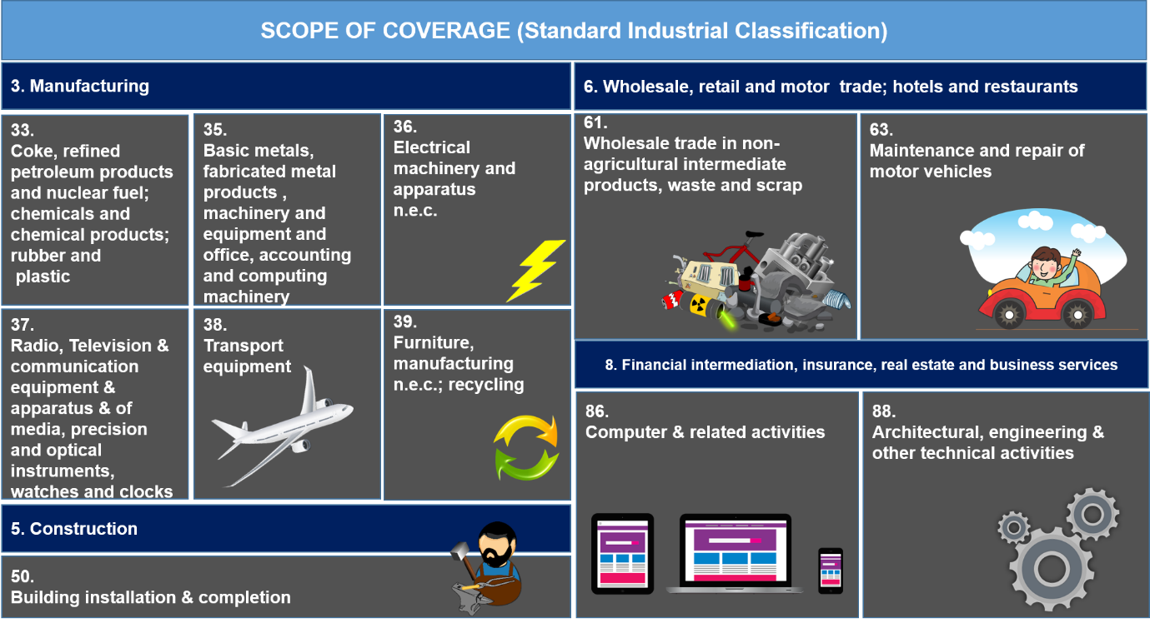Figure : Scope of coverage (Standard Industrial Classification)

The merSETA until recently arranged its sectors into 5 Chambers but as reported in the SSP 2020 – 2025, these have been revised into 6 Chambers after consultation with stakeholders to allow for more focused efforts on skills required by sector value chains, allowing for critical analysis of skills needs enabling the clustering of skills and career pathing. To this end the Chamber previously referred to as the Motor Chamber has been split into the Motor Retail Chamber and the Automotive Components Chamber. Each of the 6 Chambers are depicted below in Figure 2.

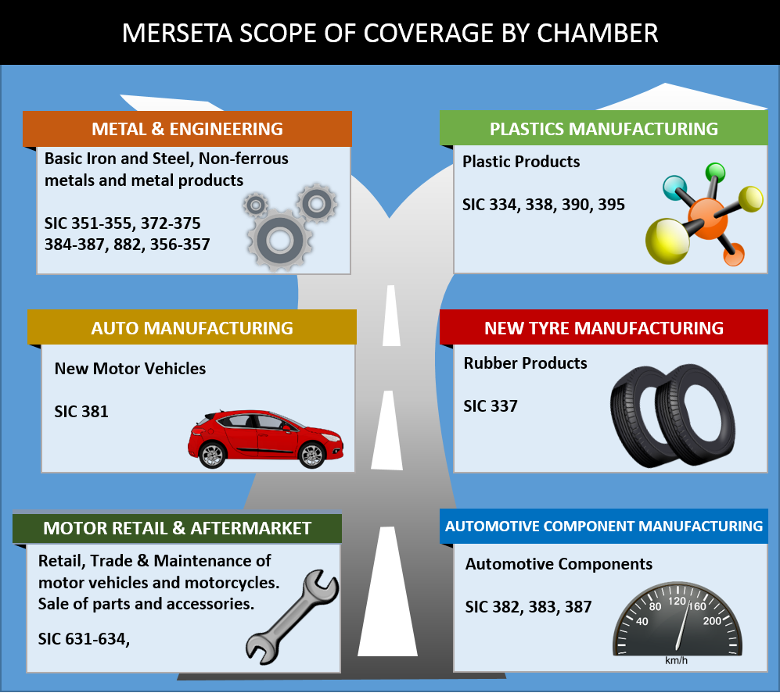 Figure : merSETA scope of coverage by chamber

**Metal Chamber**

The metals sector represents the largest of the sectors under the merSETA scope of coverage, a simplified value chain is depicted in Figure 3. This value chain consists of raw materials, iron production, steel production, and refining, manufacturing and final products.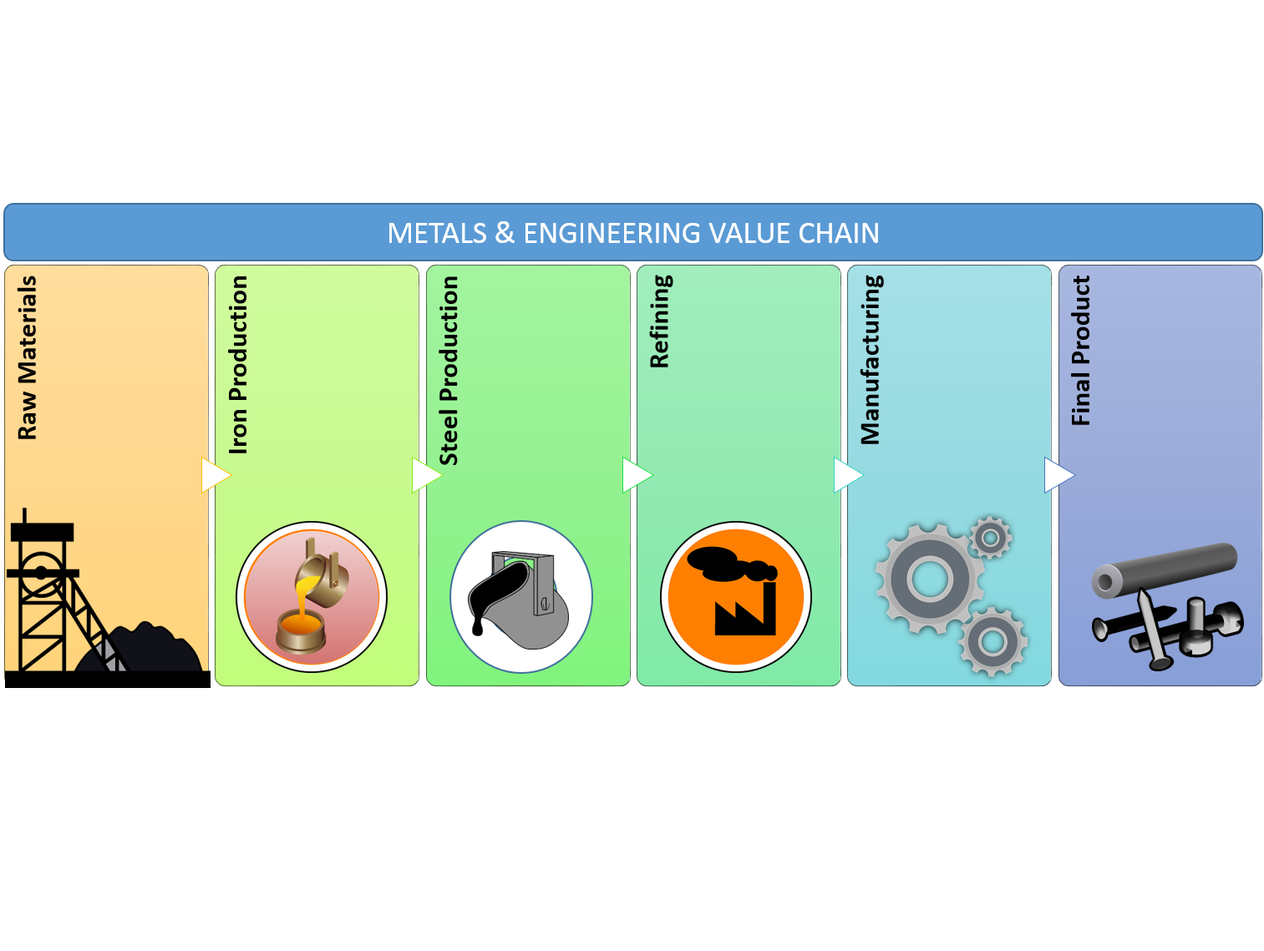

Figure : Metals and engineering value chain

The metal and engineering sector entails capital equipment, foundries, transport equipment, metal fabrication and related sub-sectors. The metal and engineering sector is an important sector in manufacturing because it produces machinery and equipment used in production and critical to all forms of manufacturing inputs.

**Figure 3**: Metals and engineering value chain In terms of specific SIC codes for firms under the metals sector, the table below demonstrates the scope of this chamber at one, two and three digit SIC codes. The Metal Chamber, being the largest Chamber and represents the widest range of SIC codes under the merSETA scope of coverage.

Table : Metal chamber SIC codes

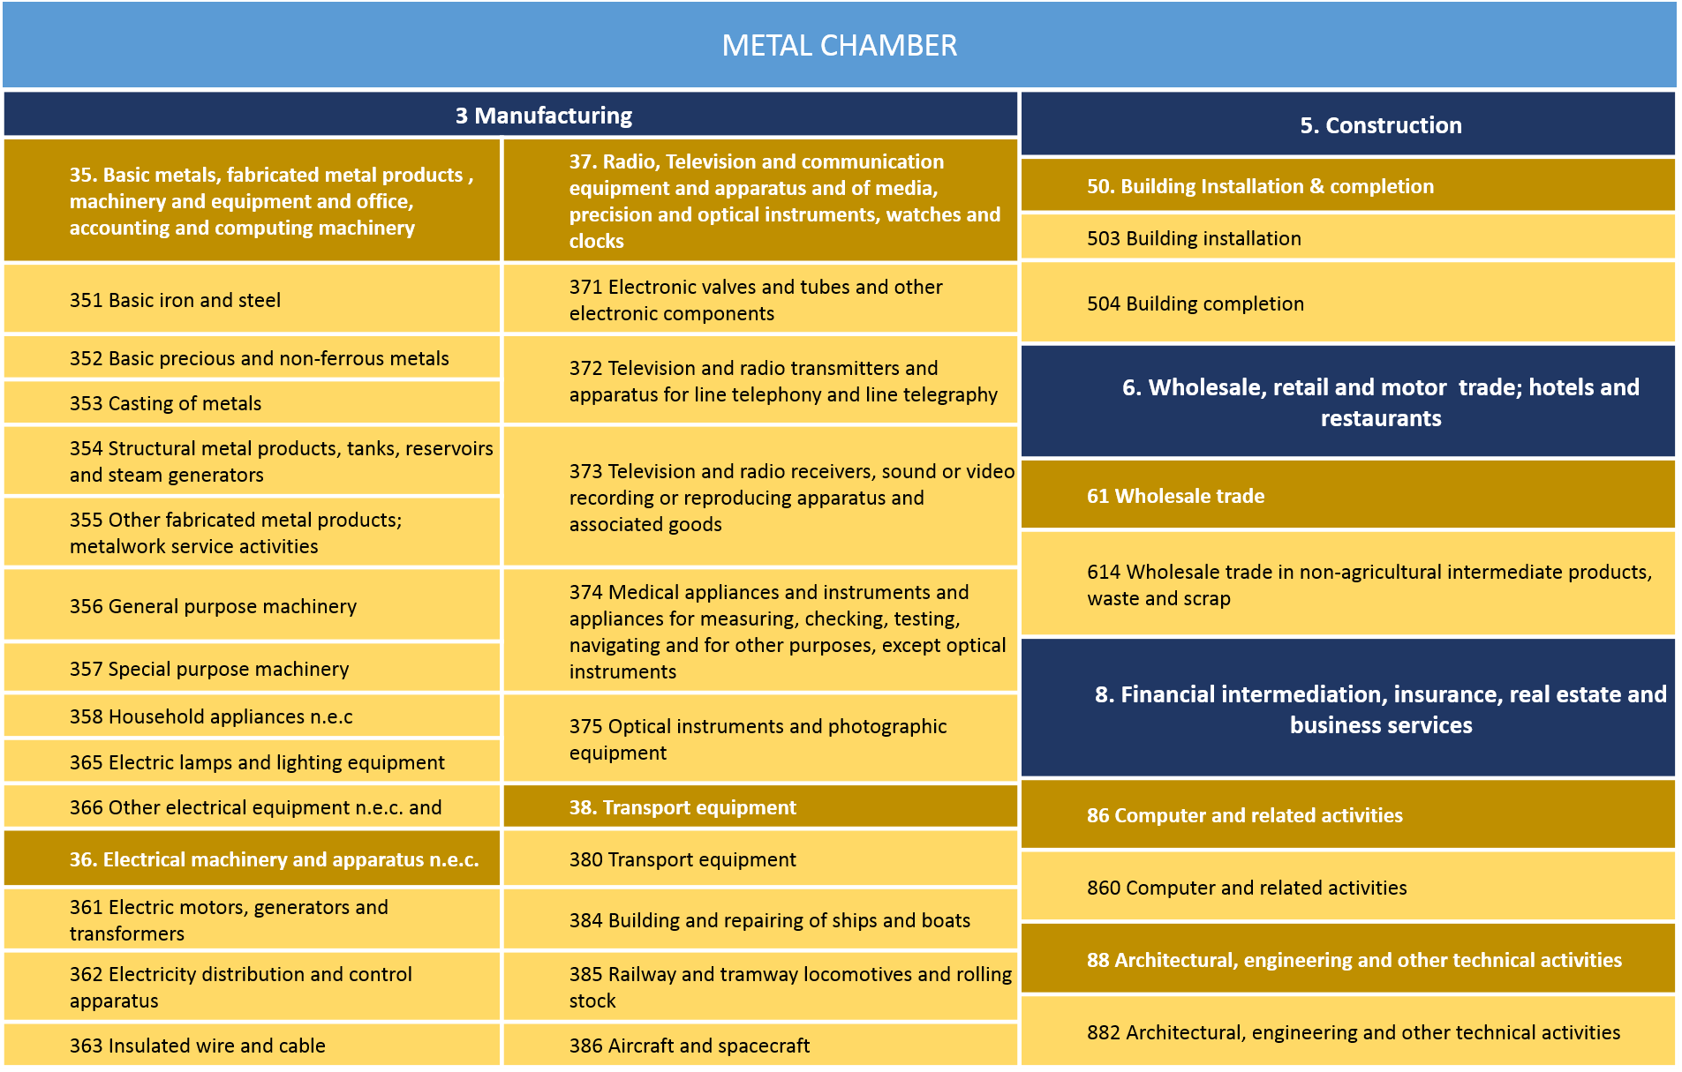

**Plastics Chamber**

Plastics sector is well developed and is one of the most dynamic industries in South Africa. It is comprised of polymer producers and importers, converters, machine suppliers, fabricators and recyclers that caters for both domestic and international markets. The leading markets for plastics in South Africa are packaging, building and construction, and the automotive industries (DTI, 2019). Plastics are used in a vast array of different applications such as preserving and protecting food and medicines, electronic devices like computers and smartphones, helping make transport more fuel-efficient. The overall value chain for the sector is represented in the Figure 4 below.

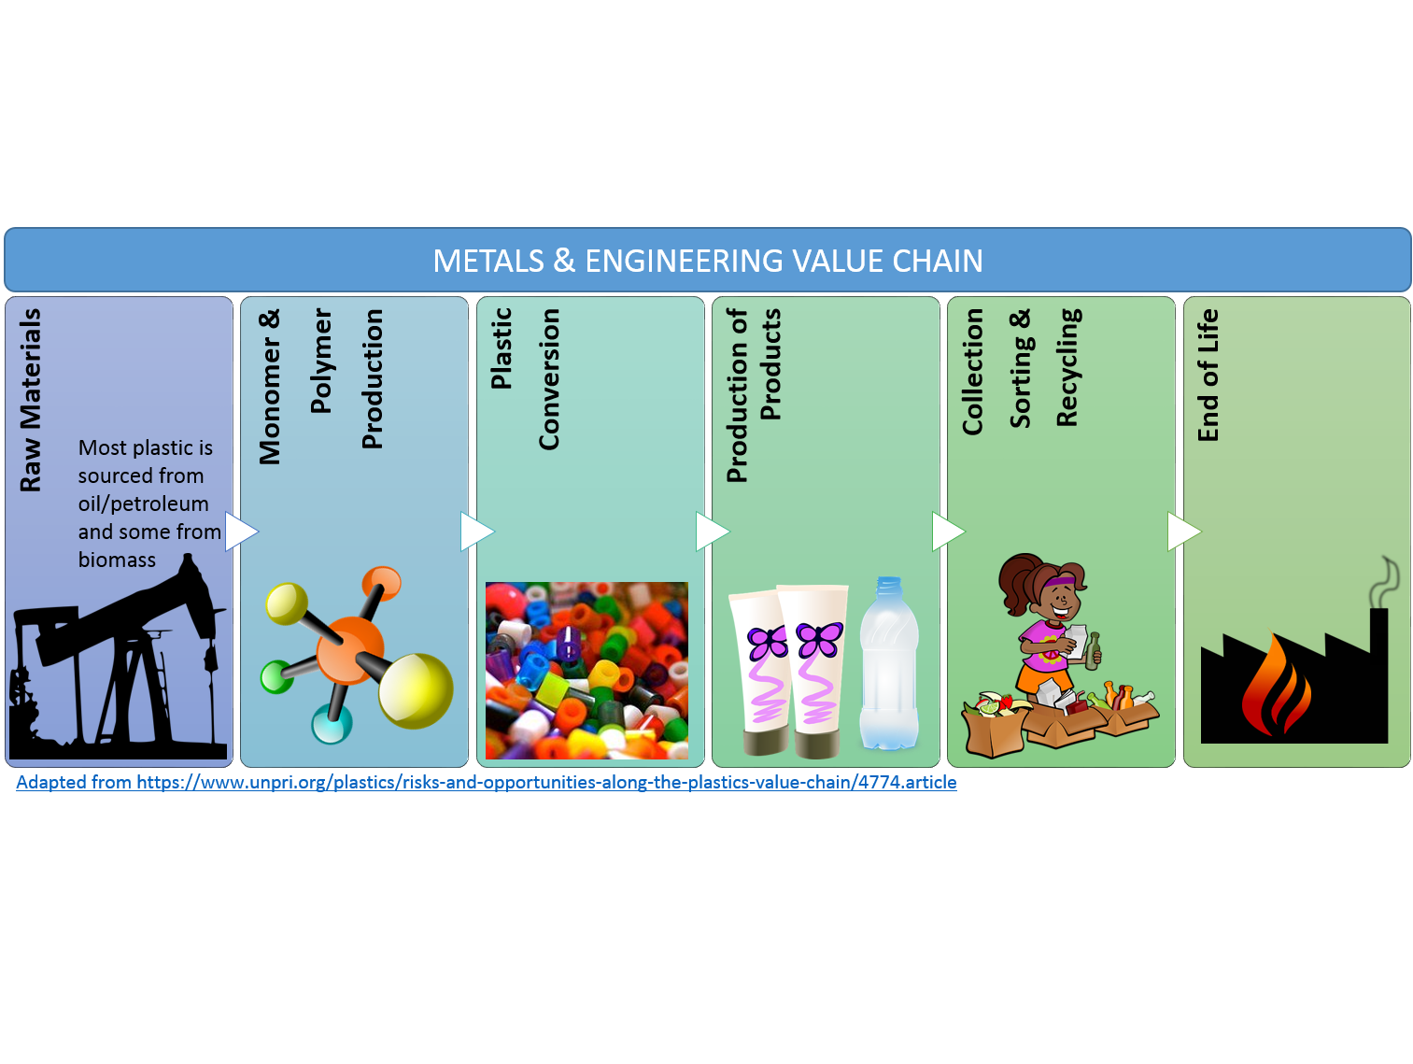

Figure : Plastics value chain

According to industrial classifications, the Plastics Chamber is wholly situated in the manufacturing sector, it comprises basic chemicals and plastic products as well as furniture and recycling as depicted in the table below.

Table : Plastic chamber SIC codes

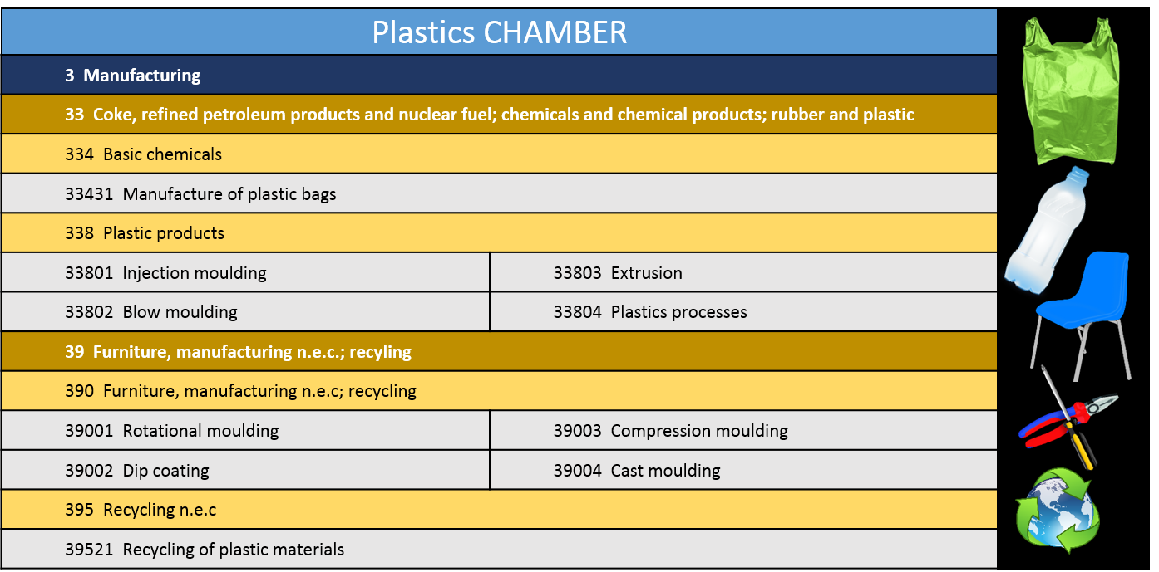

**New Tyre Manufacturing Chamber**

The new tyre sector forms a significant role in the automotive assembly and component manufacturing sector in South Africa. The different types of tyres produced in the country include tyres for passenger, commercial, agricultural, mining, construction and industrial vehicles and associated machinery (Bridgestone, 2019). There are four multinational manufacturers of tyres in South Africa, which includes Goodyear, Bridgestone, Continental Tyres and Sumitomo Rubber (merSETA, Supply and Demand Study, 2018). The overall value chain is depicted below.

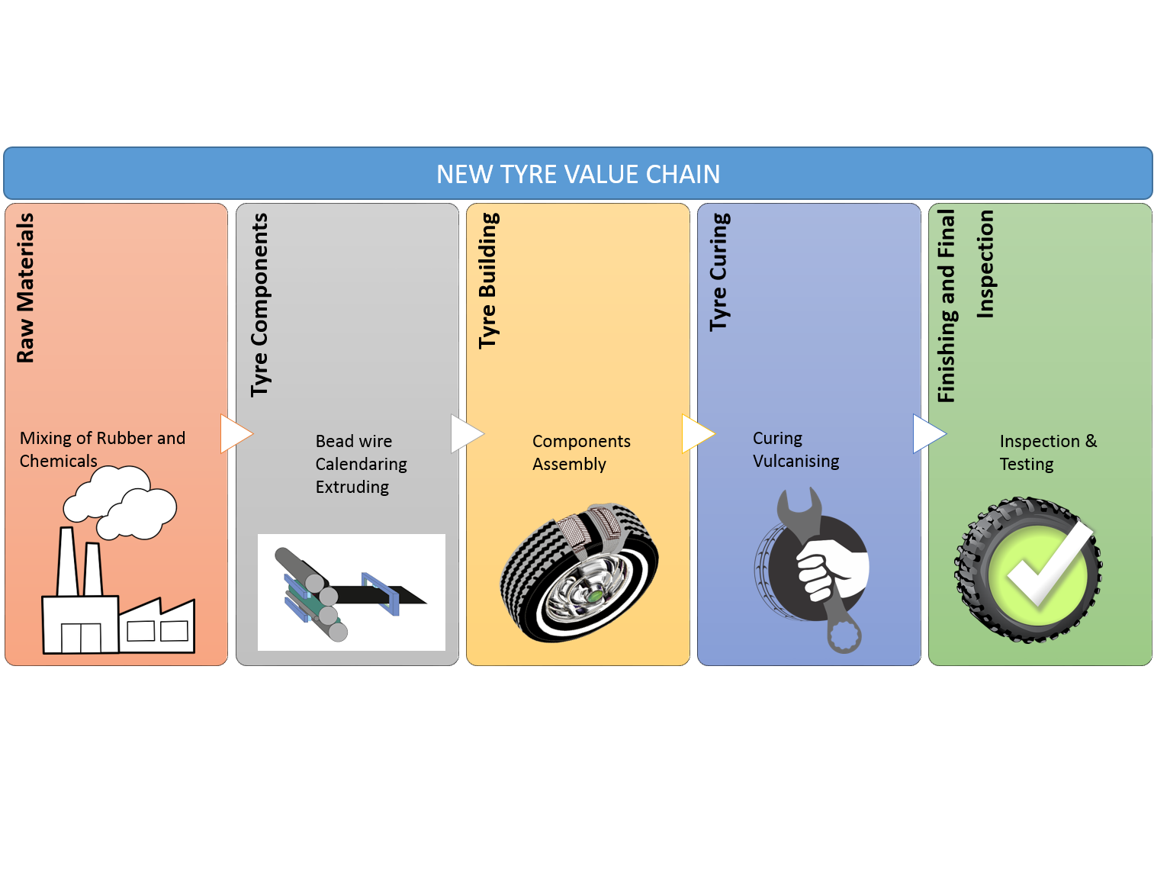

Figure : New tyre value chain

The New Tyre Chamber falls within the manufacturing sector, specialising in rubber products and comprises manufacture of tyres and tubes, retreading of tyres, manufacture of other rubber products, calendaring and compounding as presented in Table 3 below.

Table : New tyre chamber SIC codes

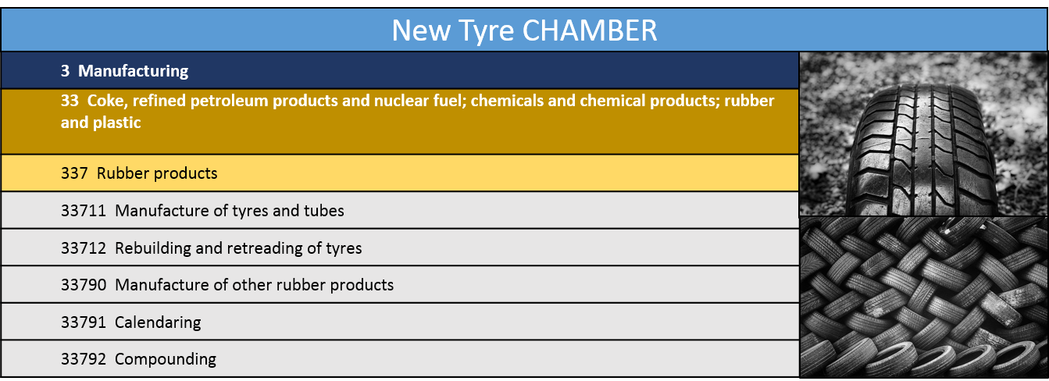

**Automotive Sector**

The automotive sector is the cornerstone of South Africa’s industrial base which accounts for over 5 % of the country’s Growth Domestic Products. The automotive sector consist of the Original Equipment Manufacturers (OEMs), tyre manufacturing and motor retail and components companies that a linked to each other through the automotive production and distribution value chains. In terms of the expanded value chain incorporating the auto, motor retail and components manufacturing chambers, which starts with raw materials and ends with the end life of vehicles, the figure below depicts the overall processes. This sector is represented in three of merSETA’s chambers: auto manufacturing, auto component manufacturing and motor retail and aftermarket.

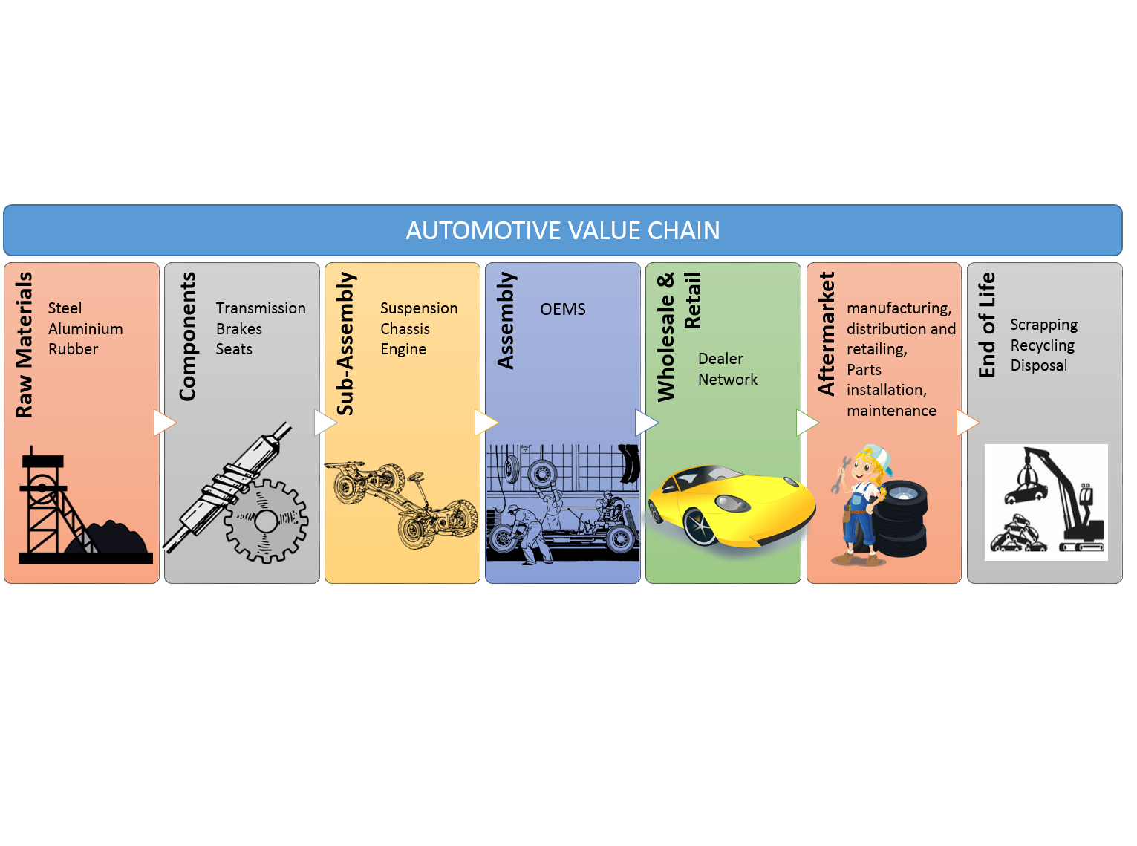 Figure : Automotive value chain

**Auto Manufacturing Chamber**

Due to the capital requirements and technical nature of producing vehicles there are only a handful of Auto OEMs in South Africa, all of which are international brands (merSETA Supply and Demand Study, 2018). South Africa’s main sites for automobile production are the Eastern Cape, specifically Port Elizabeth and East London, Gauteng, specifically Rosslyn and Silverton (Pretoria) and KwaZulu-Natal (KZN), specifically Durban (merSETA Supply and Demand Study, 2018). The Auto Sector has some of the largest scales of operation of all the sectors. The value chain for this Chamber is presented below in Figure 7.

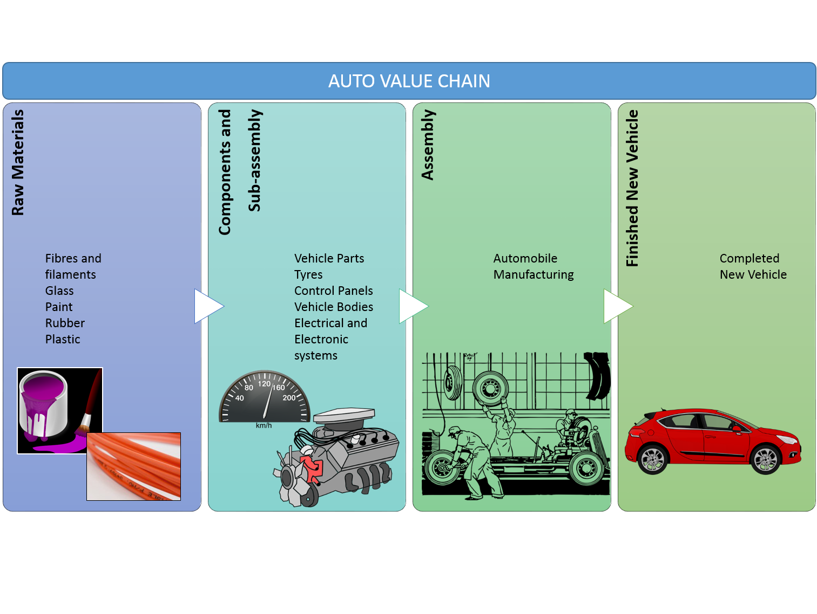 Figure : Auto manufacturing value chain

The industrial classification of the Auto Chamber comprises the manufacture and assembly of motor vehicles, and is represented by the SIC codes in Table 4.

Table : Auto manufacturing SIC codes

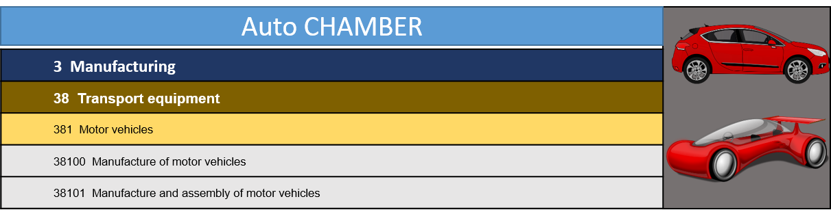

**Automotive Components Manufacturing Chamber**

The Automotive Components Manufacturing Chamber comprises manufacturers that produce vehicle components, parts and equipment. Components are sold to independent parts sellers and after service providers. Due to the increased resource needs and skills required to produce some components (i.e. compliance to meet the standards of Auto OEMs), major employers in this sector tend to be larger businesses. Components that are manufactured relate to various phases of the auto value chain from upstream manufacturing of casts, to downstream trimming (merSETA Supply and Demand Study, 2018).The components manufacturing sub-sector is one of the key sub-sectors in South Africa’s reindustrialisation and localisation efforts.

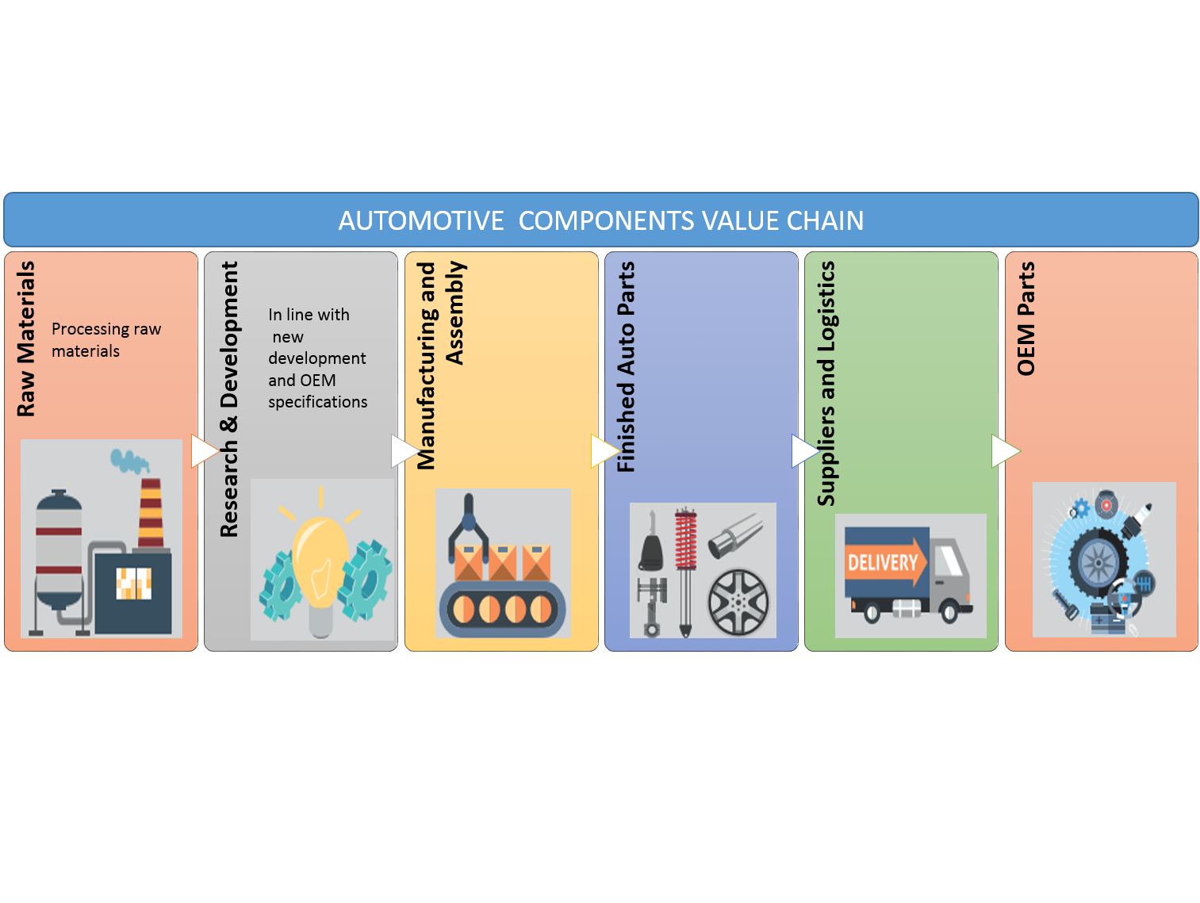Figure : Auto component manufacturing value chain

Standard industrial classification of this sector comprises basic fabricated metal products, and transport equipment as well as repairs and services related to the motor sector such as tow truck services and panel beating as seen in Table 5.

Table : Auto component manufacturing SIC codes.

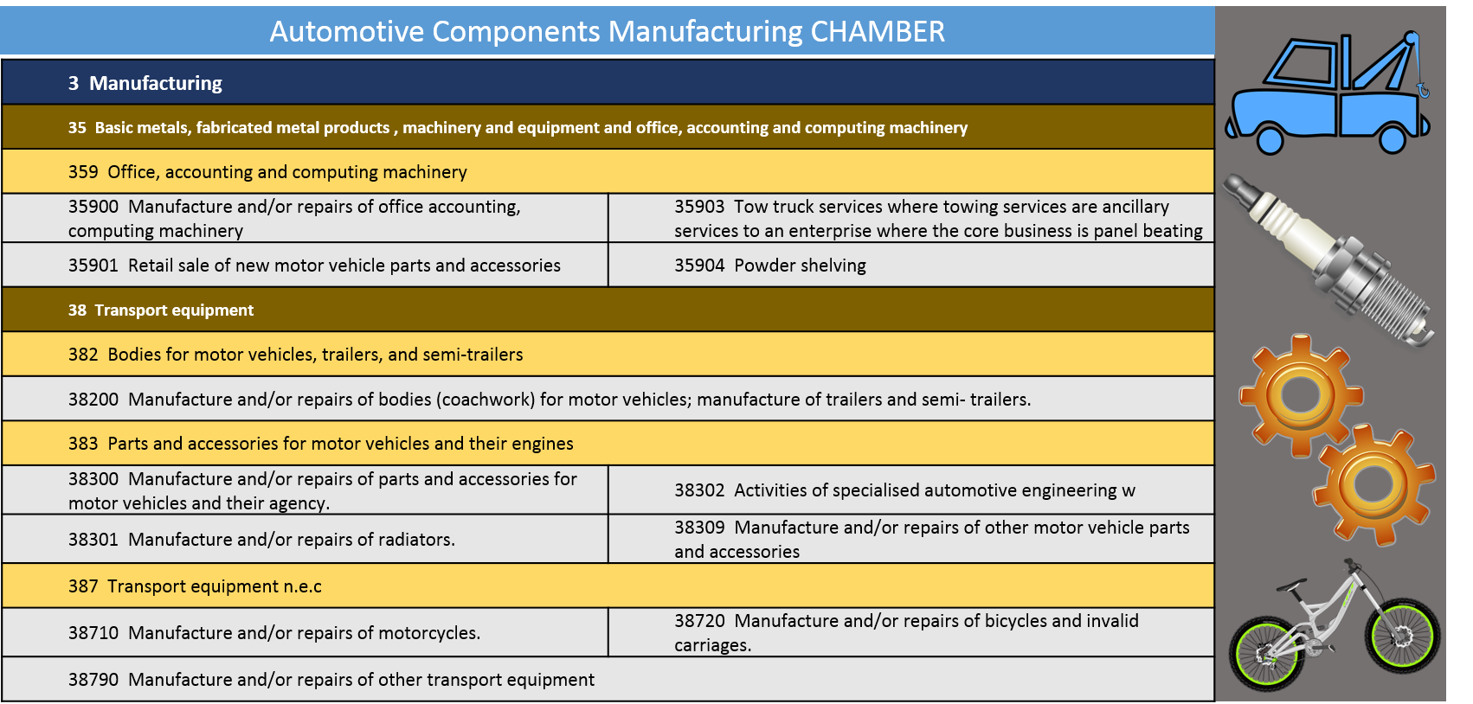

**Motor Retail & Aftermarket Chamber**

The motor retail sector is a key part of the automotive sector. It is this sector that is responsible for the retail sale, maintenance and repair of motor vehicles, parts and accessories. The Motor Retail value chain is presented below in Figure 9.

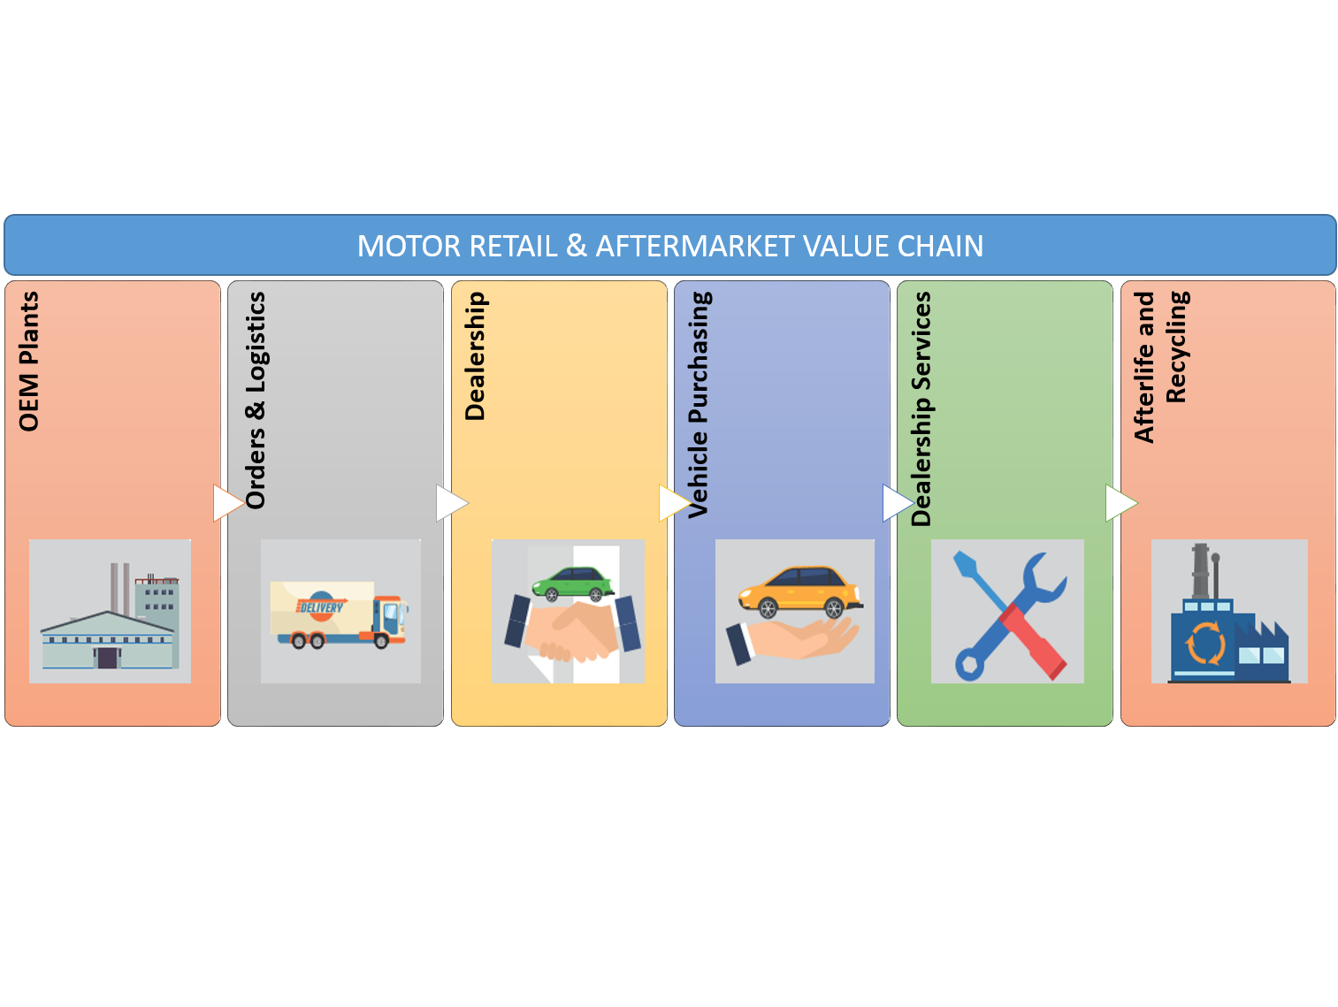 Figure : Motor retail and aftermarket value chain

In terms of its industrial classification, the figure below outlines the key activities of this Chamber as per SIC codes.

Table : Motor and retail aftermarket SIC codes

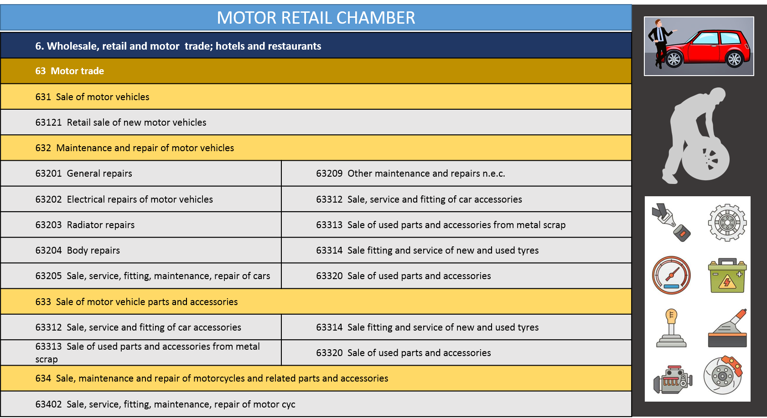

## Key Role Players

The key role players in skills development for the mer sector comprise government, industry bodies, organised employers, labour unions and civil society. Education and training institutions are the key mechanism through which skills are provided to the sector in partnership with these key role players. In addition, the merSETA has recognised the importance of the social economy in its scope of coverage as organisations in these sectors contribute to the labour market and the economic fabric of society such as cooperatives, non governmental organisations, mutual benefit societies and social enterprises. All these role players have a critical role to play in building an integrated PSET system that is responsive to the needs of employees, employers and national priorities. This is core to the implementation of the NSDP.

The diverse skills development needs of the South African economy requires a well coordinated and integrated post school system. This system should also be inclusive, and is shaped by 3 key policy documents adopted for the skills development sector. These are the NPPSET (2019-2030), the White paper on Post School Education and Training (WPPSE) and the National Skills Development Plan (NSDP).

The NNPSET, which derives its mandate from the WPPSET is a roadmap for the development and strengthening of post-education and training from 2019-2030. The plan acknowledges that we do not have adequate and diverse education opportunities for all those who leave school (on completion of grade 12 or earlier). Therefore, the central importance of the plan is the recognition that more post school opportunities are needed outside the higher education sub-system. The NPPSET focuses on education in high demand that are needed for economic growth, will provide opportunities for employment of large numbers of people and support social development priorities. Therefore PSET system must work collaboratively across all platforms to ensure that the labour market and the economic trajectory of the country is monitored such that relevant education and training interventions can be implemented. Taking this into account, the NSDP tasks SETAs with:

* Understanding the demand and signalling the implications for supply;
* Steering the system to respond to skills supply;
* Supporting the development of the intuitional capacity of public and private education and training institutions.
* Performing system support functions and managing the budgets and expenditures linked to the SETA mandate.

The role players highlighted below work together within the PSET system to enable the merSETA to achieve its mandate, they all play and integral part in the supply of relevant skills into the labour market and through the partnerships approach adopted by the merSETA to ensure the outcomes of the NNPSET, WPPSET and NSDP are brought to fruition.

Table : Key Role Players in PSET

| **ORGANISATION TYPE** | **NAME OF ORGANISATION** | **ROLE** |
| --- | --- | --- |
| **Government Departments** | Department of Higher Education and Training (DHET) | Government’s role is to ensure adequate policies and legislation are in place to facilitate sustainable economic development as well as address social issues.  These institutions drive national priorities and skills development should be rolled out in support of the national vision. |
| Department of Trade and Industry (DTI) |
| Department of Science and Technology (DST) |
| Department of Environmental Affairs (DEA) |
| Department of Planning, Monitoring & Evaluation |
| Department of Small Business Development |
| **Education and Training Institutions** | Higher Education and Training Institutions | These training institutions are responsible for skills provision to the labour market. They are the key delivery mechanisms for a differentiated PSET system and should be supported to provide skills to support economic growth. |
| TVET Colleges |
| Community Education and Training Colleges |
| **Employer Organisations** | The Steel and Engineering Industries Federation of Southern Africa (SEIFSA) | Employer organisations represent members in collective bargaining, data and information gathering and skills development.  In line with many of the national priorities, these organisations are important for the regulation of the sector as well as ensuring the interests of employers and workers. |
| Automobile Manufacturers Employers Organisation (AMEO) |
| Retail Motor Industry Organisation (RMI) |
| National Association of Automobile Manufacturers (NAAMSA) |
| National Association of Automotive Component and Allied Manufacturers  (NAACAM) |
| Automotive Industry Export Council (AIEC) |
| The South African Tyre Manufacturers Conference (SATMC) |
| Plastics South Africa (PlasticsSA) |
| **Professional Organisations** | Engineering Council of South Africa (ECSA) | Its core functions are the accreditation of engineering programmes, registration of persons as professionals in specified categories, and the regulation of the practice of registered persons.  Professional organisations ensure that professionals are of a high quality and that their skills are up to date and relevant. |
| **Bargaining Councils** | National Bargaining Forum (NBF) | The Labour Relations Act provides for the self-regulation of industries through the medium of Bargaining Councils. Bargaining Councils deal with collective agreements, solve labour disputes, establish various schemes and make proposals on labour policies and laws (DoL, 2016). |
| Metal and Engineering Industries Bargaining Council (MIEBC) |
| Motor Industry Bargaining Council (MIBCO) |
| Bargaining Council for the New Tyre Manufacturing Industry |
| **Labour Organisations** | National Union of Metalworkers South Africa (NUMSA) | Unions play a significant role in advocating and fighting for worker's rights, skills development and improving conditions of employment and advocating for transformation among other things. |
| Chemical Energy Paper Printing Wood and Allied workers Union (CEPPWAWU) |
| Metal and Electrical Workers Union of South Africa (MEWUSA) |
| Solidarity |
| United Association of South Africa (UASA) |
| Motor Industry Staff Association (MISA) |
| **Civil Society** | Non governmental Institutions (NGOs) | These organisations play a significant role in communities and assist the state in terms of providing services required by the community. These organisations are partners for skills development within communities. |
| Community Based Organisations (CBOs) |
| Faith Based Organisations (FBOs) |

The key role players identified above play a critical part in realising the outcomes of the NSDP (Government Gazette, 2019). Many of the organisations are partners with the merSETA in ensuring that skills are improved, there is adequate career awareness, there are links between education and the workplace, workers embark on lifelong learning and that there are opportunities to support entrepreneurship and cooperative development through skills development. A critical component of the NSDP is the need for community development through the community college system and not for profit civil society organisations and social change entities. The social economy is integral to community development, fostering social cohesion, inclusion and solidarity (National Social Economy, Draft Green Paper, 2019). Compared with other countries, South Africa has a relatively low skilled workforce, with a smaller proportion of the community achieving a secondary level education. Statistics show that those with little education are more likely to unemployed than their more highly skilled counterparts (OECD, 2019). With the onset of the COVID-19 pandemic, many companies in the mer sector have either shut down or have had to retrench workers or reduce the incomes of workers (merSETA data, 2020). This means that unemployment levels will increase even further, particularly among those with lower skills levels. The OECD (2019) have lamented the fact that there exist very few opportunities for adults to attain additional skills through formal education and training or through the skills levy system. To this end the role of community colleges becomes ever more important to support those in the informal and social economies. The role of civil society and the community colleges will require additional focus and support to assist with skills interventions in a post COVID-19 economy.

## Economic Performance

Following a decade of economic weakness, there were positive signs that the 2019/20 South African economy had begun to gain lost ground. This came in the form of policy inertia and uncertainty previously constraining investment and confidence had began to lift. After shrinking sharply in Q1 of 2019, the economy rebounded from a low base to record positive growth of 3.1% in the second quarter. The medium-term outlook for the South African economy is subdued, supported by a gradual improvement in confidence, more effective public infrastructure spending and a better commodity price outlook than previously assumed (National Treasury, 2019). However any positive momentum generated in the early part of the year has been over shadowed by the COVID-19 pandemic, and the forced lockdown by the South African Government, leaving millions with a restricted earning capacity. According to the Stats SA business impact survey of the COVID-19 pandemic, the manufacturing sector has been significantly impacted as a result of the lockdown restrictions. Out of 279 manufacturing companies responding to the survey (between 30 March and 30 April 2020) 48.4% were temporarily closed, 6,1% permanently closed, 36,9% continued to partially operate and only 8,6% continued to operate at full capacity. With regard to manufacturing turnover in the same period (30 March – 30 April 2020) 91.7% indicated a below normal turnover, while 6.1% had a normal turnover and only 2,2% recorded an above normal turnover for this period.(Stats SA, 2020).

The survey administered by the merSETA in June 2020 has demonstrated similar results in terms of the impact of COVID-19 lockdown restrictions. The sample comprised of 530 respondents operating within the mer sectors. Initially, operations were completely suspended during lockdown level 1 with operations returning to mostly only partial suspension during lockdown level 3.

Figure : Suspension of operations due to COVID-19 (n = 530)

With regard to South Africa’s economic outlook for 2020, the Moody’s rating agency recently cut its forecast for our economy to a 6.5% contraction in fiscal 2020, saying the country’s R500 billion rescue package will weaken its public finances and constrain government’s ability to provide support to state-owned firms. With the impact of the weak economy on revenue, the ratings agency now expects the government to record a budget deficit of 13.5% of GDP in fiscal year 2020 (Money Web, 2020). Based on these concerns and predictions Moody’s has finally dropped South Africa to sub-investment grade at Ba1. “This new Ba1 rating reflects downside risks to economic growth and fiscal metrics, that could lead to an even more rapid and sizeable increase in the debt burden, further lowering debt affordability and potentially weakening South Africa’s access to funding (Investec, 2020).”

According to the results of the merSETA COVID-19 firm survey, the outlook In terms of the business sentiment, the outlook was generally positive however most seem to reflect that the businesses will take between 6 months and a year to see some recovery. Most felt that the business not recovering was impossible (around 55%) but 40% indicated that it was somewhat possible that the business would not recover as seen in figure 11 below.

Figure : Business sentiment during the COVID-19 Pandemic (n = 530)

The second survey conducted by StatsSA on the impact of the COVID-19 pandemic on the indicator access to financial resources, 38.3% indicated a decrease in access to financial resources 37.7% indicated access to financial resources remaining the same, and 30% of businesses indicated they had applied for financial assistance using government relief schemes. Twenty while nine point seven percent indicated they can survive less than a month without any turnover, while 55.3% can survive between one and three months, with 61.9% indicating that they are not confident their businesses have the financial resources to continue operating throughout the COVID 19 pandemic. Key workforce indicators were: that most companies had laid off staff to cope with COVID 19 in the short term, and most were expecting to decrease their workforce size, the highest decrease being in enterprises with less than 10 employees (48%), followed by those with 10 to 49 employees (33%) and those with 50 to 249 employees (10%). Indications were also that 50.4% of the workforce were unable to meet business demand and about 89.7% expected other financial or operational activities to continue to be affected.

Results from the merSETA survey however indicated that the biggest impact on employment was workers being placed on short time and salary cuts. About a quarter of the sample indicated that they have either retrenched or are considering retrenchment of workers due to the financial strain brought on by the COVID-19 pandemic.

Figure : COVID-19 Impact on Employment

Overall it would seem that the financial impact of the pandemic has been the highest concern for most businesses, however they tend to place workers on short time and cut salaries rather than to let go of workers through retrenchments.

In terms of business continuity due to lockdown restrictions, the majority of businesses have implemented work from home measures with businesses reporting they either partially or totally implemented work from home policies.

Figure : COVID-19 Work from Home measures

* + 1. **Economic Performance by Sector[1]**

In the next sub-sections, we explore the economic performance sectors[2] under the merSETA scope of coverage.

* + - 1. **Automotive Sector**

According to the National Association of Automobile Manufacturers of SA, the automotive sector contributes 6.8% to GDP. The industry accounts for 29.9% of the country’s manufacturing output and 14.3% of South Africa’s total exports (Automobil, November 2019). Measured in nominal terms (current prices), motor trade sales increased by 4.9% year-on-year in July 2019. The largest annual growth rates are identified in Figure 14 below.

**12,9%**

Used Vehicles

**8,7%**

New Vehicles

**7,8%**

Sale of Accessories

Figure : Growth rates for motor trade Figure : Distribution of automotive car sales for October 2019(July 2018 to July 2019)

Seasonally adjusted motor trade sales increased by 1.1% in July 2019 compared with June 2019. This followed month-on-month changes of 0.7% in June 2019 and -3.2% in May 2019. In the three months ended July 2019, seasonally adjusted motor trade sales increased by 1.1% compared with the previous three months.

NAAMSA confirmed that aggregate domestic new vehicle sales, at 51 978 units, reflected a marginal increase of 122 units or 0.2% from the 51 856 vehicles sold in October 2018. Monthly export sales had registered a further solid performance in line with industry expectations (NAAMSA, 2019). Overall, out of the total reported industry sales of 51 978 vehicles, see Figure X.Y above for breakdown of automotive sales in October 2019.

The 2019 (Q1-Q4) export sales number at 387125 vehicles reflected an increase with a 3.6% increase in the contribution to global production (one of the few markets with an increase in global production). For the first ten months of the year, vehicle exports, at 338 955 units, were at their third highest level on record for the year and were well on track to achieve another record in 2019 (NAAMSA, 2019).

NAAMSA announced that in March 2020, the domestic new vehicle sales declined sharply by 29,7% and total vehicle exports were also negatively effected with a decrease of 21,5%, compared to the corresponding period last year (March 2019). The effects of COVID-19 are further compounded by persistent and recessionary pressures our economy in the recent past. During current COVID-19 uncertainties production investment initiatives activities have been halted. As seen in Figure 17 above the effect of COVID-19 is predicted to impact the next two years, with vehicle exports being the least effected (predicted reduction does not seem as significant).

Even though all steel-using sectors are affected by the lockdown measures, the mechanical machinery and automotive sectors are highly exposed to a prolonged demand shock, as well as to disruption in global supply chains (Automotive Industry Development Centre (AIDC), 2020). Taking into account anticipated 6.1% decline in South Africa’s economic growth owing to the COVID-19 pandemic, new vehicle sales will probably fall by 20% and 230% in 2020. Local vehicle production will probably track this decline, adds the report (Engineering News, 2020)

According to Engineering News (2020) government’s assistance is required. Currently South Africa’s Automotive Masterplan, as governed and incentivised in the Automotive Production and Development Programme, aims to boost growth and create jobs by more than doubling yearly vehicle production to 1.4-million vehicles by 2035, and to increase locally manufactured components content on these vehicles from the current 39% to 60%. However, currently OEMs and components manufacturers will this year “likely not be able to adhere to the manufacturing and employment requirements to qualify for certain incentives”.

* + - 1. **Motor Retail and After Sales Services**

Consumer woes due to rising fuel prices and the overall sluggish economy have increased. Adding to this the current impact of the COVID-19 pandemic and reduced economic activity have had a significant impact of the motor retail and after sales services. Those who opt to purchase motor vehicles are tending to buy used vehicles. In addition, the sector has seen a change in consumer behaviour with respect to vehicle maintenance –they tend to utilise informal workshops due to rising costs and this informal or home-based industry has been on a steady incline.

In terms of manufacturing, those who supply the OEMs have not fared too badly however the manufacture of bodies, trailers and semi-trailers has seen a marked decline and no growth has been experienced by the parts and accessories sector until recent months which saw sales increase by 4% (economists.co.za, 2019). This may bode well for the sector especially due to governments’ investment and support of the South African Automotive Master Plan 2035.

The expansion of South Africa's car manufacturing industry is central to government's economic development strategy but the COVID-19 crisis has forced car makers into survival mode and could push ambitious growth plans of the South African Automotive Masterplan out of reach. According to (Independent Online, 2020) National Association of Automobile Manufacturers South Africa (NAAMSA) indicated that the overseas headquarters of some local component manufacturers were possibly looking to shift production to factories outside South Africa, if they thought the need arises due to the restrictions of the lockdown on manufacturers. Looking at new vehicle sales for May 2020 still reflects a substantial decline of 27 496 units or 68,0% from the 40 428 vehicles sold in May last year compared to the aggregate domestic sales of 12 932 units in May 2020, this was a noteworthy improvement from the April 2020 performance. Similarly, although export sales, at 10 819 units, also registered a big fall of 19 333 units or a decline of 64,1% compared to the 30 152 vehicles exported in May last year, is an improvement on April 2020 considering that many of the vehicle manufacturers will only commence production in June 2020 (NAAMSA, 2020).

* + - 1. **Plastics Sector**

The plastics sector has come under heavy criticism lately due to the negative effects waste plastics have had on the environment. The world seems to be advocating for a “life without plastics”. It is specifically single use plastic products that are seen as the major contributor to the negative environmental impact (News24, 2019). South Africa has also seen this culture being implemented in many of its major shopping malls opting for “plastic free” bags (PlasticsSA, 2019). In light of this drive to reduce the effects of plastics, Japan and South Africa signed an agreement (August 2019) to fund a plastic recycling initiative termed MARINE (Management of waste, Recovery of marine litter, Innovation and Empowerment). This initiative forms part of a larger Osaka Blue Vision, which seeks to reduce ocean plastic litter to zero by 2050 (PlasticsSA, 2019).

Plastics South Africa has emphasised the need for government to become more involved in the implementation of proper waste management strategies. In addition the sector has embraced the circular economy, producing products with a strategy for recycling, repurposing and upcycling (design for recycling). The sector body Plastics SA believes that working in partnership with government, producers and retailers, new technologies can be put in place to change behaviours and reduce the impact that plastics has had on the environment. This in turn also produces the opportunity to develop new skills for new opportunities in the sector. Efforts put in to the recycling campaign have seen South Africa surpass the recycling rate of Europe. These efforts have resulted in work for 58 100 workers comprising waste pickers, entrepreneurial collectors and other formal jobs (Plastics SA, 2019). The sector has really rallied behind finding sustainable solutions to mitigate the problems and also promote the responsible use of plastics for the good of the economy.

Challenges experienced by the sector include the lack of advanced manufacturing practices and the slow technological upgrading, skills shortages and the lack of downstream focus on R&D efforts. The industry needs to focus its attention to the newly emphasised “circular economy” which should become the [plastics](http://www.engineeringnews.co.za/topic/plastics) industry’s new roadmap to [sustainable](http://www.engineeringnews.co.za/topic/sustainable) growth (merSETA Supply and Demand Study, 2018). Previously sustainability growth was limited to recycling [waste](http://www.engineeringnews.co.za/topic/waste-company) and its methods, however with a circular economy emphasis, the focus is on adapting [products](http://www.engineeringnews.co.za/topic/products) and processes before plastic even becomes [waste](http://www.engineeringnews.co.za/topic/waste-company).

Furthermore, the competitiveness of the local industry has been negatively impacted by factors such as the impact of the COVID-19 pandemic, cost of polymers, proximity to markets, relatively small local and regional market, and electricity pricing as well as inland location of production facilities in the case of exports. The competitive landscape is also changing dramatically with international players establishing themselves in the South African market (as is evidenced by the disposal of Astrapak to RPC plc, Boxmore to Alpla, and Nampak Flexibles to Amcor and Afripack to Constantia Flexibles). Therefore, a number of local players are now looking to position and strengthen themselves as this situation is expected to continue.

Since the COVID-19 pandemic, the plastics manufacturing industry has seen a dramatic increase in demand for products across the sector. During the lockdown period it was essential to have workers in their manufacturing facilities in order to maintain an uninterrupted supply of products. The plastics industry provides employment to an estimated 60 000 workers, only some of them have jobs that allow them to work from home. Manufacturers of basic and essential plastic packaging, hygiene and health products needed a steady supply of raw materials during the lockdown, which saw many complimentary industries operating over the lockdown period. Special care was taken to ensure they produce their products in a hygienic environment and that their workers are also protected from possible COVID-19 infections (Southern African Polymer Technology, 2020)

Some of the products plastic manufacturers are capable of producing to assist in the fight against the COVID-19 pandemic, include ventilators, face masks, various equipment for healthcare workers, containers and bottles for hand sanitisers and soaps, infection control bags, clinical waste bins, anti-infection soluble laundry bags, and polythene sheeting. This does create opportunity for plastic manufacturers in our weakening economy (Plastics SA, 2020)

* + - 1. **Metals Sector**

The metals sector is arguably the most well-developed and largest manufacturing sector in South Africa, representing roughly a third of the overall manufacturing of the country (DTI, 2019), and contributes close to 30% of the manufacturing GDP. In the recent years, the metals sector has experienced a consistent decline largely due to challenges that include: high volatility in production, lack of new investment and poor fixed-capital stock, an increasing share of imported intermediate inputs, a high imports-domestic demand ratio and high dependency on exports, as well as high interdependence with the mining, construction and automotive industries (SEIFSA, 2019).

The Steel and Engineering Industries Federation of Southern Africa (SEIFSA) is discouraged by a slowdown in the Producer Price Index (PPI) for intermediate manufactured goods, a proxy for selling price inflation in the Metals and Engineering (M&E). This does not seem like good news for beleaguered businesses in the Metal and Engineering cluster of industries, especially against the backdrop of increased volatility in imported input prices as a result of a generally weak exchange rate. Statistics SA data shows that on a year-on-year basis, the PPI for intermediate manufactured goods slowed from 1.9 % in August 2019 to 0.5 percent in September 2019. Correspondingly, the PPI for final manufactured goods for the broader manufacturing sector also registered a slowdown of 4.1 % year-on-year in September 2019. This slowdown in the PPI for intermediate manufactured goods prevents businesses from leveraging on the improvements in trading opportunities (SEIFSA, 2019).

The local Metal and Engineering environment has been tough for local businesses, caused by a relatively stagnant demand, rising materials prices, increasing input costs (including electricity costs), oscillating political will and a generally downward revision of real GDP growth prognostic since 2018. As a result, companies in the broader manufacturing sector and its diverse Metals and Engineering (M&E) industry are finding it increasingly difficult to stay competitive, which is reflected in the monthly economic data such as the producer price index, the business expectation index and the Absa purchasing managers’ index (PMI), which has largely been in the stagnation since December 2018.

The sector exported R259 billion’s worth of output in 2019 (a decrease of R8 billion from 2018) and imported R378 billion’s worth of products (an increase of R8 billion), resulting in an expanded trade deficit of R118 billion (State of Metals and Engineering Sector 2020-21, 2020).

The continuous influx of imported steel into the domestic economy remains a great concern for companies operating in the metals and engineering sector, in spite of a relative reduction in import volumes, owing to the protection measures for the upstream steel industry announced by the Government, import penetration remains a cause for concern. Although the establishment, through interest rate subsidy, of a R1.5 billion downstream steel industry competitiveness fund over three years has relieved some pressure from a number of structural factors (SEIFSA, 2019).

Another significant stakeholder in the Metal and Engineering Environment, ArcelorMittal South Africa (AMSA) began under-taking an orderly and commercial wind-down of steel operations at its Saldhana Works, with the intent to place the operation on care and maintenance. Saldanha had lost its structural competitive cost advantage to effectively compete in the export market, mainly owing to raw material and regulated prices. The process of winding down Saldanha’s steel operations will be completed during the first quarter of 2020. About 900 people stand to lose their jobs (Engineering News, 2019).

Steel production dipped and domestic consumption was generally low over lockdown levels 5 to 3, while administered prices of raw materials have steadily been increasing (Steel and Engineering Industries Federation of Southern Africa (SEIFSA). The South African steel industry “suffers from structural problems” that existed before COVID-19, with “a slow and gradual degradation of the country’s economic environment” making the local steel industry increasingly uncompetitive (Engineering News, 2020).

The current state of the steel industry calls local policymakers and decision makers to promote the concept of buying local and encouraging all State-owned businesses to adhere to using products and inputs designated for local production. Given the COVID-19 context and existing challenges facing companies in the local steel value chain, there is clearly a need to rethink relevant policy measures in the steel industry in line with the ‘new normal (Engineering News, 2020).

* + - 1. **New Tyre Sector**

The sale of illegal reused tyres is on the increase, creating a disruption in the market. The number of not fit-for-use tyres has been on the increase as a survey conducted in 2014 recorded that 47% of second-hand tyres were not fit-for-use. In 2019 this study was repeated and statistics reveal currently 61% of second-hand tyres sold are not fit-for-use. This could potentially increase the number of accidents on our roads endangering the lives of our citizens (Engineering News, 2019).

## Employer Profile

WSP data collected up to the end of June 2020 yielded 6566 respondent enterprises. These include levy exempt companies, entities that operate as training providers, non-profit organisations, universities and TVET colleges and other training providers as well as entities that do not belong to the mer sector. Entities that are either unknown or operate outside of the mer sector have been removed the analysis. The final sample includes 5070 companies and 536164 employees.

The sample represents a majority of levy paying employers. Where possible, companies have been manually assigned into the appropriate chamber based on their main business activity.

The figure below shows the number of companies and employees in the final sample by size of the enterprise.

Figure : Employees and Company Size

The mer sector comprises a majority of small enterprises with 3 243 small enterprises that employ 71 727 employees. The majority of employees (363 838) are employed by only 650 large enterprises and 1 177 medium enterprises that employ 100 604 employees.

In terms of the chamber breakdown of enterprises and employees, the figure below shows. The Auto chamber comprises 11 larger companies made up of the 7 auto manufacturing OEMs as well as bus and truck OEMs. Typically the New Tyre Chamber comprises the 4 large tyre manufacturers, in the sample this year there were many rubber products manufacturers and therefore the chamber accounts for 64 companies.

The Metals Chamber is the largest employer in the mer sector and accounts for more than 50% of all large companies across all the Chambers, it also accounts for the majority of small and medium enterprises. After the Metals Chamber, the Motor Retail and Aftermarket Chamber accounts for 117 large, 315 medium and 1137 small companies, they are the second largest employer. The Automotive Components Manufacturing Chamber is a newly established chamber and accounts for 497 companies and around 55 000 employees.[3]

Figure : Enterprise Size by Chamber

Table : Enterprise size by chamber and employees

|  |  |  |  |  |  |  |  |  |
| --- | --- | --- | --- | --- | --- | --- | --- | --- |
| **Chamber** | **Large Enterprises** | **Employees** | **Medium Enterprises** | **Employees** | **Small Enterprises** | **Employees** | **Total Enterprises** | **Total employees** |
| Auto | 11 | 22371 |  |  |  |  | 11 | 22371 |
| Automotive Components Manufacturing | 79 | 40792 | 86 | 7943 | 332 | 5939 | 497 | 54674 |
| Metal | 358 | 189472 | 637 | 54412 | 1604 | 36908 | 2599 | 280792 |
| Motor Retail and After Market | 117 | 78684 | 315 | 25856 | 1137 | 24339 | 1569 | 128879 |
| New Tyre | 13 | 7234 | 19 | 1915 | 32 | 840 | 64 | 9989 |
| Plastics | 72 | 25285 | 120 | 10475 | 138 | 3699 | 330 | 39459 |
| **Grand Total** | **650** | **363838** | **1177** | **100601** | **3243** | **71725** | **5070** | **536164** |

**Provincial Distribution of merSETA Companies**

In terms of the provincial distribution of the companies within the merSETA five Chambers as seen in Figure 9, most are concentrated in Gauteng, the Western Cape, KwaZulu-Natal and the Eastern Cape. The metal sector also has a footprint in the Northern Cape and Mpumalanga. The Motor Retail sector shows a footprint in all other provinces as do the other sectors, but to a lesser degree. The Auto Chamber has a limited footprint with its OEMs situated in the Eastern Cape, KwaZulu-Natal and Gauteng.

Figure : merSETA Companies by Chamber and Province (merSETA WSP, 2020)

## LABOUR MARKET PROFILE

In total, the WSP data accounts for about 536 164 employees with 68% of workers working in large companies and 19% working in medium-sized companies, small companies only account for 13% of total employment as per the 2020 WSP data.[4] The statistics based on the WSP data are therefore representative of the designated companies who participate in the merSETA mandatory grant process.

* + 1. **Provincial Distribution of Employees**

The geographical distribution of employees is likely to follow the geographical distribution of the sector as a whole, with employment concentrated in Gauteng, KwaZulu-Natal, the Western Cape and Eastern Cape. These provinces account for 90% of all employees in the sector.

Table : merSETA Provincial Distribution of Employees (WSP data, 2019)

|  |  |  |
| --- | --- | --- |
| **Province** | **Employees** | **%** |
| Gauteng | 311065 | 58% |
| KwaZulu-Natal | 71821 | 13% |
| Western Cape | 57792 | 11% |
| Eastern Cape | 41923 | 8% |
| Mpumalanga | 18931 | 4% |
| Limpopo | 13479 | 3% |
| Free State | 10448 | 2% |
| North West | 7985 | 1% |
| Northern Cape | 2720 | 1% |
| **Grand Total** | **536164** | **100%** |

* + 1. **Workforce by Occupational Category and Chamber**

The majority of employees in the mer sector are trades workers or operators (40%), and significantly 18% find themselves in elementary occupations. In the new tyre and plastics sectors, just short of 60% of workers are at this level. Managers, sales workers and professionals are the smallest categories respectively.

Figure : Employment by Occupational Category

The metal chamber accounts for around half of all employees in the sector. Motor Retail and Aftermarket accounts for about a quarter of employees followed by automotive components manufacturing at 10%. Plastics, Auto and New Tyre chambers respectively account for 7%, 4% and 2% of employees.

Figure : Employment by Chamber

The figure below shows employees by chamber and occupational category. The metal sector, being the largest accounts for the majority of occupations across all the chambers barring service and sales workers who are predominately employed in the Motor Retail and After Sales Chamber.

Figure : Categories of employees by Chamber (merSETA WSP, 2020)

If we look at the data slightly differently, in the table below, we see that the majority of Chambers have employees at occupational levels below service and sales workers with a higher concentration at operator and elementary level. Only the Auto Chamber has around 30% of workers at technician level. Most employees across all the Chambers are involved in the production process on the shop floor.

Table : Employees by Occupational Category and Chamber

| **Occupational category** | **Metal** | **Motor Retail and After Market** | **Automotive Components Manufacturing** | **Plastics** | **Auto** | **New Tyre** | **Grand Total** |
| --- | --- | --- | --- | --- | --- | --- | --- |
| Managers | 8% | 13% | 7% | 8% | 7% | 9% | 9% |
| Professionals | 7% | 4% | 5% | 4% | 7% | 6% | 6% |
| Technicians and Associate Professionals | 11% | 7% | 10% | 7% | 27% | 9% | 11% |
| Clerical Support Workers | 10% | 13% | 10% | 9% | 8% | 9% | 11% |
| Service and Sales Workers | 3% | 16% | 4% | 2% | 2% | 3% | 6% |
| Skilled Agricultural Forestry Fishery Craft and Related Trades Workers | 21% | 16% | 22% | 10% | 17% | 11% | 19% |
| Plant and Machine Operators and Assemblers | 19% | 11% | 30% | 33% | 31% | 39% | 20% |
| Elementary Occupations | 20% | 19% | 12% | 28% | 1% | 15% | 19% |
| **Total** | **100%** | **100%** | **100%** | **100%** | **100%** | **100%** | **100%** |

* + 1. **Race and Gender Distribution of Employees**

Race and gender are important indicators of transformation in the sector. The mer sectors are male dominated with 75% males and 25% females represented. Last year we reported that in most sectors, the representation of women was less than 25%. This year however it seems that there have been improvements in female representation. The plastics chamber has a third of their workforce represented by women, followed by Automotive Components Manufacturing at 30% and Motor Retail at 28%. The Metal and New Tyre Chambers have lower representation of women.

Figure : Gender of Employees by Chamber

When considering the gender split in terms of occupational category, there is improved representation at occupational levels at sales worker and above. A third of professionals are women followed by 30% at technician level and 55% at clerical worker level. Women are least represented in the skilled trades (10%), an area that merSETA can work to improve on.

Figure 23: Gender Distribution of Employees According to Occupational Groups (merSETA WSP, 2020)

In terms of race, there has been no change in the composition of the workforce since the last SSP update. The sector does not reflect the demographics of the country, and does not seem to be moving in that direction. In South Africa, Black Africans represent 77% of the population, Whites, 9% and Black Coloured, 9% and Black Indian/Asian representing less than 3%. In the merSETA data, a total of 60% of merSETA employees are Black African, more than a fifth (22%) are white. Black Indians/Asians constitute 5%, while Black Coloureds constitute 13%. The sector thus demonstrates overrepresentation of White people with Black people underrepresented.

Table Race Distribution of merSETA Employees (merSETA WSP, 2020)[5]

| **RACE** | **FREQUENCY** | **%** |
| --- | --- | --- |
| Black African | 321261 | 60% |
| White | 117889 | 22% |
| Black Coloured | 67120 | 13% |
| Black Indian / Asian | 28229 | 5% |
| **Grand Total** | **534499** | **100%** |

The data as reflected in the figure below, also reveals that transformation in the sector is slow with Black racial groups still occupying lower occupational categories. For managers, 61% are white, 20% Black African and 10% Indian/Asian. For professionals, the data show shows 43% White, 39% Black African and 9% Coloured and Indian/Asian. For technician, clerical workers and sales workers around 50% are Black African and around 30% are White with Coloured and Indian/Asian race groups accounting for the remaining 20%. Skilled craft workers comprise 62% Black African and 20% White, 14% Coloured and only 4% Indian/Asian. Operator and Elementary occupations are 80% Back African and only 5% White, very few Indian /Asians are represented (<3%) and around 15% are Coloured.

Figure : Racial Distribution of Employees by Occupational Group (merSETA WSP, 2020)

Transformation efforts have not yielded significant results in adjusting the top level occupations in favour of Black people, even the skilled trades have an overrepresentation of White workers. This could signify a lack of structural transformation in the economy with White people still able to access not only higher levels of education but also higher level occupations. It would seem that equity constraints are not significant in the recruitment process because at the higher level, recruitment of white people is offset by the high volumes of Black people recruited at lower levels. The merSETA will have to review its transformation strategy in light of this and perhaps this requires more strategic partnerships in industry to promote diversity and transformation to ensure more women are represented as well as more Black Africans. Bursaries and skills development support initiatives should be scaled up in favour of women and Black race groups. Supply side challenges must be reviewed carefully in light of the strategy to enable access and the ability to meet minimum entry requirements for professional and management level programmes

* + 1. **Age Distribution of Employees**

The figure below represents the age of all mer sector employee. It shows that the majority of employees in the mer sector are aged between 26 and 45 years.

Figure : Age Distribution of Employees (WSP, 2020)

The age profile of workers is different across the different occupational categories. Elementary workers represent a higher proportion of youth. As the categories increase workers are clustered around age 24 – 46. Occupational categories 1 to 5 do not have a pronounced apex – the curve is flatter, representing fewer individuals across older ages. Managers in particular demonstrates that there are more managers at higher ages, the majority falling between the ages of 35 to 55. This is due to the positive correlation between age, skill and experience.

Figure : Age and Occupational Group of Employees (merSETA WSP, 2020)

There is a significant proportion of workers aged 50 to 62, these will exit the sector in the next 3 to 15 years. With the current pandemic, businesses who are considering laying off or retrenching workers may target these age cohorts, especially those with lower level occupations.

* + 1. **Disability**

According to merSETA WSP data, merSETA organisations employ approximately 7479 disabled people which represents less than 2% of all employees.

In terms of type of disability, the majority are unspecified disabilities (45%) followed by physical and cognitive/intellectual disabilities.

Figure Employees with Disabilities by Type of disability (merSETA WSP, 2020)

More males with disability are employed in the sector (62%) and women represent 38% of workers with a disability. The majority of males with disability trades’ workers and the majority of women are clerical workers.

Figure : Occupational Categories and Gender of Employees with Disabilities (merSETA WSP, 2020)

According to primary research evidence from the merSETA, there are key challenges for persons with disabilities that ultimately results in high drop out rates and low completion of programmes. Additional support is needed to ensure success for disabled people on skills interventions. Intervention should be of high quality and suited to the needs of the individuals participating in the programmes. A bespoke individual approach is needed in which the following are considered:

* The impairment/disability itself
* Socioeconomic factors that act as barriers to individual development
* The individuals career or work aspirations (motivation)
* A support structure in the form of family and friends
* The ability to train with others who also have disabilities

The study recommended the following which should improve skills attainment and absorption into the labour market:

* Develop Organisational Capacity
  + There is a need for inclusivity and awareness across the organisation to be able to know the meaning of being disabled
  + Raise regional awareness in order to promote inclusivity and awareness among partners
  + Provide expertise to the organisation to guide implementation of projects
* Build awareness
  + The qualities of a disabled person are not the same as an abled bodied person, often these individuals have come from an impoverished background without access to a high quality education and challenges when confronted with conventional classroom dynamics
  + Skills interventions should build in additional support structures to cater to unique challenges and foster inclusive learning while at the same time the curriculum should be aligned to the NQF, a toolkit is recommended in this regard
* Build a community of practice
  + To support development of the disability project with implementing partners

## The Social Economy

The Social Economy is a people-centred approach to economic development based on the principles of sustainable economic activity that stimulates socially and environmentally responsible growth by leveraging and simultaneously building solidarity and social inclusion (Green paper, 2019). As part of the profile of its sector, the merSETA is cognisant of the social economy and the role played by enterprises in the small, medium and micro sector, the cooperatives sector and the informal sector. In these sectors we find marginalised people who tend to live in poverty and embark on activities for survival, the youth and women make up a substantial proportion of this sector. About one in every six people in South Africa finds themselves in the informal sector and the COVID-19 pandemic is set to increase this statistic.

In terms of the small and micro enterprise sector, primary research data suggests that enterprises span the spectrum of formal yet low scale to informal and survivalist. They are employers to a very small workforce and can be sole traders or have one or two employees. In the mer sector there is also a space in which entrepreneurs can be classified as leaders, creators and innovators, however they require special support to become successful.

Entrepreneurship and being entrepreneurial is something that has become synonymous with small business development and allowing people to access some sort of livelihood. Primary data from the merSETA youth diaries study has shown that youth have qualifications, skills and experience in the mer sectors yet they are unable to access formal employment or to formalise their businesses. Coupled with this is evidence that these enterprises are entrenched in the community through family and social networks, making the social economy a central issue in terms of support.

More than just training is needed, people in these sectors require access to information and funding. Many have expressed little knowledge of the merSETA and its programmes. An ecosystem approach is recommended which should include access finance, access to operational efficiency support, access to markets and entering value chains and access to training.

## Conclusion

Under the constraints of the COVID-19 pandemic, the mer sector is under immense strain, more so than previously reported in the 2019 financial year.

Global economic trends have proved to heighten the negative effects in the domestic market particularly in the metal sector. Efforts to reindustrialise will have to increase. In line with the NDP, NSDP and most government strategies, it is key to concentrate on localisation, to be considerate of the social economy and policies to improve the prospects of medium, small and microbusinesses. Plans and policies that were already on the table will have to be expedited, for example the Automotive Master Plan, support in terms of incubation hubs and bringing smaller components manufacturers up to par with international standards is key. Furthermore, workers who have been marginalised due to the negative effects of the pandemic will require support to re-enter the labour market through support mechanisms to access available opportunities, particularly in terms of self employment.

Metal sector could benefit from policy reform to spur local demand. Global demand is largely affected by economic conditions and commodity prices. The sector must monitor international conditions and ensure that South Africa can benefit from international trade agreements, or adopt protective policies to stimulate the local economy across the manufacturing value chain.

Despite uncertainty around the employment brought on by the COVID-19 pandemic, the majority of companies in the sector have reported that they are optimistic about recovery in the next 6 to 12 months. As such workers should be supported to retain their jobs which despite the precariousness of the economy, short time and reduced salaries are something that will have to be monitored through the labour organisations. Given this situation, skills development support in terms of stipends for learners should be implemented. For those not in formal employment, there is a need to better understand the intricacies of the informal sector, looking at independent trades’ workers, the youth and specific requirements of support. Entrepreneurship remains a key mechanism to support sustainable livelihoods.

New technologies and changing business practices are key drivers under the current context. It is essential that even workers in large companies should be able to remain viable in the market through lifelong learning and empowering themselves as the wold evolves to ever more precarious job roles.

Concerning is the fact that a significant number of workers in the sector operate at elementary and operator levels who will be particularly impacted due to the negative effects of the pandemic.

# KEY SKILLS CHANGE DRIVERS

## Introduction

This chapter highlights the key skills drivers of change influencing the demand and supply of skills across the mer sector as well as their implications for skills development. The key skills change drivers identified include automation, digitalisation and technology advances, changing customer tastes and expectation, environmental sustainability, reindustrialisation through localisation and manufacturing diversification, and economic transformation. The chapter also provides an overview of the key polices and strategies shaping skills development and the development of the mer sector. New economic and social policies that will have shape the development of the sector, economy and society are also discussed with a view of understanding their implications for skills development. This chapter is key in understanding the context within which the mer sector operates in to assist the merSETA with developing a context relevant strategy that responds to the needs of the sector, national priorities as well the communities it saves.

## Factors affecting Demand and Supply

The mer sector operates in a complex economic, social, technological, environment and legal environment that demands a responsive skills development ecosystem to support the growth and development of the sector. To understand some of these key skills drivers, the merSETA has embarked on a number of primary research projects that will be key in informing skills planning. The key skills change drivers in industry unpacked in this chapter are drawn from the economic complexity research in the mer sector, 4IR report for the metal chamber, atlas of occupations interim report, skills supply and demand report, and the green skills report among others. Industry and government reports and strategies were also used as a secondary source of data. The section below addresses the disruptors and the skills change drivers for the six chambers of the merSETA.

Key skills change drivers in the automotive sector

The automotive sector plays a critical transformative role that contributes directly to the sustainable development of the country’s productive economy. The automotive sector in South Africa accounts for 113 000 direct jobs and its value chain beyond car bodies and components is extensive (Automotive Export Manual, 2019). For this reason, the sector is one of the focus industries for the Department of Trade and Industry, supported by the Automotive Master Plan 2035. Key forces driving this sector through the Master Plan include the following:

Growing South African vehicle production to 1% of global production by 2035;

Doubling automotive employment in the supply chain;

Improving automotive industry competitiveness levels to that of leading international competitors;

Transformation of the South African automotive value chain; and

Deepen value-addition within South African automotive value chains

The automotive industry is already grappling with rapid change and disruption created by the COVID-19 epidemic and faces an unprecedented economic crisis that is rapidly unfolding and stabilising the sector (Deloitte, 2020). Rapid technological advances in the global automotive manufacturing landscape have changed how the vehicle and automotive component manufacturer's function, from product design and development to production optimisation, to techniques selected to penetrate new markets, and in delivering products to customers (Automotive Export Manual, 2019).

From a skills development perspective the sector will have to keep pace with rapid advances in technologies such as AI, robotics and big data. In addition new technologies require significant research and development which can be costly as this will require the skilling and re-skilling of the country’s labour force, as well as investigating new manufacturing potential to ensure a smooth transition. South Africa also continues to face stiff competition from low wage, high-productivity countries in vehicle production. Supportive policies and regulations, incentives and boosting investor confidence will remain key in ensuring that South Africa remains an attractive investment for the automotive sector.

Key skills change drivers in the automotive component manufacturing sector

The automotive component manufacturing sector is one of the sub-sectors that has been identified as pivotal in the growth of the South African automotive sector and one of the catalyst to the growth of the South African economy. Presenting the automotive sector business plan on behalf of the [automotive](https://www.polity.org.za/topic/automotive) sector at the [Business](https://www.polity.org.za/topic/business) Unity South Africa [Business](https://www.polity.org.za/topic/business) Economic [Indaba](https://www.polity.org.za/topic/indaba) in 2019, Toyota SA President and CEO, Andrew Kirbyhighlighted that the [automotive](https://www.polity.org.za/topic/automotive) sector [business](https://www.polity.org.za/topic/business) plan will focus on improving local capability to manufacture specialised [components](https://www.polity.org.za/topic/components). The plan responds to the Automotive Masterplan aim to boost local content levels of domestically assembled vehicles to 60% up from around 38% currently. Transformation of the auto industry to be more inclusive and deepen value addition within the local supply chains is also one of the priorities identified by the automotive masterplan. In response, the DTI and seven OEMs have launched a R6 billion investmentto create jobs while strengthen the local manufacturing value chain. Industry players as part *of the Automotive Transformation Fund* (AITF) to grow local content are also working towards bringing the informal auto parts sector into the fold (Polity, 2019). With rapid advances in this sector driven by technology and global value chain, skilling and re-skilling workers will remain key. Transformation and localisation is also a key driver in this sector. The sector therefore is set to play a key role in advancing the transformation agenda, particular through initiatives such as the Black Industrialist scheme.

Key skills change drivers in the motor retail sector

The motor retail sector which contributes 2.5% of the 6.9% contribution of the automotive sector to the economy and is central to the success of the automotive sector. Similar to the auto sector, the motor sector will have to keep pace in terms of the technological demands for motor vehicle components, maintenance and after sales services. This sector and its future development are challenged by the growth of a digital economy such as the application of robotics, automation and artificial intelligence. The drivers of change in this sector include new technologies and vehicles as well as structural shifts in market demand (electric vehicles), as consumers become more environmental conscious. As such, South Africa needs to prepare for a more technology driven type of education and skills ecosystem. Due to the COVID-19 pandemic the following disruptors have been identified:

Cars are becoming spaces to work, to shop online, to watch movies, to connect to medical professionals and this will result in fully-connected digitised cars

New forms of mobility, which will include current options such as Uber, Lyft and better public transport but also sharing applications like ZipCar

Changing nature of work which will mean fewer trips and thus less dependence on vehicles, which makes new mobility options more attractive

Technology innovation (e.g. electric and autonomous cars) (Industry News, 2020).

According to National Automobile Dealers Association (NADA, 2020) COVID-19 has had a huge macro and micro economic impact globally and in South Africa. The interrupted supply into the local market will cause a decline of sales, which will inevitably lead to job loses. According to David Thomas, Dealers SA founder in the time of the global COVID-19 crisis “digital solutions that enable car purchases while avoiding human contact is one area that will give this market a much-needed boost”. The global COVID-19 pandemic has once again proven that the ability of any sector to survive in the digital driven 4th industrial revolution will depend on its ability to adapt new technologies and models of doing business.

Moreover, the ability of the motor sector to understand changing consumer taste, preferences and behaviour has become key in the growth and survival of the sector. A customer centric approach as consumers become more discerning needs to be at the centre of the motor retail sector. This view is reinforced by Kruger, the managing director of Ford Sub-Saharan Africa “Traditionally, dealerships saw selling a car as a one-off transaction. They didn’t really care where the customer went from a service perspective. But retaining customers throughout the value chain is far more profitable and key to sustainable growth for business envisage the dealership of the future to have more service facilities and less showroom space. From both a convenience and investment perspective, it makes sense” (Fin 24, 2019).

Key skills change drivers in the metal sector

The global metals industry is recovering from one of its most difficult periods in decades. Market volatility and a downturn in commodity prices have created a new normal where cost cuts, automation and operational efficiency are vitally important (World Economic Forum, 2020). Meanwhile, industry-specific issues related to regulation, geopolitical risk, legal limits on natural resource use, shareholder activism and public scrutiny have created additional challenges. The South African steel industry has not been spared.

The COVID-19 crisis which has put further pressure on the steel industry. This crisis has refocused our attention on greatest challenges such as unemployment, and youth unemployment, in particular, calls for urgent intervention not only to halt the scourge but also to ensure that social ills that are a direct result of unemployment including poverty and crime, among others, are also simultaneously dealt with (Rasool, 2020).

In the Fourth Industrial Revolution, steel and metals manufacturers face a huge opportunity to transform their operational model by implementing digital technology, enabling them to improve operational efficiency, customer service, inventory levels and profit margin (World Economic Forum, 2019). Economic pressures and the growing impact of the Fourth Industrial Revolution (4IR) have seen pressure placed on organisations and workers with skills requirements changing faster than curricula and an increase in the scope of flexible work opportunities. From a skills development perspective the implications are that the propagation of the 4IR could undermine inclusive growth, especially given the poor growth, high unemployment rate and scarcity of relevant high-tech skills. Lower-skills jobs will become more vulnerable, needing workers to either re-skill or up-skill to stay relevant. Therefore, in order for the government to create jobs, the integration of artificial intelligence should be introduced, while preparing existing workforce for the type of work which will be initiated in an automated economy (Mabasa, 2019).

Key skills change drivers in the new tyre sector

The South African Tyre Industry is one of the key supporting industries for the domestic automotive industry. Similar to the automotive sector, the new tyre Sector is also experiencing drivers in respect to technological advancements. Investments in new technology will create a need for a new generation of skilled operators. The new machines require different skills such as the ability to use digital applications and related computer-based technologies. Key forces driving skills implications in the sector include the following:

Green Knowledge and sustainability

Incorporation of latest technology, innovation and research; and

Legislation and regulation related to carbon emissions

As the automotive sector advances, the new tyre sector needs to keep pace with producing tyres to meet the demands of new vehicle conditions such as the recent advances in tyre technology which includes Goodyear’s futuristic Oxygen photosynthesis tyre, and Michelin's puncture-proof airless concept tyre which will be virtually maintenance-free and will not have irregular wear from over- or under-inflation (Mahomedy, 2019).

The sector also keeps pace with the demands of the green economy for instance Bridgestone has announced the launch of Enliten, a new innovative lightweight tyre technology that represents an unmatchable reduction in material and rolling resistance performance to contribute to the reduction of a vehicle’s CO2 emissions, while providing the same wear life as a standard original equipment tyre. This technology will benefit car manufacturers, drivers and the environment, while also improving the vehicle's handling and stability (Bridgestone, 2019).

The Tyre market is growing partly due to the increase in urbanization, per capita income and altering lifestyle. The rise in population is another factor affecting the growth of the market. The Tyre market will grow rapidly owing to the strong growth in the automobile industry (Bridgestone, 2019). As such, suitably qualified engineers, technicians and artisans are in demand in this sector. This trend requires support for opportunities to continuously up-skill workers in the sector to meet the high level skills demand of modern day manufacturing. Therefore, government and business are attempting to increase the competitiveness of the manufacturing sector through modernisation and advanced manufacturing (Digital Journal, 2020).

Key skills change drivers in the plastics Sector

The South African plastics market is well developed throughout the plastics value chain and caters to both local demand and export markets. Within plastics the value chain the two sub-sectors that fall within the merSETA scope, includes manufacturers and recyclers. South Africa’s Industrial Policy Action Plan- 2018/2019-2020/21 identifies the plastics sector as important to the manufacturing capacity of the economy. Moreover, having recycled 46.3% of plastic waste in 2018, plastics industry association Plastics SA aims to recycle 48% of plastic waste by the end of 2019, despite economic challenges (Engineering News, 2019). The plastics sector is also key in the automotive value chain, Ford, one of the 7 OEMs in the motor industry operating in South Africa, for example recycles 1.2 billion plastic bottles every year for vehicle parts, on average 300 bottles per vehicle.

According to Plastics SA the current COVID-19 crisis has left no sector or industry untouched. With the country in a national lockdown, waste reclaimers suddenly have unexpectedly found themselves unable to put food on the table, as economic activity was limited to essential food and health products or services only. While responding to the COVID-19 pandemic, key areas of opportunity for growing the plastics sector while increasing employment include: the automotive interior and exterior products; food packaging; medical product; buildings pipes, flooring and building sheet; and electrical and electronics cables, appliances and casing components. The following disruptors were identified in the plastics sub-sector:

New breed of workers which are high skilled and technology savvy

Research, innovation and development capability

Growing interest in environmental sustainability

Changing mental models that destigmatise the notion of not having a full-time job

## POLICY FRAMEWORK AFFECTING DEMAND AND SUPPLY OF WORKERS

Skills Development in South Africa is governed under the Skills Development Act No. 97 of 1998, which has subsequently been amended a number of times. The Department of Higher Education and Training (DHET) is responsible for managing and developing all higher education and skills development training.

**Policies impacting on skills development for the mer sectors**

Several national policies give direction to the mer industries, including: the New Growth Path, the National Development Plan, and the National Industrial Policy Framework and the associated Industrial Policy Action Plan. The figure below outlines some of these policies.

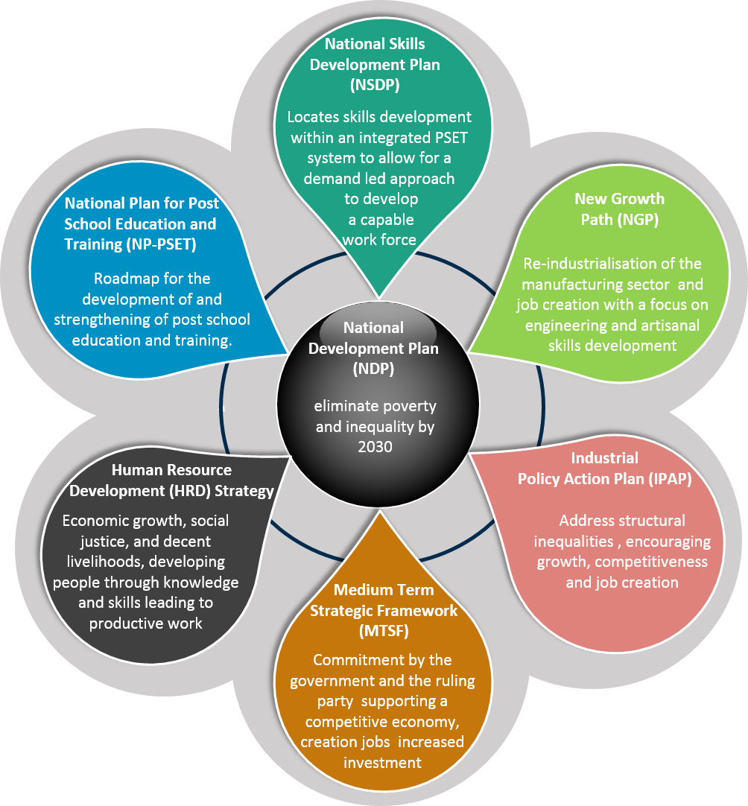

Figure : Policies impacting skills development in the mer sector

Collectively, the aim of these policies is to encourage employment-intensive growth (Bhorat, & Rooney, 2017; Williams, Cunningham & De Beer, 2014). They all have at their core; key levers to ensure continued economic growth, job creation, sustained livelihoods, social justice and access to decent living conditions through human and community development. These plans draw a focus to the following key issues, which the merSETA needs to respond to through various interventions:

* Inclusive growth and transformation of the national economy
* Employment creation (including self-employment) and entrepreneurship
* Supporting the informal, small and community based enterprises
* Community and youth development
* Environmental sustainable economic development
* Gender equality and sustainable development

The merSETA acknowledges the significance of national strategies in driving imperatives that are central for the growth and development of South Africa's civil and business sectors. The National Development Plan, National Skills Development Plan, Human Resource Strategy and the IPAP aims to stimulate sustained economic growth through re-industrialisation and “learning by doing” in order to compensate for global shifts and uncertainty in an age of technology. It acknowledges the manufacturing sector as the main sector to drive economic growth and employment creation.

**2.3.1 Policies impacting on skills development for PSET**

**The National Skills Development Plan (NSDP) 2030**

Promulgated by Minister Pandor on 06 February 2019, in terms of the skills development act, locates skills development in an integrated PSET system which is demand-led in order to assist economic growth and structural transformation. The result of planned action and transformation should ultimately lead to a South African labour market that is skilled and capable. Further to this the current minister of Higher Education, Science and Technology, Mr Blade Nzimande announced in July 2019, the completion of the National Plan for PSET (NPPSET) which is developed as a roadmap for the development and strengthening of the PSET system.

The key principles of the NSDP speak about developing the country across all sectors through inclusive growth and income generation as set out in the NDP, NGP and IPAP within an equitable and integrated system. Its key beneficiaries are the currently employed workforce and new entrants to the labour market seeking work experience. Skills development is seen as a system that works through collaboration within the public and private sectors to provide quality education and workplace experience to allow for adequate articulation between programmes and qualification offerings. Support is therefore key for both learners and employers to ensure an efficient, informed approach to education through standard processes (levy system and SETAs) and enabling technologies. All players in the PSET system will be held to the highest standards in terms of governance, quality of provision, sector analytics and research for demand led interventions, which will be supported by quality councils and education and train institution who are well organised and well resourced. These institutions are in turn supported by the SETAs as intermediaries. Strengthening the role of the SETA as an intermediary body will therefore remain pivotal in successful implementation of the NSDP. The eight outcomes of the NSDP are noted below:

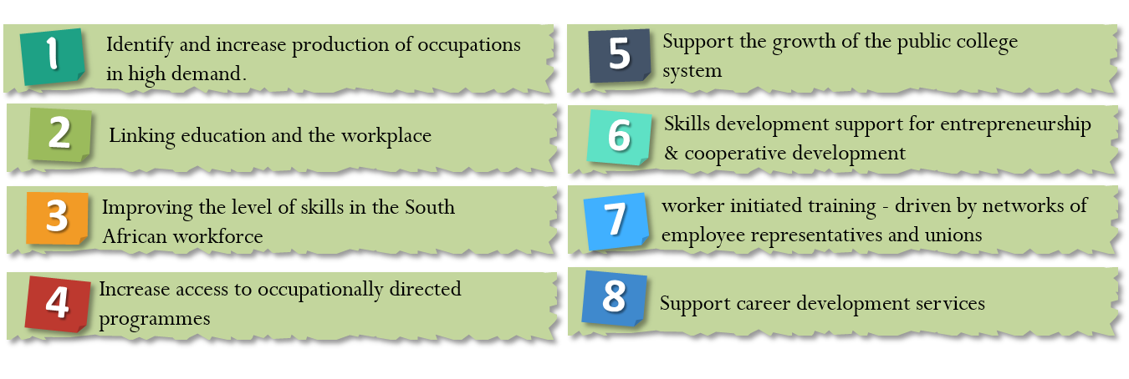

Figure : NSDP outcomes

Post-School Education and Training (PSET) is critical to South Africa’s future skills development, it dramatically improves the employment prospects of young people and raises their income earning potential. In addition, broadening the skills base would be socially and economically transformative, and promote economic and employment growth (Government Technical Advisory Centre, 2019).

National Plan for Post –School Education and Training

The Honourable Minister Blade Nzimande made an announcement on 12 July 2019 that the National Plan for Post-School Education and Training (NPPSET) has been completed to give practical planning effect to the policy goals and objectives of the post-school system. NPPSET is a consolidated roadmap for a more integrated, transformed, articulated and effective post-school system.

In the National Plan, the Fourth Industrial Revolution (4IR) team would provide critical policy advice on how the PSET system should respond to opportunities and challenges that are presented by the 4IR, “particularly on issues relating to curriculum development, science and innovation” (Bizcommunity, 2019). On the Sector Education and Training Authority (SETA) landscape, the Honourable Minister Nzimande further announced that the new SETA landscape will be implemented from 1 April 2020, with an aim to strengthen, realign and re-purpose the SETA system.

The National Development Plan 2030 emphasises the need to understand the supply of and demand of skills in our economic climate. The White Paper observes that although South Africa has put in place a range of ambitious measures to improve skills planning, the system neither produced good information about skills needs, nor increased the quality of provision in areas needed in the economy. The Paper concludes that the limited credibility and impact of the current sector skills planning system is due to inadequate research capacity; lack of economics, labour market and industry expertise; poor data management and lack of planning (DHET, 2019).

To address the challenges, the White Paper commits the department to establish a central unit for skills planning as part of the vision of building an expanded, effective and integrated post-school system for the country. This unit will conduct its work within a broad framework of the Human Resources Development Strategy and National Development Plan.

There is growing consensus regarding the skills related problems facing South Africa. Key strategy documents like the Human Resource Development Strategy for South Africa, National Skills Development Strategy III, National Development Plan and White Paper for Post-School Education and Training all draw attention to the risks related with the poor supply of skills from the education and training system and misalignment between skills supply and demand for implementation of economic growth strategies (DHET, 2019)

New policy developments: Economic and social policies that will impact the mer sector

Green paper on the social economy

The draft Green Paper proposes the following overall policy position for consideration: While facilitating the growth of the Social Economy, its characteristics of solidarity, social cohesion, social inclusion, self-organisation and self-sustainability should be nurtured. Regulation and financial incentives should be focused, supportive and incisive. The range of measures to be considered to stimulate the social economy include measures to enable the Social Economy to benefit from the Fourth Industrial Revolution (4IR) while promoting employment-creation as a response to potential job losses as a result of the introduction of 4IR technologies, needs to be prioritised. SETAs including the merSETA have a critical role to play in enabling the social economy to meaningfully participate in the new economy through relevant skills interventions. The merSETA is in the process of exploring the feasibility of partnering with TVET colleges and other training centres to provide community based entrepreneurs and informal workers with access to their workshops and equipment for work and training purposes.

Economic transformation, inclusive growth, and competitiveness: Towards an Economic Strategy for South Africa

The combination of low growth and rising unemployment means that South Africa’s economic trajectory is unsustainable. Government should implement a series of growth strategies that promote economic transformation, support labour-intensive growth, and create a globally competitive economy (National Treasury, 2019). At the centre of this strategy is economic transformation defined as the rapid and fundamental change in the systems and patterns of ownership and control that govern the economy. The primary focus of the change in economic relations must be the creation of opportunities for all South Africans to live productive, prosperous, and dignified lives. The strategy identifies a complexity of factors that have hindered greater participation by new firms in the economy, such as the existence of scale economies; regulations and policies that support incumbents or are ineffective in assisting rivals and new firms; competition legislation that favours large firms and incumbents; and access to finance challenges (National Treasury, 2019). The strategy identifies Implementing youth employment interventions such as continued support for government programmes that incentivise job creation (e.g. learnerships) and apprenticeships that facilitate school-to-work transition based on close cooperation between institutions of learning and the private sector as one of the five building blocks for supporting growth that promote economic transformation, support labour-intensive growth, and create a globally competitive economy. The strategy also acknowledge that a combination of short and long-term solutions are required to address the skills challenges confronting the South African economy

National strategic plan on gender-based violence & femicide

Gender-based violence and femicide in South Africa has reached alarming levels. Addressing the Presidential Summit on Gender-Based Violence and Femicide on 1 November 2018, President Cyril Ramaphosa, reiterated that gender-based violence is “a crisis that is tearing our society apart. It is a crisis that affects every community in our country and that touches the lives of most families in one way or another. Gender-based violence is an affront to our shared humanity”. The National Strategic Plan (NSP) on Gender Based Violence and Femicide (GBVF) sets out to provide a cohesive strategic framework to guide the national response to this scourge. The purpose of the strategy is to provide a multi-sectoral, coherent strategic policy and programming framework to ensure a coordinated national response to the crisis of gender-based violence and femicide by the government of South Africa and the country as a whole. The department of Higher Education and Training has responded by developing a policy framework to address gender based violence in the PSET institutions and to provide a monitoring instrument for the department to assess the implementation of the Policy Framework. The merSETA is determined to support the fight against gender-based violence in South Africa, which has reached crisis levels. The merSETA will therefore seek opportunities to partner with organised employers, unions, civil society, public institutions and institutions of learning in supporting initiatives such as research, training and awareness campaigns in the workplace and institutions of learning aimed at addressing gender-based violence. The manufacturing sector remains largely male dominated, thus, is a high-risk sector when it comes to issues of gender-based violence.

## STRATEGIC MEASURES TO SUPPORT SKILLS DEMAND AND SUPPLY

In this section we summarise the sectoral drivers and alignment to national strategies to inform strategic measures which are either currently in process or should become more emphasised in the merSETA list of priority actions.

As a precursor to its overall strategy the merSETA have developed its strategic outcomes in line with national policies. The merSETA strategic outcomes are as follows:

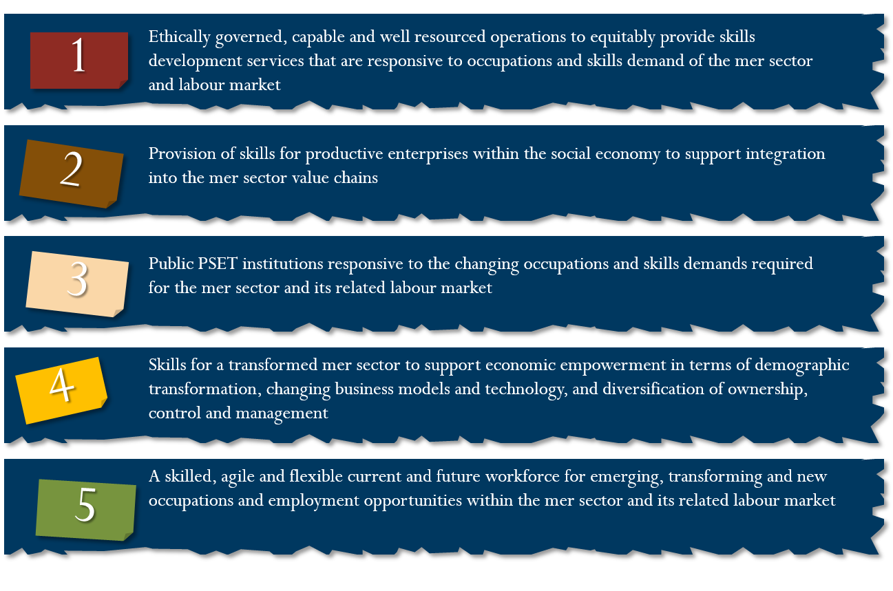

Figure : merSETA outcomes

These outcomes assures the merSETA and its stakeholders that it is able to address the key challenges faced by the sector through skills interventions which will assist both employees and employers to access better livelihoods and become more competitive in the labour market and the larger national and international economies.

In summary the following key drivers and their impact on skills are presented on the table below.

Table : Sectoral Drivers and Impact on Skills Development

| **Sectoral Drivers** | **Implications for Skills Development** |
| --- | --- |
| 1. **Reindustrialisation through localisation and diversification of the manufacturing sector**   Reindustrialisation and localisation is key in stimulating economic growth, employment and developing potential in both local manufacturing value chain and increased participation of South African markets in the global manufacturing value chain. The COVID-19 global crisis has once more highlighted the importance of a sound local manufacturing base for sustaining the domestic market while creating opportunities for the export of critical products. In April, government launched a National Ventilator Project aimed at building more local machines due to the shortage of ventilators globally. De-industrialisation and increased competition in the global manufacturing sector demand the South African economy to increase its complexity to remain competitive**.** The need to industrialise through the growth and diversification of the manufacturing sector features prominently in South Africa’s economic policy framework (DPRU, 2020).In the aftermath of the COVID-19 pandemic, the sector will struggle to regain its presence in the domestic and international markets but building economic complexity offers opportunities to diversify and create employment opportunities. | * Skill interventions are required in support of the DTI’s IPAP, SEZs and designated trades. Government ambitions for economic growth should be supported through key partnerships for skills development and the private sector. * Skills to support entrepreneurship and the growth and sustainability of SMEs and community based enterprises in the social economy. The merSETA has committed to Supporting the “**Economic stimulus for small medium and micro enterprises (“SMMEs”) and cooperatives: COVID-19 and beyond project”** by providing the much-needed support and training for the SMMEs and Cooperatives. * The merSETA has a key role in facilitating this process of industrialisation through manufacturing diversification and increasing complexity through the facilitation of skills development interventions that ultimately enable growth along this industrialisation pathway. * The merSETA **VIRO-VENT Skills Innovation Challenge** aims to foster collaboration during the unique conditions of the COVID-19 pandemic in promoting the capabilities and expertise of HEIs to industry partners in a way that facilitates a transition of graduates into emerging technology innovation employment or entrepreneurial opportunities. This initiative supports the national ventilator project |
| 1. **Automation, digitalisation and technology advances**   New technologies and changes to the way business is conducted in the sectors brought about by advanced methods in 4IR. Full-time jobs will diminish and the *gig economy* will grow As companies try to streamline and optimise their process and operations including the reduction of full time employment  National plans and strategies call for support for accessing markets, structural transformation and using technologies to improve the business sector as well as improving efficiencies in the public sector for demand led interventions.  Business leaders and other stakeholders should address the below primary challenges within the larger context of youth workforce development (Deloitte Global, 2018):   * Reimagine 4IR as a unique opportunity to be welcomed, not a problem to be confronted. * Reposition discrete and disconnected programs as a system-wide, unified set of approaches. * Realign toward achieving both scale and impact, rather than framing solutions as scale versus impact.   Reframe the possibilities for marginalized youth.  Full time jobs are expected to diminish due to the COVID-19 pandemic and the gig economy is expected to grow.  Skills are required that are updated and adaptable to the needs of industry in the near and longer term future.  The South African Government has already indicated the willingness to expand learning modality especially to those who experience barriers to participation such as geographic location, lack of access to digital infrastructure, time pressures, lack of admission qualifications, lack of finances etc. The department has therefore adopted an “open learning” strategy (Government Gazette, April 2017).  Remote and teleworking will become the ‘new norm’  Remote and teleworking proved critical in limiting the impact of the COVID-19 global crisis. The new way of working demands companies to adopt flexible and people centred approach to work culture. | * Interventions should be about assisting job preservation and growth through realignment of skills where necessary as the country has seen massive retrenchments and company closures. * The 4IR has the potential to raise global income levels and improve the quality of life for populations while developing a skills strategy in line with future demands (World Economic Forum 2016). * Jobs with a direct impact on the organisations intellectual property will remain stable, and organisations will now hire more freelancers and contract workers as we are moving to the gig economy. The gig economy calls for an agile, skilled and flexible workforce**.** Itoffers a fantastic opportunity to connect people up with highly skilled professionals via easy to use digital platforms that allow these highly skilled professionals to reach out to a critical mass of clients. * **New or improved curricula must account for broad areas with respect to:** predictive analytics, artificial intelligence, additive printing, and the internet of things (5G), automation and robotics. * **Professions in the future will typically center on the following types of jobs:** motor manufacturing technicians, wind turbine service technicians, flexible app developers, computer programmers, artificial intelligence and robotics specialists, and cloud computing specialists among others. * Skilling will overtake credentialing as businesses will hire people who possess the attitude and skills to get the job done. Online learning will grow exponentially. Short courses and micro-learning will gain traction as a legitimate form of learning. Quick deskilling, re-skilling & up-skilling that will enhance the rapid adoption of e-learning tools & platforms will become popular (Metal Chamber Report, 2020). * Remote and teleworking in the services, product support services and other support professionals such as sales and marketing, human resources have proven to be key not just in the mer sector but every sector. In the motor retail industry companies such as BMW, Mercedes Benz have set up virtual showrooms allowing sales people to interact with customers remotely even during the lockdown. |
| 1. **Environmental sustainability and new business models**   South Africa views green economy as a sustainable development path based on addressing the interdependence between economic growth, social protection and the natural ecosystem (Environmental affairs, 2019). The South African government has put in place initiatives aimed at supporting energy and resource efficiency to promote sustainable development.  The circular economy can be seen as an economic model that minimises resource input and waste generation. There should be a focus on facilitating environmentally sustainable “green” practices.  The focus on marine transport manufacturing has the opportunity to deepen component manufacturing and rebuild domestic capabilities, facilitating reindustrialisation and localisation.  The way in which business is conducted is changing globally, in line with green technologies and this presents new opportunities. Green is said to be the new “gold”. It has had unprecedented success as it provides a quantifiable metric to people’s efforts towards Sustainable development (The Master Builder, 2019). | * Greater efficiency in the use of energy, water, and materials is given South Africa’s struggle with energy generation currently. Skills around cleaner energy sources are thus critical in South Africa’s adoption of cleaner energy production. * Opportunities exist to upskill small businesses participating in the upstream recycling value chain (collection and distribution of waste) to participate in the upstream value chain where recycled material is further processed and used in the manufacturing of other products. * Creating greater awareness and advocacy for green skills and green technologies in the sector is key as the first step to the road to greening the mer sector. * To ensure the relevant skills are developed for the circular economy, curriculum design and development of new qualifications and occupations should take into account developments in sustainable manufacturing, energy and resource efficiency. * Initial findings from the green skills research project identify the need to raise awarenessto understand the green economy. What was also apparent is the need for up-skilling and transforming current jobs to be greener. |
| 1. **Supporting a diverse and inclusive labour market system**   High demands of structural change may exclude many in the workforce due to limited skills, to be truly inclusive those who are unable to access the labour market should also have opportunities to be up-skilled and re-skilled to access a decent and sustainable livelihoods.  The South African government has strongly emphasised inclusivity (poverty, disability and breaking barriers to access), community development, youth development and support for small and informal business. | * Increasing workforce with skills for emerging, transforming, or new occupations and skills * Skills development support should be of a high quality and it should also ensure an offering of bespoke packets of support to break barriers to entry and succession once enrolled. * A partnership model in line with NSDP is required. Civil society partnerships and regional focus areas should be developed where communities can access skills development opportunities through either community education centres, TVET colleges or higher education institutions. * As the COVID-19 is disruptive employees will need to engage in life-long learning and acquire skills faster to remain in jobs. The ability to adapt to the changing nature of work is essential as this will mean much more than the number of qualifications an individual has. |
| 1. **Changing customer tastes and expectations**   Customers more than ever have become more discerning and are increasingly demanding quality services and products, convenience, product design choices and flexibility. The rise of the digitally discerning customer “who is open to digital, is aware of its benefits and who expects it to deliver on its promise” has added a new twist.Customer satisfaction and retention is increasingly dependent on positive user experience (Atos, 2020). | * The Fourth Industrial Revolution has changed the way customers interact, their tastes and expectation around product and service support. Customer experience, product design and development, digital sales and marketing skills will increasingly become key. |

## CONCLUSION

The manufacturing, engineering and related services sector continues to experience shifts due to global and domestic economic developments, technology advances and innovation. The SETAs in partnership with other role players have a significant role to play in responding to some of these shifts through relevant skills development interventions. The World Economic Forum future of jobs of Tomorrow: Mapping Opportunity in the New Economy report (2020) identified the seven key professional clusters with emerging prospects across in the future these include Data and AI; Care Economy; Green Economy; Engineering and Cloud Computing; People and Culture; Product Development; as well as Sales, Marketing and Content. Collectively, these professions are set to yield 6.1 million new job opportunities in the coming three years. These findings are consistent with findings from this chapter as discussed above. Developments in the digital driven Fourth Industrial Revolution, environmental sustainability, national priorities such as economic transformation and reindustrialisation and disruptions as a result of the global COVID-19 pandemic will define new priorities in the sector.

# OCCUPATIONAL SHORTAGES AND SKILLS GAPS

## Introduction

This aim of this chapter is to highlight skills supply and demand issues as well as to identify the occupational shortages and skills gaps in the sector. The data was sourced from multiple datasets and documents such as the merSETA WSP data, merSETA research, desktop research and Statistics South Africa as well as interviews with merSETA stakeholders.

## Sectoral occupational demand

Hard to Fill Vacancies

The WSP 2020 data provides information on hard to fill vacancies (HTFVs) based on a template provided by the DHET.

Of all the WSPs submitted, 4761 companies filled out the skills requirements section pertaining to HTFVs. Most 3857 (81%) companies indicated that they did not have any HTFVs due to them being able to easily fill vacant positions (65%) or not having any vacancies to fill (35%). The table below shows the number of vacancies by occupational group. In total, companies indicated 4636 vacancies. The majority of these were for skilled trades’ workers, sales workers, machine operators and managers. This shows that there were more opportunities for artisans and sales workers with relatively little demand for clerical workers and elementary workers. A key observation here is that the elementary workers represent a significant portion of the workforce but they have the least opportunities for work. The vacancies required also require mid level skills rather than high level skills and qualifications as those required for managers and professionals.

Table : HTFVs by No. of Company and Occupational Group (WSP, 2019)

| **Occupational Group** | **No. Vacancies** | **% HTFVs** |
| --- | --- | --- |
| Managers | 502 | 11% |
| Professionals | 378 | 8% |
| Technicians and Associate Professionals | 309 | 7% |
| Clerical Support Workers | 97 | 2% |
| Service and Sales Workers | 1053 | 23% |
| Skilled Trades Workers | 1712 | 37% |
| Plant & Machine Operators & Assemblers | 526 | 11% |
| Elementary Workers | 59 | 1% |
| **Total** | **4636** | **100%** |

The table below shows the HTFVs by occupational group for companies that indicated they require these vacancies. The vacancies are only those that had 20 or more unfilled seats (this is used as a proxy for heightened demand despite limitations in the vacancy data as described in the preceding paragraph). This means that employers were not able to fully fill their recruitment requirements at the time of data collection. It is evident from the table that the majority of HTFVs that remain unfilled is at skilled trades’ worker level and professional level.

Table : Hard to Fill Vacancies by Occupation (merSETA WSP, 2018)

|  |  |  |  |
| --- | --- | --- | --- |
| **Occupational Category** | **OFO Occupation** | **Total**  **Vacancies** | **Unfilled Vacancies** |
| **Managers** | Corporate General Manager | 105 | 62 |
| Sales Manager | 180 | 59 |
| **Professionals** | Management Consultant | 54 | 52 |
| Mechanical Engineer | 51 | 26 |
| Industrial Engineer | 48 | 23 |
| Industrial Products Sales Representative | 64 | 21 |
| **Technicians and Associate Professionals** | Credit or Loans Officer | 48 | 22 |
| **Service and Sales Workers** | Motorised Vehicle or Caravan Salesperson | 930 | 318 |
| Automotive Parts Salesperson | 76 | 39 |
| **Skilled Trades Workers** | Mining Blaster | 296 | 258 |
| Automotive Motor Mechanic | 377 | 143 |
| Boiler Maker | 129 | 112 |
| Metal Machinist | 61 | 51 |
| Steel Fixer | 150 | 50 |
| Diesel Mechanic | 76 | 49 |
| Millwright | 49 | 33 |
| Fitter and Turner | 43 | 27 |
| Electrician | 60 | 27 |
| Welder | 102 | 23 |
| **Plant & Machine Operators & Assemblers** | Engineering Production Systems Worker | 411 | 70 |
| Plastic Compounding and Reclamation Machine Operator | 21 | 20 |

Reasons for Hard to Fill Vacancies

Overall, the reasons for difficulty in filling vacancies are a lack of specific skills, a lack of experience and qualifications as demonstrated in the figure below.

Figure : Reasons for HTFVs

Different occupational categories present different reasons for the HTFV. A lack of specific skills are prevalent across all categories but seem more prevalent among elementary workers, operators and professionals. A lack of experience seem more prevalent in sales, clerical and managerial positions. A lack of qualifications seems most prevalent in HTVs for the trades and technicians – an area that merSETA specialises in. While demonstrating low prevalence across the board, equity considerations seems to have a higher impact in recruiting for professional, technician and management positions. Candidates not having a good attitude and poor remuneration do not seem to be reasons for difficulties in recruiting.

Figure : Reasons for HTFVs by Occupational Category

Skills Gaps in the sector

According to the DHET SSP framework, skills gaps refer to “skills deficiencies in employees or lack of specific competencies by employees to undertake job tasks successfully to required industry standards. Skills gaps may arise due to lack of training, new job tasks, technological changes, or new production processes, to list a few. The term ‘top up skills’ also refers to skills gaps and usually requires a short training intervention”.

Throughout this document the notion of future skills has been noted in light of globalisation and competitiveness, re-industrialisation and skills for 4IR. The COVID-19 pandemic has tended to exacerbate the 4IR in that companies had to adopt new technologies rapidly to ensure continued production under social distancing regulations. In order for workers to keep pace and remain viable over time, they need to possess key skills that will allow them to be more successful in their work and more marketable to relevant sectors. Commentary of expert practitioners in the sector have reiterated the difficulties in terms of firstly ensuring learners have access to a workplace but secondly that newly developed qualifications take far too long to be developed and registered making it difficult for SETAs and industry to respond. COVID-19 has made this more challenging as social distancing as well as company closures further impeded the number of workspaces available as training spaces. The PSET fraternity including the QCTO, NAMB, SAQA and the SETAs need to act with expedience to ensure continued training in the time of COVID-19. Workers and learners alike need to possess certain critical/top up skills to adapt to the ever changing demands of the workspace.

The analysis below reviews skills gaps. Respondents on the WSP questionnaire were asked to identify skills gaps for each occupational category. The top 5 skills gaps by occupational category are demonstrated in the table below.

Table : Skills Gaps across (merSETA WSP, 2020)

|  |  |  |  |  |  |  |  |  |  |
| --- | --- | --- | --- | --- | --- | --- | --- | --- | --- |
| **skills gaps** | **1. Managers** | **2 Professionals** | **3. Technicians and associate Professionals** | **4. Clerical Support Workers** | **5. Sales and Service Workers** | **6. Skilled Trades Workers** | **7. Machine Operators** | **8. Elementary Workers** | **Grand Total** |
| Planning and organising | 445 | 376 | 396 | 461 | 360 | 336 |  |  | 2374 |
| Problem Solving |  | 294 | 406 | 369 | 272 | 402 | 336 |  | 2079 |
| Management and Leadership | 914 | 492 | 343 |  |  |  |  |  | 1749 |
| Supervisory skills | 418 | 397 | 489 |  |  | 350 |  |  | 1654 |
| Technical (job-specific) |  |  |  |  |  | 560 | 459 | 307 | 1326 |
| Project Management | 478 | 417 | 351 |  |  |  |  |  | 1246 |
| Office Administration |  |  |  | 637 | 270 |  |  |  | 907 |
| Teamwork |  |  |  | 262 |  |  | 327 | 286 | 875 |
| Production |  |  |  |  |  | 398 | 406 |  | 804 |
| Occupational Health and Safety |  |  |  |  |  |  | 331 | 336 | 667 |
| Marketing and Sales |  |  |  |  | 488 |  |  |  | 488 |
| Legal, governance and risk | 348 |  |  |  |  |  |  |  | 348 |
| Customer Service |  |  |  |  | 324 |  |  |  | 324 |
| Financial and Accounting Skills |  |  |  | 315 |  |  |  |  | 315 |
| Reading writing and numeracy |  |  |  |  |  |  |  | 277 | 277 |
| Communication (oral) |  |  |  |  |  |  |  | 266 | 266 |

The table shows the top 5 skills gaps for each occupational category in the columns. Managers have gaps in management and leadership, project management, planning and legal, governance and risk. Skills gaps are clustered at the top of the table and affect many occupations, these gaps are planning and organisation, problem solving, management and leadership, supervisory skills, technical skills and project management respectively. Office administration was identifies for clerical and sales workers. Teamwork was identified for clerical workers, operators and elementary workers. Technical skills was identified for the technical occupations of the trades, operators and elementary workers. Reading, writing, numeracy and oral communication skills were deemed as gaps for elementary workers

The reasons for skills gaps are outlined in the figure below. It would appear that overall new work processes and new technologies are the main drivers of skills gaps. A lack of experience, lack of qualifications and new products seem equally important in terms of the reasons for skills gaps.

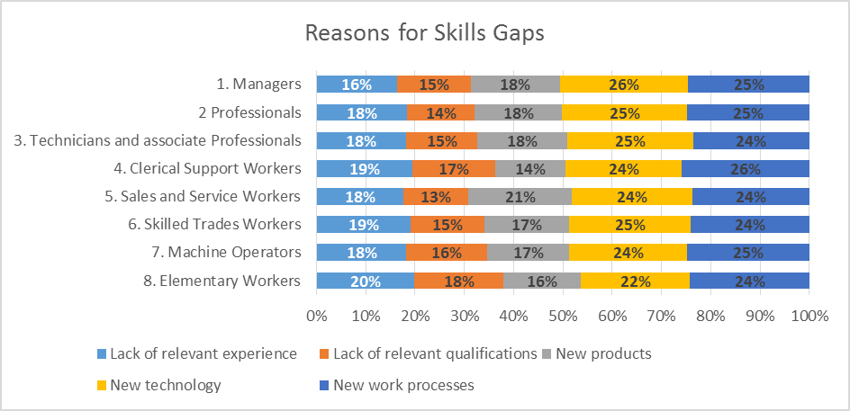

Figure : Reasons for Skills gaps by occupational group (merSETA WSP, 2020

## Extent and nature of supply

The State of Education and Training Provision

This section looks at the provision of education and training of skills with the focus specifically on merSETA accredited qualifications. Therefore, skills supply include a consideration of both the skills of the current labour force and those of the future labour force. Further to this, this section also reviews provision in higher education, TVET colleges and skills programmes. It assesses the gaps in the supply pipeline in order to help identify where the merSETA can most effectively intervene. The Quarterly Labour Force Survey (QLFS) results for the quarter January to March 2020 show an increase of 1% in unemployment bringing unemployment to 30.1%. The rise in unemployment was in the formal sector whilst employment in the informal sector and household sector increased. Manufacturing shows the largest decrease in employment in the formal sector, whilst the rise in informal sector employment has been in trade, construction, mining, community & social services and manufacturing. Furthermore the country is experiencing a shortage of skills across many occupations. The skills needed in the mer sector are primarily in the engineering sector.

The South African workforce continues to battle challenges such as the skills gap, a high youth unemployment rate and economic uncertainty, which present challenges for both organisations and job seekers alike. Although, the root of unemployment is not only a lack of jobs; a key underlying issue is the inadequately educated workforce which is the main challenge of the post-school education and training. A report by Channel Wise (2020) indicates that following are labour market trends in South Africa must be considered in the development of the skills supply channels:

Flexibility: In light of the Covid-19 pandemic the trend is beginning to gain traction, with more local companies offering flexible working hours and remote working options and this will become essential to attracting and retaining top talent in 2020 and beyond.

Learnability: As the workplace continues to evolve, skills of the future continue to emerge. Again, learning how to learn will be essential to all job seekers and employees.

Skills transfer: Further, as the skills gap widens, organisations have to shift their focus from solely hiring the right skills to creating and transferring these skills. One of the best ways to build new skills is through mentoring.

Human Tech integration: Due to the pandemic, technological advancement and automation is the order of the day across industries and sectors globally, and 2020 is set to see a rise in this, not only in the way organisations do business but in the way they manage their staff.

Focus on sustainability: Organisations are currently seeking sustainable practices and partnerships with a specific focus on employee wellbeing and mental health.

Higher Education and Training

Higher Education Institutions (HEIs) provide the requisite high-level skills for the mer sector. One of the biggest challenges is that previously disadvantaged universities have not developed engineering faculties, implying that the pipeline of graduates is limited to universities that have traditionally produced engineers (ECSA Report, 2019). The analysis of the supply of skills at HET level focuses only on the fields of study that are most relevant to the mer sector. It also focuses on the growth in output over the five-year period from 2012 to 2018.

In 2020, 26 public universities will provide access to 201 042 new students wishing to pursue their studies across all general, technical and professional fields including Business and Management, Science, Engineering, Agriculture and Technology, Humanities, Social Sciences, the Arts and Education. In addition, of the 201 042 new entrants, 16 152 new entrants will enrol in Engineering programmes (DHET Report, 2020).

The Higher Education Minister Blade Nzimande has recently announced in a media briefing that COVID-19 continues to take a heavy toll not only on the health, but on people’s ability to learn and develop. Some impediments to learning at this time include the following:

A lack of devices, data and connectivity for students and staff;

Requirements for the implementation of alternative flexible teaching and learning modalities;

The phased-in return of students and staff and campus readiness; and

Financial sustainability into the future.

The emergence of the COVID‐19 pandemic, has highlighted the lack of online teaching experience, early preparation and support from educational technology teams.

TVET Colleges

TVET colleges play a pivotal role in addressing South Africa’s skills needs and cater for a wide spectrum and growing numbers of students. TVET colleges provide technical and vocational education and training programmes to learners who have completed at least grade 9 at school level. The TVET colleges have been identified by the government as a vehicle to improve pass rates and expand the number of qualified people entering the workforce. Arguably, government’s intention to improve TVET colleges support includes the following (DHET Report, 2020):

The Support in ensuring transformation with regards to relevant and responsive curricula;

Lecture development;

Improved administration; and

Management and government of TVET colleges with the aim of producing employable young people with high quality occupational and vocational education and training skills.

The recently launched 25 year review by the Department of Monitoring and Evaluation suggests that the TVET college system can improve its standing in the hearts and minds of South Africans by guaranteeing demand for its graduates and positioning itself to providing skills needed for the fourth industrial revolution (4IR).

Notably, the sector education and training authorities (SETAs) continue to do their part in advancing the TVET college system. TVET colleges form a critical component of the current training capacity of artisans. Considering the need to boost the annual production of artisans to 30 000 by 2030, activities focused towards artisan development remain critical. A prime example is the R100 million injection from the Manufacturing Engineering and Training Authority (merSETA) towards the College of Cape Town Welding Academy.

According to the Department of Higher Education and Training (2020), in the 2020 academic year, 226 685 new entrant opportunities will be provided by TVET colleges of which 156 800 opportunities will be available for students interested in studying towards a National Diploma in Engineering, General or Business Studies. Meanwhile 63 658 new entrant opportunities will also be available across 19 programmes for the National Certificate (Vocational), which provides both theory and practical experience in various vocational fields.

Further to this the Minister of Higher Education, Science and Technology, Blade Nzimande, has urged young people to consider alternatives to university by considering technical, vocational, educational and training (TVET) colleges. There are 5 387 entry opportunities into the Pre-vocational Learning Programme (PLP), which will enable a student not meeting the requirements for the TVET college programme of his/her choice to obtain the required knowledge and competences to do so in the following academic year.

TVET Centre of Specialisation (CoS)

A Centre of Specialisation is a department within a public TVET college campus dedicated to training and address the demand of priority trades needed for the governments National Development Plan (College of Cape Town, 2019). The Centres of Specialisation (CoS) is a national programme aimed at building the capacity of the public TVET college system to deliver trade qualifications while building the much-needed skills for Strategic Integrated Projects (SIPs) of government’s infrastructure programme (DHET Report, 2020).

The National Skills Fund, supported by the Sector Education and Training Authorities and other donors are funding the development of the CoS. The new occupational qualifications comprise three components: theory, practical/ stimulated training work experience (SSACI, 2019).

The DHET is also applying the model of selecting certain colleges to focus on particular trades, to lay the foundation for differentiation in the college system.  And whilst some other colleges may later specialise in the same trades, it is desirable that others develop expertise in other trades and occupations to reduced duplication and increased quality specialisation (College of Cape Town, 2019). To this end, the ‘dual system’ (where learners rotate between the college and the workplace) is being tailored to meet specific South African conditions, to produce the ‘artisan of the 21st century’, or the A21 artisan (NEPAD, 2019). In addition employers are also expected to take part in apprentices and send them to colleges between February and March. Four Employer Associations, which include the Retail Motor Industry (RMI), Steel and Engineering Industry Federation (SEIFSA), Institute of Plumbing (IOPSA) and South African Institute of Welding (SAIW), are part of this ground-breaking initiative (DHET Report, 2020).

College sites are providing training in order to develop artisans with industry partners in 13 priority trades comprising skills sets in brick laying, electrician, millwright, boilermaker and automotive mechanics to name a few (DHET Report, 2020). Therefore a pilot programme has been implemented to expose students to workplace practices during training so that they become work ready once qualified (SA News, 2020). Subsequently the pilot programme is at the point of implementation and with colleges ready to begin rollout; the pilot life cycle key results are as follows:

Twenty-six delivery sites in 19 public TVET colleges are committed to the pilot;

Trained-49 facilitators/ TVET college lecturers;

Recruited 518 apprentices, all of whom will begin their theory and practical skills components and workplace rotations, the first 16 students started in march 2019; and

Over 90 employers (including municipalities and government departments) across the thirteen trades have either committed to workplace hosting or are in process discussions.

A significant achievement has been recognised by the main role-players: government agencies involved in skills development, industry and trade associations, employers and TVET colleges for a shared vision of an integrated TVET system where education, training, industry needs, and employment are part of a unified system (NEPAD, 2019).

Learnerships and Apprenticeships

Since its inception, the merSETA has registered 87599apprentices on apprenticeships and 95505 learners on learnerships. The predominant trades attained through apprenticeships include motor mechanic, diesel fuel injection mechanic, electrician (engineering), fitter and millwright. In the same period, a total of 53058 apprentices qualified as artisans in the sector and another 53072 learners successfully completed their learnerships (QMR, 2019). The most dominant learnership programmes include production technology, metals production, welding application, automotive repair and maintenance and automotive components: manufacturing and assembly (QMR, 2019).

The annual registration and completion figures for apprentices and learnerships since 2002 are shown in Figure 26 and Figure 27 below. It is clear that apprenticeships and learnerships form a crucial part of the supply of skills to the sector. Therefore, the merSETA continues to support the uptake of these learning pathways and continues to monitor trends in registrations and completions.

Figure : Apprenticeships Entered and Certified (merSETA QMR, 2018/19)[6]

Figure : Learnerships Entered and Certified (merSETA QMR, 2018/19) [7]

Skills Programmes

A skills programme is a structured learning programme that is occupationally based and when completed it will constitute a registered National Qualifications Framework (LMIP Dictionary on Skills Supply, 2017). To elaborate further provision is undertaken by a training provider accredited by an ETQA (Skills Development Act No. 97 of 1998). A skills programme may specify the sequence in which the unit standards must be achieved and the practical workplace experience that forms part of the programme. The Department of Higher Education and Training developed strategies to address skills and artisan shortages in the country (DHET, 2019a).

In the year 2020, The Department of Higher Education and Training (2020) will be implementing a new SETA landscape to further respond to the skill demands of the economy. The department will further strengthen, realign and repurpose SETAs so that they respond to the skills needs of the economy (DHET Report, 2020).

According to a report issued by the Statistics on Post-School Education and Training (2017), the 2017/18 cohort indicates that merSETA recorded the highest number of persons who completed artisanal learning programmes with 7938 competent learners. MerSETA complies with the overarching government policies which are fundamental to its mandate. In the 2017/18 financial year, 269 147 learners were registered for SETA- supported learning programmes in South Africa. The distribution was as follows:

Skills Programmes: 144 531 or 53%

Learnerships: 111 681 or 41.5% and

Internships: 12 935 or 4.8%.

A total of 177 477 or 65.9% of the learners who were registered for SETA-supported programmes in the 2017/18 period were certified with the majority being for skills programmes (DHET, 2017).

Skills programmes continue to form an important part of training and development, they offer short and focused skills interventions. The figure below shows workers and unemployed works entered and certificated between 2-11 and 2019. It seem that more workers are enrolling and becoming certificated in the latter years demonstrating higher demand and higher success rates.

Figure : Skills Programme Registrations and Completions: 2011/2012-2018/2019 (merSETA QMR, 2020)

Furthermore, the figure above indicates that the skills programme of workers and unemployed workers entering the programme is often the highest however, those who are certificated tend to be less than the number of registering individuals. This seems to be consistent, and the challenges associated with this trend have been attributed to:

Inappropriate Training Programs;

Lack of employee Interest;

Lack of management support;

Excessive training costs; and

Low return on investment.

In addition, (Andritios, 2019) suggests that some of the solutions to the above mentioned challenges is to categorise learning outcomes to be essential to the employee, while leveraging training in order to update skills and to use relatable case studies and scenarios to reinforce the relevance of the training program to the employee’s jobs. The

Community Education and Training

The Community Education and Training (CET) gives an individual the opportunity to develop basic literacy skills such as reading, writing and basic problem solving. In the completion of the training, individuals receive a nationally recognised certificate and with this qualification improves an individual‘s chances of finding a suitable job or provide growth within an organisation (Western Cape Government, 2018). Moreover, Community Education and Training Centres contribute in creating alternative education and training pathways. The current public adult learning centres should be transformed into Community Education and Training Centres that offer a variety of courses ranging from adult basic education to secondary and non-formal education.

The White Paper stipulates that by 2030, community colleges should be enrolling 1 million students. The importance of lifelong learning is signalled in the NDP and is a critical link to community education and training. The NDP specifies that all sectors of society need to set up lifelong learning initiatives to ensure that citizens have ample opportunities to develop their skills and gain a deeper understanding of the ever-changing environment in which they live. Furthermore, Community colleges will support the achievement of three of the NSDS III goals: to address the low levels of youth and adult language and numeracy skills; to support cooperatives, small enterprises, worker initiated, NGO and Community training initiatives; and to build career and vocational guidance (NPPSET Report, 2019).

Community colleges will help to balance out the pressure on the TVET and higher education sub-systems, which are under constant and relentless pressure to expand beyond current capacity and funding. They will provide a necessary expansion of post school opportunities and an alternative choice for young people and adults who have left school, while providing progression opportunities for those who have already left schooling (DHET Report, 2019).

The South African government’s ambition to precipitate rapid growth in the post-school education and training sector was expected to occur through the expansion in enrolment into TVET colleges and also by diversifying delivery mechanisms of higher education studies. This can accommodate a diverse range of people who wish to acquire marketable skills for subsequent life opportunities and comes with straight forward admission criteria which consist of completion of Grade 9 schooling and being 16 years and older (StatsSA, 2017). The graph below indicates the trends on the enrolment for TVET, CET and private colleges as analysed by DHET (2017).

Figure : Enrolment Trends 2010 and 2016

The above graph demonstrates a preference for TVET college enrolment with a large increase in 2016. Community college enrolment is relatively small compared to TVET enrolment but still higher than private college enrolment. There is however a decline in enrolment between the two periods which signals that that the CET sector requires additional support.

With the COVID-19 pandemic leaving many unemployed and many entering the informal sector, the CET Colleges should be an avenue to upskill the youth and the unemployed to enable them to access a living. In the merSETA informality study, it was shown that the majority of those operating in the informal trades, many had learned the skill by association, that being through family members and other community members. Access to CET could provide these individuals with some qualifications to empower themselves in their communities.

Participation in CET

A substantial 19%of the sector’s employees are employed as elementary workers and likely to have formal education levels below NQF level 4. The sectors educational levels increase overtime even at lower occupational groups this is confirmed by sector interviews as well as merSETA research. According to (Fourarge, Trudie & de Grip, 2010) low-educated workers invest less in training or because they have lower economic returns to on the job training and lesser willingness to participate in training courses, due to distinct economic preferences and personality traits.

Literacy remains a concern in South Africa due to low levels of formal education in organisation. The fact that a worker has literacy or numeracy skills at level 1 or 2 on the five level all scale does not necessarily mean that they are unable to perform their job in a satisfactory manner at present. Some jobs do not require much use of literacy or numeracy skills, and some workers whose literacy skills are low may still have the essential knowledge that is required for the tasks they need to carry out at work. People whose foundation skills are low are more likely than people with higher skill levels to have difficulties with tasks at work that require reading, writing or maths, with learning new knowledge and skills or with adapting to changes at work (Department of Labour, 2020). According to StatsSA, almost 15% of adults over the age of 20 are regarded as functionally illiterate in 2017 and 70% of grade 4 learners have difficulty reading for meaning in any language; this was attributed to a lack of access to reading material (UCT News, 2019).

For the merSETA it will be imperative to pay cognisance to the high proportion of workers who are working at elementary level and the likelihood that adults in the sector could have lower level of literacy than their level of education; furthermore new entrants into the sector may have similar characteristics which may be compounded by limited numeracy skills. Supporting community education and development will go a long way in fostering a pipeline of better skilled individuals who can take up further learning opportunities in the mer sectors, particularly among the youth and rural communities. In addition Community Colleges need to be better supported to produce a pipeline of learners to take up opportunities in the sector with respect to basic IT, effective workplace communication, entrepreneurial skills and problem solving, a need that is ever more pressing in the time of COVID-19. In addition a draft policy on new National Norms and Standards for funding Community Education and Training (CET) Colleges has been published in order to strengthen the role of colleges in the provision of skills, education and training for out of school youth and adults (SA News, 2019).

## SKILLS SUPPLY SIDE CHALLENGES

Basic Education and Training

The basic education and training sector as the feeder into the PSET sector seems to be improving overtime; the achievements of the class of 2019 confirm that the standard and quality of the South African examinations system is improving annually and stabilising. According to (NSC, 2020) the proficiency of our education system is confirmed by:

An improvement in the pass rate and quality of passes in many gateway subjects;

A noteworthy and credible increase in the percentage of learners who achieved the NSC;

A significant increase in the percentage of learners qualifying for Bachelor’s Studies; and

Phenomenal gains in the margins of improvement among Quintile 1 to 3 schools.

The education sector has listed eleven priorities for this administration, which include inter alia, improving the foundational skills of literacy and numeracy; implementation of a curriculum with skills and competencies for a changing world; dealing decisively with the quality and efficiency through the implementation of standardised assessments; urgent implementation of the two-years of Early Childhood Development before Grade 1, promote school safety, health and social cohesion and complete an integrated Infrastructure Development Plan (NSC, 2019).

The sector still faces some challenges including the lack of study material, large number of learners in classes and inadequate teaching staff. The South African government announced that changes will be made to improve the curriculum, recognising the importance of skills for a changing world, making reference to the need of 4IR (NSC, 2018). It seems as if the changes that were made are becoming more effective looking at the 81.3% – the overall pass percentage of the class of 2019 – a 3.1% improvement on the previous year of 78.2% (Business Tech, 2020). Referencing to some areas where there were poor performance, it was recommended that the NSC school subject report should be used to help education stakeholders to identify subjects in which performance was poor to ensure that appropriate interventions are introduced. Early identification of poor performance will thus, help these stakeholders to maintain high levels of performance (NSC, 2020). The 2019 year represent the 6th cohort to be exposed to the CAPS curriculum.

Figure : Maths and Science Pass Rates

When comparing the average pass rate of mathematics and physical science for 2015 to 2016, mathematic increased from 49.1% to 51.1% and physics science increased from 58.6% to 62%. The pass rates seem to be increasing continuously since 2015 for both subjects with physical science increasing with 74.2% to 75.5% in 2018 to 2019. Although mathematics had 3.4% declined from 58% to 54.6% in 2018 to 2019. The figure shows that physical science pass rates increased by 3.1% between 2016 and 2017 and almost 10% increase between 2017 and 2018 (NSC Examination Report, 2018). Thus far, physical science pass rate constantly keep increased year by year. However, the pass rate is achieved at 30% and insufficient for the demands of the curricula required to enter training at PSET level for the sector. Learners will require additional support.

President Cyril Ramaphosa has announced that the immediate task is to improve the foundational skills of literacy and numeracy, especially reading for meaning. Reading for meaning has been declared as apex priority. The Governments immediate task is to improve the foundational skills of literacy and numeracy, especially reading for meaning. Further to this, research has shown that for learners to thrive in today’s fast changing world, they require a new breadth of skills.

Skills such as literacy, numeracy and science are all interconnected to things such as team work, critical thinking, communication, persistence and creativity. These skills are part of the skills set necessary to meet the demands of a changing economy and the future of work (IoL News, 2020).

Quality of Provision in the PSET Sector

Education and training in the sector is mainly through the PSET system and merSETA accredited programmes. The White Paper for PSET, released in 2013, gives effect to the commitments set out in the National Development Plan 2030. It guides and steers the PSET system by setting outcomes and targets for each of these sectors. The targets for the university sector are to reach a headcount enrolment of 1.6 million by 2030 (DHET, 2013). In the college system, the target is to increase enrolments in TVET colleges to 2.5 million. The Post-School Education and Training (PSET) landscape in South Africa comprises of 26 universities providing undergraduate and post-graduate qualifications, 50 TVET colleges providing vocational and occupational qualifications and a vast number of private institutions, 9 new community colleges (incorporating all the former Public Adult Learning Centres); private higher education institutions and colleges (DHET, 2019).

The Department of Higher Education and Training is responsible for PSET, and state and private sector both have a role to play in providing post-school education and training (DHET, 2012). The White Paper is clear that skills development is not something different from education and training. Furthermore merSETA must position itself as an intermediary between the employer, employee, government and institutions of education and training. Among the recommended skills priority actions for engagement and delivery, merSETA must support and develop the PSET provisioning infrastructure which includes workplace, community colleges, TVET colleges, HEIs and skills development providers (merSETA, 2019).

TVET and private colleges constitute another key subsector of the PSET system. The NDP emphasises that TVET colleges should play a critical role in skills development, with the aim of reducing skills shortages and thereby also youth unemployment (DHET, 2019a). Further to this expanding enrolment at technical and vocational education and training (TVET) colleges to 2.5 million by 2030 is articulated in the WPPSET. Moreover the Technical and Vocational Education and Training (TVET) colleges are undervalued and misunderstood by their role and purpose.

Evidently in the 2020 academic year NSFAS reflected a low number of applications received from TVET colleges. This stipulates that South Africa has not yet positioned TVET education and the associated criticality of skills development as an imperative choice for national development ideals. The following challenges for TVET colleges are further outlined below:

*Policy Incoherence*

Policy incoherence remains a biggest structural issue facing Post School Education and Training. The Department of Higher Education and Training identified a number of systemic blockages, including the lack of synergy between the various post-school subsystems and a lack of clarity in relation to the role expected of the skills development system. Articulation between TVET’s and the labour market, and between the colleges with universities and Sector Education and Training Authorities (SETA’s) is not very clear (IoL News, 2020).

Minister of Higher Education and Training Blade Nzimande proclaimed that SETA’s must have direct relationships with TVET colleges to facilitate pathways to the labour market. Further to this the department needs to address the issue of role clarity and synergy within the system. The lack of clear articulation results in roles being duplicated, causing inefficiencies exacerbating the already low confidence ascribed to TVET’s by society. Articulation between TVET’s and the labour market and between the colleges and universities and SETA’s is not very clear (DHET, 2019).

*Course Differentiation*

The issue of curriculum offering at Post School is also crucial. It appears that despite the reforms at TVET colleges the curriculum offering has been put at the backburner, while other issues such increased access to funding are prioritised. It is important for students to be offered occupationally relevant courses in line with the industry needs (DHET, 2019).

The arrival of the pandemic in the country as well as the subsequent lockdown has forced tertiary institutions to adopt remote and online methods in a desperate bid to try to get through various curricula. In addition there is an increased need for curriculum development to serve multiple learning delivery channels and a growing shift to online learning, blended learning and other hybrid forms (Labour Market Series, 2020). Furthermore every qualification should be coupled with an experiential component to ensure graduates have experience when they qualify (Business Tech, 2020).

*Institutional Capacity*

The capacity of management and lecturers remains a concern and partnerships with industry remain weak and even non-existent at some colleges. A national programme involving all major stakeholders is required to solve these challenges. Therefore, social partners such as industry, implementing agents and researchers need to be brought in to help improve the capacity of the TVET system (Mail and Guardian, 2020).

One of the fundamental challenges linked to the state of the education and training system that impact on skills development is access, despite improvements in access over the past decade, a very small percentage of the population is able to access PSET. To elaborate further access to PSET is constrained by the poor quality of basic education, high school dropouts, as well as the limited financial aid and absorption capacity at PSET institutions (DHET, 2013).

In light of Covid-19 there will be Reprioritisation of spending by PSET institutions and support bodies such as SETAs, Quality Councils and the DHET, which will result in Public budget cuts for PSET provision and reduced skills development levy income (Labour Market Series, 2020).

There is a need for strong, vibrant, and sustainable institutions, well managed and governed and adequately funded to meet expectations, but we also need the lecturers, administrators, researchers and managers that will make these institutions work better, and to improve the chances of success for all students. We must invest in new generations of teachers and scholars to support post-school education and training, and we must support initiatives that will improve teaching, learning, curriculum development, and workplace access (DHET, 2019).

Equally important, all higher education institutions (colleges, universities) must introduce foundation programmes for learners in transition from the basic to higher education learning environment. These foundation courses should include soft skills development to help students cope with university demands (Business Tech, 2020).

The White Paper aimed to “align the post‐school education and training system with South Africa’s overall development agenda, with links to various development strategies such as the New Growth Path, the Industrial Policy Action Plan 2, the Human Resource Development Strategy for South Africa 2010‐2030, and South Africa’s Ten‐Year Innovation Plan. The White Paper for Post‐ School Education and Training and the NDP has identified skills as a constraint to addressing many of the socio-economic challenges within the country. There is often a mismatch between the skills produced at higher education level and the actual skills required by employers. Therefore, the government has published its Draft National Youth policy for 2020 – 2030, outlining its plans to get more young South Africans into education and employment opportunities over the next 10 years. A major problem that has been identified in the system is the inadequacy in the provision of post‐school education and training in terms of quantity, diversity and in some instances quality (HSRC, 2016).

Open Learning

In light of the Covid-19 pandemic online self-guided learning could solve some of the current teaching problems and address the educational backlog. In addition, open learning is a flexible learning system, including distance education, resource-based learning, and all of the preceding forms of learning based on open learning principles. Open learning seeks to remove all unnecessary restrictions to learning and it seeks to remove all unnecessary restrictions. The challenge is that self-guided online learning is doomed to fail, in South Africa particular with socio-economic disparities, more so in key subjects like mathematics and physical science where prior knowledge, conceptual understanding and self-motivation to succeed are critical (IoL News, 2020).

The current lockdown has suddenly compelled teachers to adopt predominantly online, blended learning teaching practices which involve instructional resources and face-to-face facilitated activities. Further to this the recent recognition by the South African government that science, technology, engineering and mathematics are important in the Fourth Industrial Revolution has had little effect on the skills development of teachers, infrastructure or modernisation of resources in schools.

Competition for Skills with Other Sectors

The manufacturing and engineering sector competes with other sectors to attract engineering graduate whose skills are sought out in the sector such as Construction, Human Resource Management, Finance and Information Communications Technology (ICT). The movement of skilled artisans and engineers across the sectors also pose a supply-side challenge for the manufacturing, engineering and related services sector. To elaborate further Consulting Engineers of South Africa has reported that the sector has experienced a huge attrition of engineers leaving the industry and joining the banking sector and immigrating to other parts of the world because South African qualified engineers are generally well accepted internationally and attests to the quality of engineers with South African postgraduate qualifications (Business Report, 2019). In addition attractive working conditions in other sectors may be a pull factor for engineers, technicians, artisans and professionals in the mer sector. CESA’s focus and objectives for the sector comprise of the following:

Establishing trust between the private and public sector;

Building skills;

Capacity and competence;

Ownership and accountability through activism, volunteerism and value for money, resilience and sustainability;

Fostering healthy relationships with all stakeholders in the industry; and

Changing social norms.

The decline of the manufacturing sector which has been coupled with declining employment in this sector as indicated in previous chapters has reduced the attractiveness of this sector.

Employability of merSETA Graduates in the Labour Market

The merSETA has embarked on a tracer study in association with the DHET and the other SETA’s in order to track and trace learners who completed the workplace based learning (WBL) component of their training at least 1 year after completion. Tracer Studies are considered an important tool to help with sectoral skills planning and the understanding of broader national social perspectives. The study helps provide information on where learners end up, after graduating from the learning institutions or programmes and follows their success in the labour market. This study reports on labour absorption, impact of education to gain insight for improvement, learner appetite to embark on additional training and learner ambitions with regards to their careers.

According to the merSETA 2019 Tracer Study, completing learnerships resulted in a 36% increase in employment for beneficiaries who were unemployed pre-learnership. The results for those who were employed prior to a learnership however yielded disappointing results, it showed a 19% decrease from (98% to 79%) in employment for beneficiaries who were employed prior to completing learnership.

Apprenticeship and internship completers tended to have improved employment levels with a 36% and 54% increase in employment once completed. The vast majority of beneficiaries who completed WBL programmes and were employed, are employed in the manufacturing and related services sector.

## Future Skills

This section focuses on how skills demand can be expected to change further in the future. The emerging occupations identified suggest that higher-skilled management occupations and higher-skilled occupations related to technological change are emerging (Skills Supply and Demand Report, 2020).

The WEF report presents a table of emerging occupations for South Africa. These are occupations for which demand is expected to increase in the country over the period 2018–2022. The listed occupations were the occupations most frequently cited by survey respondents within companies that are operating in South Africa.

The table identifies emerging occupations and skills challenges

Table : Occupations and Skills Challenges

|  |  |
| --- | --- |
| **Occupations** | **Skills** |
| Software and applications developers and analysts | Analytical thinking and innovation |
| Sales and marketing professionals | Creativity, originality, and initiative |
| Managing directors and chief executives | Active learning and learning strategies |
| General and operations managers | Technology design and programming |
| Data analysts and scientists | Complex problem-solving |
| Financial and investment advisers | Leadership and social influence |
| Assembly and factory workers | Reasoning, problem-solving, and ideation |
| Sales representatives, wholesale and manufacturing,  technical and scientific products | Critical thinking and analysis |
| Industrial and production engineers | Resilience, stress tolerance, and flexibility |
| Human resources specialists | Emotional intelligence |
| Data analysts and scientists | Big data analytics, block chain development, AI, software  design, coding, drone technology, cyber security |
| Robotic engineers | Social media |
| Software engineers and coders | Business modelling |
| Block chain, cybersecurity, AI specialists,  forensic investigators, app developers | Strategy |
| Social media specialists | People and conflict management |

The emerging occupations identified suggest that higher-skilled management occupations and higher-skilled occupations related to technological change are emerging. An exception to this rule seems to be the assembly and factory workers category identified in the WEF report. This is a relatively lower-skilled occupation, and it is important that jobs at this occupational level be created alongside the more higher-skilled management and technical jobs. Skills that are strongly related to management and the adoption of new technologies are cited as growing in importance (Skills Supply and Demand Report, 2020).

The World Economic Forum report (2018) notes that the future of jobs is not singular. It diverges by industry and sector, influenced by initial starting conditions around the distribution of tasks, different investments in technology adoption, and the skills availability and adaptability of the workforce. As a consequence, different industries experience variation in the composition of emerging roles and in the nature of roles that are set to have declining demand.

The NEDLAC report (2019) considers the key drivers of change in different sectors and industries in South Africa. To elaborate further, sectors and industries in the future as a result of the identified drivers of change. Automation, demographic changes, and globalisation are noted in the report as the three broad drivers of change across sectors that are likely to result in some occupations and activities disappearing.

Table : Emerging and Redundant Occupations

|  |  |  |  |  |
| --- | --- | --- | --- | --- |
| **Sector or Industry** | | | **Emerging Occupations** | **Occupations becoming redundant** |
| Informal Economy | | | * Gig-like service providers * Personal security service   providers   * Occupations related to informal banks (stokvels) * Day-care specialists * Crafters (related to the ‘maker’ movement) * Elderly care specialists * Networking specialists * (connecting people) * Home-care specialists * (Social) media specialists * Data analysts for informal sector * App developers to connect informal traders and service providers | N/A |
| Education | | * Designers of learning offers for mobile devices * Curated knowledge specialists * Learning progress analysts * Transition coaches (preparing people for next jobs) * Special needs education facilitators * Blended learning designers * AI coders for teaching and   learning   * Cross-disciplinary integrator of knowledge | | * Registration clerks * Accountants and bookkeepers * Mediocre teachers * Teachers that just share content * Librarians * Facilities teaching outdated skills and materials * Proof readers * Printing press operators * Statistics assistants * Education that is not   personalised or customised   * Office and admin clerks * Attendance control clerks |
| Manufacturing | | * Digital manufacturing workers * Worker experience creators * Factory automation workers * Value chain ‘greeners’ * Digital fluency trainers * Production line worker coaches and re-skillers * Creators and facilitators of   customised offers   * Supervisors of autonomous things * African markets analysts | | * Cargo and freight agents * Inspectors, testers, sorters * Machine setters and operators * Procurement clerks * Packaging and filling machine * operators * Machine feeders and off bearers * Assembly line workers * Payroll and timekeeping clerks * Timing device adjusters * Mould makers * Mechanical drafters * Patternmakers * Painting and coating workers |
| Automotive | * Non-fossil-fuel energy   technologists   * Cyber security experts * Digital fluency trainers * Production line worker re-skillers * Value chain ‘greeners’ * In-vehicle infotainment system * Developers * System optimisers * Robot engineers | | | * Assembly line workers * Welders, cutters, solderers, braziers * Procurement clerks * Inspectors, testers, samplers * Crane, hoist, and winch operators * Automobile testers * Car sales people * Mechanics and diagnosticians * Machine setters and operators |

Existing occupations may be augmented by these technologies, while new tasks and occupations are also expected to emerge altogether. Across sectors and industries, occupations that are expected to decline in importance are mainly those that involve routine tasks and those that may be made redundant by automation and other types of technology.

The metal industry offers career opportunities in many different fields and often in an international setting. Metal companies are committed to fostering the well-being of their employees and provide them with a safe and healthy work environment.

Steel companies around the world also work closely with universities in the development of learning and research initiatives to develop future talent and promote innovation (World steel, 2020). Metals industry is recovering from one of its most difficult periods in decades. Market volatility and a downturn in commodity prices have created a new normal where cost cuts, automation and operational efficiency are vitally important

Digital technologies are changing the world and dramatically improving the way that organizations operate. Today, steel and metals manufacturers face a huge opportunity to transform their operational model by implementing digital technology, enabling them to improve operational efficiency, customer service, inventory levels and profit margin (World Economic Forum, 2019). Ways on how to land opportunities have been outlined by World Economic Forum (2019).

* Harnessing the power of data through digital technologies. To effectively deploy digital technologies, it is important to break the problem down into specific independent topics. These so-called “use cases” can be deployed sequentially and allow companies to capture value early without waiting for the full scope being implemented.
* Building the digital “muscle” in the organisation while companies can achieve quick-wins with pilots, the gains of digital will only become sustainable through broader organizational measures. Changing cultures and behaviour can be difficult but it is critical to fundamentally improve performance. Departments can no longer function in silos; digital allows for collaboration across the company, but only if silos are opened up to foster a more comprehensive view of the value chain.
* Maintaining relentless focus on direct business value to capture the full promise of digital, companies need to focus on a clear path to value by linking all initiatives to quantifiable benefits and actively tracking against it. Digital enables companies to quickly create value by deploying agile teams that use the insights created to change ways of working already in the concept development phase. This creates buy-in for the broader initiative by winning over sceptics. It also funds the journey, allowing companies to go further and move faster in their embrace of digital

The plastic manufacturing industry is facing unprecedented challenges as well as exciting opportunities thanks to changing consumer behaviours and innovative advances. Some of the trends and opportunities have been outlined by (Nguyen, 2018): The following trends are further outlined below:

* The fragmented industry: Most manufacturers tend to be small in size, as they offer products for specialised / customised applications that are produced in low volumes.
* Increased use of plastic: Industry growth has been fuelled by the expanding use of plastic in high growth industries (such as construction, automotive, aerospace and electronics).
* Innovation: companies are finding new uses for existing plastic, or are producing newer plastics with novel physical properties that make them suitable for new uses.
* Environmentalism: Fears of environmental damage have led to an increased focus on biodegradable plastic manufactured from renewable materials.

Opportunities

* Additive manufacturing: additive manufacturing is being applied in industries like, automotive, and consumer goods. 3D printing, chiefly used for rapid photocopying may eventually advance into producing finished products on a large scale.
* Replacement of other materials: High performance plastics are replacing metals like aluminium, brass, and steel, used in manufacturing. Demand is increasing in the packaging and container market, as plastic is preferred over glass and metal for containers.
* Rising use of Bioplastics: Demand for bioplastics, derived from biomass, is expected to eventually exceed demand for traditional petrol payments.
* Booming Auto Parts Industry: Due to less weight and lower costs, use of plastics in the automotive sector has grown, from primarily interior and trim components and now includes body parts panels, bumpers and other parts.
* Global automotive CEOs are exploring new ways to expand. They are focusing on adopting digital technologies to create value in new ways, developing diverse and dynamic partnerships and finding different ways of thinking and working (PwC research, 2020).

Government’s plan for a motor programme aimed at fuelling growth in the industry, will see the South African Automotive Masterplan (SAAM) come into effect in 2021 and remain in place until 2035.One of its key targets is to achieve 1% of global vehicle production by 2035.Saam will replace the current Automotive Production Development Programme (APDP), which came into effect in 2013 and failed to meet its target of producing one million vehicles per annum by 2020.

The global automotive market is approximately 95 million vehicles – including 28 million in China and 18 million in the US, while Africa in total only accounts for 1.2 million, with South Africa accounting for nearly half of that. So there are good growth opportunities in Africa. Such opportunities can be unlocked through the African Continental Free Trade Agreement, which aims to create a single marketplace across the continent, citing this as a positive for local manufacturers.

According to a recently released TechSci Research report, “South Africa Tyre Market Forecast and Opportunities, 2020’’, tyre market in South Africa is forecast to grow at a CAGR of over 11% through 2020.Tyre industry in South Africa is dominated by four global tyre companies– Goodyear, Bridgestone, Continental and Sumitomo. These companies have established their tyre manufacturing plants in South Africa to cater to the growing demand for tyres in the country (TechSci Research, 2020).

Government, through its Motor Industry Development Programme (MIDP), has been incentivising global car manufacturers to set up plants in the country to make new vehicles for local and international markets. Tax breaks and favourable business conditions have been the order of the day. In return, the manufacturers have promised to create more jobs (City press, 2019).

According to (Wheels24, 2019) All South Africa’s automotive stakeholders focus on exporting to the US or Europe, but the rest of the developed world wants to export there as well, and they are well ahead of the game with high efficiency and plants closer to those markets. The only advantage that Africa has is low labour costs in some countries, but South Africa hasn’t even got that. So, the only way to promote growth is to connect Africa’s economies for mutual trade

To match the changing digital landscape cloud; AI and machine learning, big data and security technical skills at and the opportunity for more security, big data and analytics skills. The biggest skills gap lies in security-related and data protection skills a reflection of the heightened awareness among businesses about the increasing threat of cyber crime ((Brothwell, 2020).

## Sectoral priority occupations and interventions

In this section of the report, we identify priority occupations for the mer sector. Overall, HTFVs are not a good indicator of sector priorities as they tend to represent immediate demand and are subject to economic conditions and company policy, e.g. freezing headcount or expanding portfolios rather than additional recruitment requirements. This is even more so in the current climate due to the COVID-19 pandemic.

The merSETA has commissioned a study to identify sectoral priorities and how these will change in the future, these will be presented in an interactive Atlas of Occupations. As already described in the future skills section, occupations will not remain the same, they will take on different characteristics in the future due to technological advances. That being said, the merSETA should still be aware of immediate skills priorities as well as longer term priorities. The COVID-19 pandemic has caused a state of crisis and confusion due to looming global recession and domestic instability due to a failing economy. In updating this first draft of the SSP, the WSP information and data from the Atlas of Occupations have been considered. This will further be augmented by econometric analysis and sector interviews for the final draft of the SSP[8].

The Table below represents the sectoral priority occupations for this first draft SSP.

Table : Priority Occupations

|  |  |
| --- | --- |
| **OFO Code** | **Occupation** |
| 2019-718905 | Engineering Production Systems Worker |
| 2019-653101 | Automotive Motor Mechanic |
| 2019-122102 | Sales Manager |
| 2019-651302 | Boiler Maker |
| 2019-651403 | Steel Fixer |
| 2019-121901 | Corporate General Manager |
| 2019-651202 | Welder |
| 2019-653306 | Diesel Mechanic |
| 2019-652301 | Metal Machinist |
| 2019-242101 | Management Consultant |
| 2019-522303 | Automotive Parts Salesperson |
| 2019-671202 | Millwright |
| 2019-671101 | Electrician |
| 2019-243301 | Industrial Products Sales Representative |
| 2019-214401 | Mechanical Engineer |
| 2019-652302 | Fitter and Turner |
| 2019-214101 | Industrial Engineer |
| 2019-331201 | Credit or Loans Officer |
| 2019-714202 | Plastic Compounding and Reclamation Machine Operator |
| 2019-671208 | Transportation Electrician |
| 2019-524901 | Materials Recycler |
| 2019-313501 | Metal Manufacturing Process Control Technician |
| 2019-652201 | Toolmaker |
| 2019-821201 | Livestock Farm Worker / Assistant |
| 2019-734402 | Forklift Driver |
| 2019-642702 | Refrigeration Mechanic |
| 2019-432201 | Production Coordinator |
| 2019-653303 | Mechanical Fitter |
| 2019-226302 | Safety, Health, Environment and Quality (SHE&Q) Practitioner |
| 2019-642701 | Air-conditioning and Refrigeration Mechanic |
| 2019-132102 | Manufacturing Operations Manager |
| 2019-684904 | Panel beater |
| 2019-122101 | Sales and Marketing Manager |
| 2019-432101 | Stock Clerk / Officer |
| 2019-312201 | Production / Operations Supervisor (Manufacturing) |
| 2019-714101 | Rubber Production Machine Operator |

In terms of interventions for the identified occupations, the majority are for skilled trades’ workers which would therefore require and apprenticeship. This is followed by professional and manager level positions which requires bursaries for HEI qualifications or skills programmes to elevate existing skills and skills gaps. There is also a demand for skills at the operator level which would typically require learnerships or skills programmes. There are very few occupations at clerical and sales worker level. As demonstrated in the vacancies analysis, these tend to have high number of vacancies but these are quickly filled – high churn is experienced in these occupations.

The majority of workers in the mer sector have low level occupations and therefore low level skills. This presents a concern under the COVID-19 crisis as it is these occupations which are at risk of being subjected to layoffs and retrenchments. These cohorts of workers will require up-skilling to be able to access employment or become self employed should they find themselves unemployed.

Once of the merSETAs’ key skills priorities has been to develop an agile and adaptable workforce. Therefore efforts are required to ensure the up-skilling, multi-skilling and trans-skilling of workers so that they have more autonomy in the labour market and their skills are absorbed. The key changes presented in the future skills section of this report must be taken into consideration in compiling a strategy to assist all workers in the sector and not only develop skills that are identified in the priority skills list.

## CONCLUSION

This chapter reflects on the categories of skills development needs in the merSETA sector that have been alluded to in the previous chapters.

Skills challenges are of key importance as these tend to hamper the SETAs’ efforts in terms of producing skills of the quality and volume required by the sector.

Overall, a range of factors will impact on the future of skills supply and demand in the sector. These factors include future growth of the economy, the implementation of interventions aligned with national strategies including transformation, a demand for higher level skills in the sector and the demand for better the quality of skills supplied including skills gaps.

Future skills must be researched more closely for the mer sector, particularly in terms of forecasting in a time of COVID-19. Given the developments of COVID-19 which have fast tracked the world into the future of work. To meet industry needs, interventions must be tailored and implemented using the best and latest technologies related to digital platforms, simulations and virtual reality.

Automation and technological advances require re-skilling, up-skilling and multi-skilling. Stakeholders have highlighted the demand for interventions fit for provision of skills for the future, but at the same time the sector must produce skills now for skills that are becoming redundant. Ultimately, merSETA must become ever more innovative regarding skills provision, taking on for itself agility and adaptability by better servicing both learners and employers. This requires leadership with respect to unpacking issues highlighted in this SSP and deliberating on acceptable approaches through current interventions and innovations as well as identifying key partnerships or projects to support sector demands.

Finally, there is need for up-scaled efforts to secure shared and inclusive growth, transformation of ownership and management control and empowerment through decent jobs, especially in labour-intensive sectors.

# Partnerships

## INTRODUCTION

Partnerships are the vehicle through which the merSETA is able to fulfil its skills development mandate. Partnerships are funded through discretionary grants and are therefore subject to the conditions of the discretionary grants and projects policy of the merSETA. Compliance is required related to the scope and the legislative and regulatory requirements of all its discretionary programmes, projects and partnerships.

All partnerships are informed by the strategic priorities of the merSETA as set out in its Sector Skills Plan, Five Year Strategic Plan and Annual Performance Plan. These plans in turn are aligned to national priorities of development and transformation to address social and economic demands.

The merSETA defines partnerships as, “a contractual arrangement between one or more parties where the parties agree to a common education, training and/or skills development purpose, aligned to national or sector specific strategic imperatives” (merSETA Discretionary Grants Policy, 2019).

This chapter aims to analyse the types of partnerships that the merSETA has embarked on, while highlighting best practice learnings in terms of partnership successes and challenges. Furthermore it will unpack the components of a best practice model and conclude with the discussion of potential future partnerships in line with national imperatives and sectoral needs, in a time of the COVID-19 pandemic.

## Types of Partnerships

The partnerships presented in this section arises from a summary of current partnerships in the merSETA system. As at 31 March 2020, the merSETA had embarked on more than 150 partnerships. These contractual arrangements and their implementation are monitored at a high level by the Finance and Grants Committee, a sub-committee of the Accounting Authority.

The purpose of partnerships can be quite varied, but they mainly serve to assist the SETA in fulfilling its skills development mandate. To this end the partnerships are all related to the merSETA strategy in terms of its strategic focus areas, in line with the outcomes of the NSDP. Partnerships are governed by either a Memorandum of Agreement or a Memorandum of Understanding. According to the merSETA grants policy, the following is understood in terms of these:

* Memorandum of Agreement (MoA): legal agreement between two or more parties for the execution of agreed project objectives, setting out the terms and conditions of the agreement, and clearly indicating the milestones, deliverables and associated disbursement of funds.
* Memorandum of Understanding (MoU): legal agreement that is bilateral or multilateral, written and binding with a common intent. It has to establish the terms and conditions to cooperate on a particular project or programme of projects in order to enable and promote education, training and skills development interventions. The MoU should have an indication of convergence between parties and should lead to specific agreements or MoAs.

Partnership are often clustered by the type of partner, however on looking at the partnerships at the merSETA, it emerges that there are two main intentions for partnerships. First is the intention to develop skills for a skilled and capable workforce, which sees the SETA partnering with TVET Colleges, Higher Education Institutions, Government Institutions and International Agencies to develop skills for a mer sector that is responsive, adaptable and agile. Second is the intention to develop research and innovation projects in support of labour market intelligence and skills planning, innovations for skills development and sectorial drivers in line with global trends and advanced technologies. For the latter, partners include private consultants and specialised entities housed within universities and other publically funded institutions.

* + 1. **Partnerships for a Skilled and Capable Workforce**
       1. **TVET College Partnerships**

TVET Colleges are critical for the development of skills to strengthen the economy. They accommodate a large number of learners and are tasked with supplying high quality skills to the labour market. They rely on assistance to reach their potential in terms of improved capacity and quality. These institutions are also the vehicle through which skills to support infrastructure projects are to be developed, while the Centres of Specialisation act as key partners in delivering identified occupational programmes.

The merSETA have partnered with TVET colleges in an attempt to turn them into institutions of choice for school leavers. Partnerships with TVET colleges are aimed at:

* Promoting the quality and responsiveness of TVET teaching, learning and assessments.
* Facilitate access to learning opportunities so that TVET graduates can either gain artisan status or become employable, this includes Recognition of Prior Learning (RPL).
* Develop skills required to meet the demands of new and sophisticated technologies.

The merSETA has partnerships with most TVET colleges totalling 41 college partners. The majority of these partnerships focus on learning pathways towards achieving trade-tested artisan status through bursaries, learnerships and apprenticeships. These all have a workplace based learning (WBL) component, so the partnership is also linked to employers/accredited workspaces.

On average these partnerships last around three years, with the longest being five years and the shortest being one year. A complete list of all these partnerships is provided in the annexures section of the SSP.

The table below lists all merSETAs’ TVET College Partners:

Table : TVET Colleges partnered with merSETA

|  |  |
| --- | --- |
| **TVET Colleges partnered with merSETA** | |
| BOLAND TVET COLLEGE | MOPANI SOUTH EAST TVET COLLEGE |
| BUFFALO CITY TVET COLLEGE | MOTHEO TVET COLLEGE |
| CAPRICORN TVET COLLEGE | NKANGALA TVET COLLEGE |
| COASTAL KZN TVET COLLEGE | NORTHERN CAPE URBAN TVET COLLEGE |
| COLLEGE OF CAPE TOWN TVET | NORTHLINK COLLEGE |
| EAST CAPE TRAINING CENTRE | ORBIT TVET COLLEGE |
| EASTCAPE MIDLANDS TVET COLLEGE | SEDIBENG TVET COLLEGE |
| EHLANZENI TVET COLLEGE | SEKHUKHUNE TVET COLLEGE |
| EKURHULENI EAST TVET COLLEGE | SOUTH CAPE TVET COLLEGE |
| EKURHULENI WEST TVET COLLEGE | SOUTH WEST GAUTENG TVET COLLEGE |
| ELANGENI TVET COLLEGE | TALETSO TVET COLLEGE |
| ESAYIDI TVET COLLEGE | THEKWINI TVET COLLEGE |
| FALSE BAY COLLEGE | TSHWANE SOUTH TVET COLLEGE |
| GERT SIBANDA TVET COLLEGE | TUT-INSTITUTE OF ADVANCE TOOLING |
| GOLDFIELDS TVET COLLEGE | UMFOLOZI TVET COLLEGE |
| INGWE TVET COLLEGE | UMNGUNGUNDLOVU TVET COLLEGE |
| KING SABATA DALINDYEBO TVET COLLEGE | VUSELELA TVET COLLEGE |
| LEPHALALE PUBLIC TVET COLLEGE | WATERBERG TVET COLLEGE |
| LETABA TVET COLLEGE | WEST COAST COLLEGE |
| MAJUBA TVET COLLEGE | WESTCOL TVET COLLEGE |
| MALUTI TVET COLLEGE |  |

* + - 1. **Higher Education Institution (HEI) Partnerships**

As per the NSDP, SETAs have a pivotal role to play in bringing the education fraternity and industry closer together. As a SETA grounded in vocational training, the merSETA has used HEI partnerships to support lecturer development for TVET colleges, provide experiential learning and skills for the 4IR. Table 20 below, provides an overview of

Table : HEI Partners and Scope of Work

| **Higher Education Institution** | **Scope of Work** |
| --- | --- |
| Cape Peninsula University Of Technology | ICT skills in SME sector |
| Experiential Training (P1 &P2) |
| Recruit, select, contract and register continuing students |
| Central University Of Technology, Free State | Experiential Training (P1 &P2) |
| Recruit, select, contract and register continuing students |
| Experiential Training (P1 &P2) |
| Durban University Of Technology | Experiential Training (P1 &P2) |
| Mangosutho University Of Technology | Experiential Training (P1 &P2) |
| Nelson Mandela University | 166 Bursaries |
| Development of TVET Lecturers and trainers |
| Skills for Industry 4.0 |
| TVET-Marine programmes |
| Rhodes University | Skill Development Programmes |
| Stellenbosch University | 21 Bursaries |
| Work Integrated Learning |
| Tshwane University Of Technology | Experiential Training (P1 &P2) |
| University Of Western Cape | Development of a PG Dip for lecturers |
| Extended Curriculum Programmes |
| The establishment of an Interactive Digital Centre HUB inclusive of a virtual 3-D learning platform |
| University Of Cape Town | Apprentices-3 |
|  | Recruit, select, contract and register continuing students |
| University Of Johannesburg | 40 Honours, 5 Masters & 2 PhD students |
| University Of Pretoria | Recruit, select, contract and register continuing students |
| University Of South Africa | Experiential Training (P1 &P2) |
| Career Development framework |
| University Of The Free State | Funding of various innovation, research, and support programmes |
|  | Skills for Industry 4.0 |
| University Of The Witwatersrand | Skill programme to develop research skills |
| University Of Venda | Funding of various innovation, research, and support programmes |
| Vaal University Of Technology | Candidacy (Graduate Development)-30 |
| Walter Sisulu University | WSU turnaround strategy in support of the Minister of DHET’s five key priorities. |

* + - 1. **National and Provincial Government Partnerships**

The merSETA partners with government departments for skill development purposes to develop artisans and upskill the youth and marginalised individuals such as prisoners.

Table : Government Partners and Scope of Work

| **Partner** | **Scope of Work** |
| --- | --- |
| Office of the Premier (KZN, LP, NW, EC, FS) | Apprenticeships |
| Skills Programmes |
| Internships |
| Department of Basic Education (GP, MP) | Apprenticeships |
| Skills Programmes |
| Internships |
| Limpopo Department of Public Works | Apprenticeships |
| ARPL |
| Learnerships |
| Department of Correctional Services (EC, GP, KZN) | Skills Programmes |
| Department of Economic Development, Tourism and Environmental Affairs KZN | ARPL |

* + - 1. **International Partnerships**

The merSETA has partnered with international agencies in an effort to keep abreast of developments in key sectors to assist in the development of national apprenticeship training as well as experiential learning. There are currently two such partnerships:

Table : International partnerships

|  |  |
| --- | --- |
| **Institution** | **Scope of Work** |
| BRITISH COUNCIL | To link selected TVET colleges with United Kingdom colleges in terms of curriculum development, management capacity building and TVET lecturer development. |
| CHINESE CULTURE AND INTERNATIONAL EDUCATION EXCHANGE CENTRE | To offer the TVET students internship in China through undergoing training at Chinese Institutions and work placement on Chinese companies. |

* + 1. **Research and Innovation Partnerships**

The merSETA research agenda is guided by the NSDP in terms of its support for skills development and targeted interventions to stimulate economic growth. At the merSETA, decision making is guided by credible research. Overall, research is executed through organisation-wide efforts; however the Strategy and Research Division within the merSETA is at the helm of research collaborations, partnerships and projects. The table below demonstrates research through a partnership delivery model to inform skills planning, sectoral trends and innovations which will help the sector keep pace sectoral needs and 4IR in terms of its service delivery offering.

Table : Research Partnerships

| **Research Partner** | **Scope of Work** |
| --- | --- |
| Human Sciences Research Council | Understanding the skills development needs of Black Industrialists |
| Jet Education Services | PSET Collaboration and Learning Opportunities and Utilisation of Data |
| Mzabalazo Advisory Services | Artisan Learning Pathways Evaluation Study |
| Nelson Mandela University | Youth Livelihoods in the EC |
| Nelson Mandela University | Learning work through a student-driven association |
| NUMSA | Chamber Research |
| Feasibility study: Retrenched Workers Project |
| Plastics SA | Chamber Research |
| RedFlank | Evaluation of the Retrenchment Assistance Programme (RAP) |
| SEIFSA | Chamber Research |
| Stellenbosch University (School Of Public Leadership) | Understanding Green Skills in the MER Sector |
| DPRU, University Of Cape Town | Economic Complexity in the MER Sector and the role of SMMEs |
| University Of The Witwatersrand, Johannesburg (Real) | Atlas Occupations – reference guide on occupations for the MER Sector |
| Urban Econ | Tracer Study Project – Destinations of learners completing Workplace Based Learning |

## Analysis of the merSETA Partnerships

Since its inception, the merSETA has done well in terms of fulfilling its mandate with partnerships being the key to successfully meeting skills development targets. Research, development and innovation projects have benefited from the working relationships established through partnerships.

Collaboration, communication, continuous monitoring and flexibility are highlighted as key components for successful partnerships. Unsuccessful partnerships can result in low throughput rates, wasted funds, poor quality outputs and a lack of trust between partners and a sector that does not hold the work of the SETA in high regard.

* + 1. **Demand Led Partnerships and Proactive Partnerships**

The majority of the merSETA partnerships are funded through discretionary grants. For the most part merSETA has followed a demand-led approach with regards to their partnership model. This means that potential partners would approach the merSETA through a discretionary funding application, the partner would propose projects, programmes and partnerships in line with the broader merSETA strategy. The merSETA would then review the applications and award funding in line with proposal and the proposed outputs, be it learning interventions, sector projects, research or a combination of these. This demand-led approach was meant to ensure that the sector is able to self regulate and drive skills development in line with its own needs, funding the skills and projects that are needed to keep the sector going in terms of productivity as well as national imperatives. Often, these partnerships are not fully conceptualised, they inflate the potential outcomes – especially with regards to learner numbers and they do not have a negotiated approach to ensure that all parties are fully on board and willing to see the agreement to fruition.

On the other hand partnerships can also be proactive. In this approach, the merSETA, identifies key projects and programmes aligned to national imperatives to serve the sector as well as national priorities of development and transformation to meet social and economic demands. The proactive approach allows the merSETA to seek out potential partners to see the project or programme to fruition. The proactive approach requires more time and consideration on the part of the merSETA to negotiate with partners on roles and responsibilities, administration, monitoring and delivery before the agreement is finalised.

The following section highlights the best practice learnings from some key successful and unsuccessful partnerships.

* + 1. **Best Practice Learnings**

For partnerships to work, the partners must be willing to participate fully and in line with the terms of the agreement. There must be adequate capacity to carry out all the tasks required to be completed and there must be effective mechanisms in place to adequately monitor activities for the duration of the partnership.

The components of conceptualisation, planning, negotiation, specifying roles and expectations are critical to a successful partnership. The duration of the partnership is also important because the body of work and the intended outcomes of the partnerships must have adequate time to develop to its full potential. Flexibility of the partners within the partnership agreement is also critical to success.

* + - 1. **Successful Partnerships and Challenging Partnerships**

The table below demonstrates the best practice that emerges from successful and challenging partnerships. These factors have been highlighted by merSETA managers responsible for partnerships and projects, collected through focused discussion and a short questionnaire. In addition insights were extracted from Kraak (2018) on Research Chairs established by SETAs.

Table : Attributes of successful partnerships

| **Best Practice Factors** | **What is it?** | **Challenging Partnership** | **Successful Partnership** |
| --- | --- | --- | --- |
| Conceptualisation | This refers to forming the concept or idea. The parameters of the partnership in terms of scope and required outputs should be detailed. The concept presents a sound understanding of the requirements in terms of time, cost and capacity to deliver the end product. | The concept is poorly defined. The partners do not adequately account for their abilities to follow through on the requirements and within the parameters of the scope. Project risks are not adequately addressed | The concept is thoroughly defined. The concept is elevated to a strategic level and demonstrates its importance in relation to skills development to benefit both beneficiaries and the sector. Risks are highlighted ahead of time with mitigation strategies. |
| Planning and Negotiation | Detailed planning and negotiation between partners is recommended before the agreement is finalised. It is this planning and negotiation that will ensure successful rollout of the plan. | Lack of a detailed plan. Lack of understanding with regards to the rollout and how the outcomes will be achieved on time and on budget. | The partners understand the scope and are able to produce a detailed plan of action to achieve the desired outcomes. Partners agree that the plan is reasonable and achievable. |
| Partners’ Roles are agreed and documented | The parties understand their responsibilities for the duration of the project. These are detailed and documented in the agreement between parties. | Parties are unsure of the roles and responsibilities. There is a lack of accountability which leads to mistrust and a lack of delivery. | Roles are clearly defined and linked to deliverables. Milestones are agreed and funds disbursed once parties are in agreement that the requirements for each phase or deliverable has been met. |
| Administration and Monitoring | Parties are clear on the management and monitoring processes as documented in the agreement. | There is no agreed management process to keep the project on track and monitor progress against the agreed time frames and plans. | The merSETA has found it useful to have a project management committee and project steering committee in place. The project management committee (PMC) manages the day to day operations of the project ensuring all administrative process are monitored. The project steering committee (PSC) has an oversight role to ensure that the project is unfolding as it should and remains within its scope. Methodological challenges and contractual variances are monitored by the PSC. |
| Tenure vis-à-vis Outputs | There is a well though out time frame for the project to ensure timeous delivery of outputs. | Project tenure is not well considered either too long or too short to meet the requirements captured in the agreement. The objectives of the project is not aligned to its strategic or long term focus – which negates the ability to build a body of work in the case of academic research or to allow learners adequate time to complete their programmes. | The time frames of the project are well suited to its intentions. It is considerate of the volume of learners and the requisites for their success. In the case of research, there is considerable consideration of the intent of the research partnership, either a short project is required to assist informed decision making or longer term agreements are required to delve into concepts linked to new innovations, new curricula and sectoral development. |
| Flexibility of the parties to achieve intended outcomes | Projects are seldom without challenges however the parties should have a flexible approach in terms of working towards a credible output. | Lack of presence and willingness of parties to ensure the success of projects. Difficult to meet with the required management committees due to a lack of responsibility and credibility. | Parties are flexible and avail themselves to trouble shoot problems and ensure the project meets its objectives. |

These factors may seem generic, however they stem from findings of an internal data gathering exercise to ascertain the best practice approach for the merSETA regarding partnerships. As part of the merSETA evaluation pan, a deeper investigation into partnerships will be conducted as an evaluation study to uncover reasons why some partnership succeed, while others fail. This study proposes a more balanced approach through evaluation of both internal and external factors that impact on partnerships, as such the partners themselves will be consulted to weigh in on best practice and learnings.

## Towards a Best Practice Model

The figure presented below demonstrates the best practice findings which can be incorporated into a basic model for partnerships. It comprises two parts with the majority of the effort assigned to the pre-planning and setting up phase. Once all the groundwork has been laid in terms of planning, the implementation and monitoring phase ensures that the partnership adheres to the agreed roles, objectives, accountabilities and outputs until the partnership is concluded. The merSETA has reported that in order to sustain best practice, all agreements should have a close out report which documents key challenges, opportunities and recommendations for future work on projects of a similar nature.

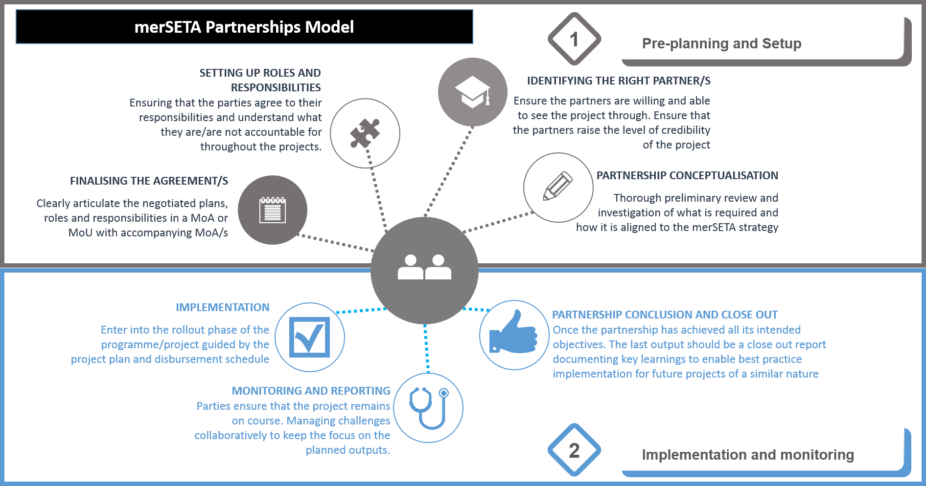

Figure : Partnership Model

## Planned Partnerships

In the preceding sections of this report, the impact of the COVID-19 pandemic is evident in terms of its ramifications on the mer sector and the work of the merSETA. Partnerships will be a mechanism through which the SETA is able to address the impact of COVID-19. In this section of the report we document the initial conceptualisations of partnerships in the midst of the pandemic. The opportunity that COVID-19 presents is to accelerate and lay foundation for long-term sustainable solutions, implementable initiatives that will geared towards contributing to stabilising existing entrepreneurial activities in the formal and other informal economies to mitigate the collapse of the mer economy, as well as catalyse new diversified entrepreneurial activities for a new economic pathway. In the case of merSETA, localisation of production as encapsulated in government’s reindustrialisation strategy is key, and partnerships be guided by this strategic directive.

* + 1. **merSETA COVID 19 initiatives** 
       1. Ensuring Learner Stipends are still availed for learners on merSETA programmes

The merSETA Accounting Authority approved the ring-fencing of R360 million for stipends for work-based learners. The current survey being run by the LMI-SSP research will assist in determining actual quantification of those traditional training companies that are to commit to continuing training of registered learners[9]. Continuing to avail stipends to continuing learners could also be viewed as our contribution to addressing the loss of income, and, hunger issues, even if temporarily.

* + - 1. Expediting TERS Funding

Increase the merSETA budget allocation for TERS (TLS) funding. Recently, through engagement the merSETA and UIF arrived at commitment from UIF to expedite UIF payment of the wage component of the scheme for those businesses that have opted for business rescue. An increase of the current merSETA allocation for the skills development component should be considered. An enhancement of the current arrangement should include the transfer of skills of business practitioners assigned to business rescue, so that such skills will be available in enterprises on an ongoing basis to monitor and develop innovative solutions for productivity and process improvement. . Such skills would be valuable for enterprises committed to re-investing in new technologies and new product diversification should opportunities present themselves. Preliminary research indicates that productivity and process enhancement skills can be availed through top-up skilling of qualified trades, technician and industrial engineering occupations. Furthermore, the merSETA and UIF should consider extending the timeline for TERS (UIF) and merSETA commitments for companies opting for business rescue to at least 12 months. Other possible issues may be those such as employers and labour negotiating changes to Conditions of Services (CoS) during the TERS-merSETA supported intervention. The TLS research and evaluation recommends that the development of policy is an imperative as the TLS. There are other recommendations in the report which will available.

* + - 1. Retrenchment Assistance

The merSETA has proposed to increase the Retrenchment Assistance Programme (RAP) budget allocation. The RAP could be enhanced to become a basket of a broader range of support that includes services such as career guidance and counselling; access to development finance and business support (public and private for RAP participants interested in self-employment opportunities); commitment towards the development of former employee self-employment initiatives. The international benchmarking study on RAP type programmes would be valuable in providing substance for a feasible approach and basket of RAP enhanced assistance that can be designed, developed and piloted.

Note: An enhanced TERS and RAP should also look to the utilisation of TVET colleges to support skills development of workers.

* + - 1. Small Business Development in the Motor Retail and After-sales Market

RMI initiative to develop small and informal businesses in the after- sales market business activity in township and rural communities. The potential to expand this initiative should be rapidly assessed so that, if feasible, within this FY the necessary resources and capacity is put in place to increase participation.

* + - 1. Empowering Youth In the Informal Sector

The research involving 40 marginalised youth from urban townships used the “diaries” methodology to investigate ways in which education and training in areas related to engineering occupations can expand entrepreneurial livelihoods for marginalised youths. These youths have had either formal or informal learning in engineering related fields and are trying to generate livelihoods of various forms in urban townships. This study provides indications that part-time studies provision by TVET colleges would be of value for both engineering studies and entrepreneurship skills. A selection of TVET partners should be approached to conceptualise, design and develop a project to test and implement.

* + - 1. Utilising Public Training Spaces for Community Development

The merSETA is in the process of engaging with PSET public education and training institutions and private training centres to identify feasible options for the use of their facilities as spaces for stimulating the growth of community based enterprises**.** Given the current economic context, growing unemployment is a serious concern. These current circumstances have placed pressure on the state to come up with sustainable solutions to empower informal workers and encourage entrepreneurs to increase their earning potential. Many skilled workers do not have the financial means to invest in equipment and machinery to either start or grow viable businesses. There is a need for workshops, equipment and machinery to assist informal workers and entrepreneurs to provide services and produce their goods. This creates an opportunity for TVET Colleges, UoTs and other training centres to avail their premises, offering a sustainable solution, while empowering the local community. Some Technical and Vocational Education Training (TVET) Colleges, private training institutions and company training centres have a wealth of resources that have a great potential to be used to benefit communities within their vicinity. There are a number of community based enterprises who may benefit from access to facilities, workshops and laboratories that have equipment and machinery, that may be financially out of reach for business and training purposes. To grant access to such facilities may be of great economic benefit to informal workers and entrepreneurs alike. The merSETA will be running a rapid 4 month investigation to determine the feasibility of such an initiative and the final report will make recommendation of what is possible including ascertaining whether there is a need for any policy changes/adaptations to enable implementation.

* + - 1. Stimulus for Small Enterprises and Cooperatives

In an effort to support the economic stimulus of small enterprises and cooperatives, would provide graduates the opportunity for practical work experience supported by mentor-specialists in these organisational functions whilst establishing their cooperative enterprises. The government has an economic cluster programme to grow small business and cooperatives. The Ministers of Health, Higher Education Science and Innovation, Employment and Labour, Small Business Development, Trade, Industry and Competition are all working together on a project to create sustainable economic inclusion of small enterprises and cooperatives. This would include the increase of the production of PPE, sanitisers and related goods. The intention is that such a project would also boost government strategy to grow domestic industrial capacity with a strong emphasis on innovation, going beyond just the production of PPE. SETAs are expected to make their contribution to this project through their skills development mandate. The merSETA has indicated in its strategic plan and annual performance that skills for small enterprises, cooperatives and other kinds of income generation activities located within economically marginalised communities, will be an area of key focus. Having already set targets and budget in its Annual Performance Plan, it will be necessary for the merSETA to accelerate implementation, while considering boosting the current budget allocation through the utilisation of surplus funds. Small enterprises and cooperatives need to be supported with other operational functions such as human resource management, marketing, financial management, and business process optimisation to name a few. Research has shown that graduates within disciplines related to these functions take longer to find employment than those graduating in the STEM disciplines, and this becoming more challenging as the financial and business services industry is haemorrhaging jobs. This creates an opportunity for the merSETA to support the establishment of cooperatives with graduates from these disciplines to provide services to manufacturing small enterprises and cooperatives in communities.

* + - 1. Supporting Digital Platforms for Skills Development

The merSETA vision of a digitally based skills development system would be one that goes beyond the provision of online training content and learning materials but includes features such as simulated training, virtual reality applications and learning factories, online mentoring, online project work, online assessments, self-driven incremental credentialing and the use of a range of technology solutions that could be developed in South Africa. Fortunately there are pockets of innovation initiatives in the PSET system including the merSETA ICT4APP pilot project. A digitally based skills development system that brings together the collaborative efforts and resources of our TVET colleges, HEIs, training centres and training employers. Such an initiative would be of value to both the employed and unemployed of the labour force in the long-term. The merSETA will be conducting an investigation in the next four months on the feasibility of simulated and virtual reality online training that could be delivered by TVET colleges, HEIs (especially UoTs) and private training providers. The establishment of learning factories would be included in the project. Fortunately the merSETA has two project the ICT4APP and the East Cape Midlands College Learning Factory project that are in development. The experiences thus far of these projects will contribute to the value proposition to be designed and developed. The acceleration of the piloting and testing of these pockets of digital based learning innovations would go a long way to putting the merSETA on a path of putting in place digital based learning for its engineering related qualifications.

* + - 1. Supporting Innovations with regard to fighting the COVID-19 Pandemic

This innovation project is conceptualised against the background of the merSETA strategic intent as encapsulated in the merSETA 5 year strategy primary strategic focus areas described as follows:

* Responding to the needs of new technologies and changing business processes related to the Fourth Industrial Revolution (4IR).
* Promoting innovation in line with socio-economic, technological and structural transformation, as well as the circular, green and blue economies.
* Influencing curriculum change and innovation for the education and training system (both institutional and workplace based-learning).
* Supporting structural transformation (ownership, control, and management) through promoting entrepreneurship, small and medium enterprises (SMEs), localisation, and uplifting the role of the manufacturing sector in inclusive growth.
* Conceptualising partnerships that are responsive to merSETA priorities.

## Conclusions

For the merSETA, partnerships presents the main mechanism for achieving its strategic objectives and to deliver high quality services to its stakeholders and learner beneficiaries.

The merSETA has established national and international partnerships to facilitate skills development, improve its understanding of the sectors to improve skills planning and keep abreast of innovations in the sector.

While there have been some challenges with respect to partnerships, the merSETA has noted many successes through its partnerships and will work to continually strengthen partnerships to meet and exceed its mandate. Working towards an accepted partnership model in collaboration with stakeholders is of key importance to achieve greater efficiencies.

The COVID-19 pandemic has brought the urgency of efficiency and targeted interventions to the fore. The merSETA will have to ensure that it can rapidly respond to the sector to assist in relief efforts, implement new skills development interventions in line with the demands of the 4IR and ensure that communities and workers impacted by the pandemic are still able to participate in meaningful interventions to empower them to make a positive contribution to the sector and their communities.

# SETA Monitoring & evaluation



## Introduction

The merSETA Monitoring & Evaluations (M&E) framework was developed to improve both the operational and organisational performance as well as to track the results and impact of its skills development interventions. This framework has been instrumental in institutionalising monitoring and evaluation in the merSETA. The purpose of this chapter is to highlight the role of M&E in supporting merSETA’s approach to skills planning, as well as how strategic priorities (set out in the merSETA SSP) are translated in the entire planning value chain of the SETA. It will also recommend strategies to improve efforts to meet these skills priorities, as well as systems for planning in the SETA.

## the merseta approach to m&e

The merSETA M&E Framework provides a set of principles and a clear roadmap on how M&E functions should be executed across the organisation. This cycle consists of the following main steps (Figure 5.1): ccollect, analyse and validate performance information in relation to the Strategic Plan and APP. The processes of the organisational wide M&E at the merSETA are summarised in Figure 41 below:

Figure : merSETA organisational wide M&E objectives

Monitoring and Evaluation at the merSETA goes beyond the compliance reporting of performance. It adopts a results-based approach by focusing on performance and the achievement of results (outputs, outcomes and impact). The role of M&E in the strategic planning process/value chain is highlighted in Figure 42 below.

Monitoring and Evaluation

Figure : Role of M&E in the strategic planning process

Monitoring and Evaluation plays a key role in scanning the mer sector, planning, implementation of programmes and projects and the reporting of achievements:

**Environmental scanning/ monitoring:** Monitoring economic, social, technological, legal and environmental developments in the mer sectorso asto better understand the context to inform the development of credible plans that are responsive to the sector and national priorities.

**Strategy formulation:** The merSETA strategy planning process comprising of five linked components (the Sector Skills Plan, Strategic Plan, Annual Performance Plan, Operational Plan and SLA) is underpinned by a strong monitoring and evaluation process. The formulation of outcome and output targets is underpinned by an understanding of a complexity of factors that include among other things monitoring of past trends.

**Implementation**: The successful implementation of programmes, projects and activities identified through the planning processes on time and within the budget requires constant monitoring and evaluation to improve current and future management of outputs, outcomes and impact. Monitoring and evaluation is key in tracking progress, identifying the scope for improvement and better understanding the challenges and opportunities.

**Reporting:**

Reporting is key in improving transparency and enhancing oversight over the financial and non-financial performance of the merSETA. The merSETA has implemented a procedure for annual and quarterly reporting to facilitate effective performance monitoring, evaluation and corrective action.

* + 1. **Key systems supporting M&E**

The following systems have been critical in supporting the institutionalisation of a monitoring and evaluation system at the merSETA:

**Quality Management System** The merSETA has implemented and continuously maintaining a Quality Management System in line with ISO 9001:2015 international standard to strategical benchmark, provide guidance and support to the merSETA in ensuring that the outcomes and outputs are in line with the merSETA Quality objectives. Measurement, monitoring, analysis, and evaluation are critical for the assessment of the performance of the quality management system (QMS). This is critical in supporting the merSETA in meeting its stakeholder and regulatory requirements as well as improving its effectiveness and efficiency on a continuous basis. The merSETA Quality Management System (QMS) also ensures that risk management activities are incorporated into the planning process and monitored for successful achievement of the merSETA outcomes and outputs. The ISO 9001:2015 requirements identify performance evaluation as a critical performance indicator for the entity that needs to be monitored, analysed, and evaluated. The merSETA has, therefore, adopted internal audits assessments and management reviews as tools and mechanisms to ensure that the processes are functioning as per the planning requirements.

**Knowledge Management System.** The merSETA has implemented a knowledge management system forpromoting the effective *management* and *governance* of information and *knowledge* as a strategic assetfor guiding planning, strategic decision making and operational efficiency within the framework of merSETA's outcomes and outputs. The merSETA knowledge management system has been instrumental in driving the digital transformation agenda to transform organisational activities, processes, competencies and models to fully leverage the changes and opportunities presented by digital technologies.

**Labour Market Information System:** the merSETA hasestablisheda *labour market information system* forcoordinating, collection, processing, storage, retrieval, and dissemination of labour market information. The M&E system is a critical component of the merSETA labour market information system and through strengthening data management systems as discussed later in this chapter, the system will be repurposed to provide credible data for skills planning in the mer sector.

**Applied Research and innovation system**: The merSETA has established an applied research and innovation system that *designs* and *tests* *innovative* and scalable solutions towards solving skills related problems identified through applied research. Monitoring and evaluation plays a key role in identifying systemic challenges and blockages in the skills development ecosystem which can then trigger ideas to be further researched through applied research and further tested through the innovation system. A significant example is the ICT4APP which was conceptualized after data from M&E processed showed challenges in the traditional apprenticeship system. The merSETA and the CSIR Meraka responded to this challenge by using a 4IR paradigm to re-imagine and develop a high quality new apprenticeship skills development process in South Africa that is more efficient, accessible, and scalable and that prepares apprentices for Industry 4.0. This initiative is set to be instrumental in developing skills for the sector in light of challenges such as the shortage of workplaces and a new dynamic presented by the COVID-19 pandemic.

**Quality assurance system:** The quality assurance system is a critical component of programmes and projects implementation. Going forward, a strong focus will be to ensure the quality assurance of merSETA funded interventions, to ensure alignment to industry expectations. The quality assurance system is also critical in ensuring that learners receive quality training. This is consistent with the NDP and NSDP vision of ensuring that South African citizens have access to quality education and training, to enhance their capability to be active participants in developing the potential of the country.

## DATA AND information to support research and skills Planning

The merSETA’s approach to the use of data to support research and strategic planning stems from the recognition of data and information as key in promoting continuous improvement, learning and innovation .To support and strengthen planning and research, the merSETA has collected data to help address the following key issues that the sector is grappling with :

**What is driving growth and development of the sectors merSETA is servicing? (e.g. growth and development policies and strategies such as NDP/IPAP/NGP, technological changes, merSETA industry/sub-sector value chains, NSDP).**

Through continuous monitoring of policy developments and monitoring of global development in the manufacturing value chain, analysis of policies and government strategies and data collected from engaging with stakeholders, the merSETA has conducted several research projects that have looked into the merSETA value chain. The development of the 6th chamber (components manufacturing chamber) is largely as a result of this process. Evidence collected from policy analysis and engagements with stakeholders have pointed to the local components manufacturing sub-sector as a potential sub-sector to drive growth, reindustrialisation and localisation.

**How can the manufacturing sector grow and reindustrialise in the face of deindustrialisation and a looming global recession as a result of the COVID-19 Pandemic?**

The COVID-19 crisis has transformed into an economic and labour market crisis. The merSETA more than ever recognises the need for urgent implementation of the Strategic Plan and APP as skills will be a key in ensuring we sustain current levels of manufacturing economy, as well as grow new areas of manufacturing including new opportunities for re-industrialisation, digitisation and sustainable circular manufacturing economic activities including sustainable manufacturing production processes. By continuously monitoring the environment, the merSETA saw opportunities to support indicatives that can contribute to growth and innovation in the sector. The following are new initiatives that are responding directly to the challenges and opportunities presented by COVID-19.

* **VIRO-VENT Skills Innovation Challenge** aims to foster collaboration during the unique conditions of the COVID-19 pandemic in promoting the capabilities and expertise of HEIs to industry partners in a way that facilitates a transition of graduates into emerging technology innovation employment or entrepreneurial opportunities. This initiative supports the national ventilator project
* Supporting the “**Economic stimulus for small medium and micro enterprises (“SMMEs”) and cooperatives**: covid-19 and beyond project” by providing the much-needed support and training for the SMMEs and Cooperatives.

The following projects have been repurposed to also respond to the challenges and opportunities brought by COVID 19:

* **Economic Complexity** in the MER Sectors project explores the opportunities of the mer sectors to diversify their manufacturing operations into frontier (new) products and closely related product spaces. It will explore the opportunities to engage SMMEs and emerging enterprises into product spaces that diversify the economy and place the country on a globally competitive trajectory. In the aftermath of the COVID-19 pandemic, leaving the sector to regain its presence in the domestic and international markets. However building economic complexity offers opportunities to diversify and create employment opportunities. Below is a list of projects which seek to address some of the challenges experienced in the South African economy.
* **Youth Entrepreneurship Project**: This project uncovers the realities of working in the informal sector for youth operating in the mer sectors in the EC. It provides insight into the skills required to be successful even in the informal economy. In light of the COVID-19 pandemic, this project assesses how youth perceive their realities in a state of disaster. It allow us to better understand the dynamics of working in the informal sector even after the pandemic.
* **Renewed efforts to support entrepreneurship**: The merSETA, for example, has committed to training 150 people for entrepreneurship skills.
* **PSET CLOUD**: This project looks into the creation of a digital interoperable system for sharing and exchanging labour market and economic data and information using advanced digital tools to support demand led education and skills development planning, monitoring, reporting and implementation.

**What are the labour and skills demands to achieve growth and development of the sector? For which jobs? What are the new emerging occupations, in the green economy for example? How many people need to be trained? Where? How?**

Data collected through engagement with chamber stakeholders indicated the changing nature of jobs and occupations, as a result of rapid changes in technology, manufacturing techniques and innovation, as a result of the 4th industrial revolution. The merSETA commissioned the atlas of occupation study to provide learners, workers, employers and skills planners with a reference guide to occupations and jobs that are in demand, in the metals, plastics, auto, motor retail, components manufacturing and new tyre sectors as defined in the merSETA scope of coverage (see Chapter 1). Across all the merSETA chambers it was found that there was a strong emphasis on generic competencies such as communication (oral and written), self-motivation, team work, computer literacy; amongst many others. These findings were consistent with the recently published World Economic Forum (2020) Jobs of Tomorrow Mapping Opportunities in the New Economy report which concluded that soft skills such as communication, creativity and computer skills are key in the 4th industrial revolution.

Developments in policy and growing advocacy the world over around sustainable manufacturing activities have caught the attention of the merSETA over the years. The merSETA commissioned a study to understand green skills within the mer sector in order to foster merSETA’s understanding of its sub-sectors regarding the green economy and its related skills progress and requirements. Initial findings from study are indicating that in order to transition the mer sector to a green economy, there was a need to raise awareness to understand what the green economy is and what drives it. Initial findings also indicated that although there was a recognition for the need for introducing new green jobs and activities within the mer sector, the findings indicated a need for upskilling and transforming current jobs to be greener.

**What transformation imperatives should be addressed and what skills development initiatives are needed to support these transformation imperatives? Levels of access to learning opportunities? Representation of youth, black people, PwD and women in the manufacturing sector? Supporting Cooperative and SMEs?**

The merSETA has been tracking and monitoring employment trends in the sector over the past 5 years. The analysis indicated a slow progress in transformation in the sector. Women for example remain underrepresented in the sector and on average constitute less than 35% of those employed in the sector. Moreover, women and black people remain underrepresented in higher occupational categories such as management and professionals. Initial findings from the artisan learning pathways are showing that despite changes in attitude of companies towards being receptive to female artisans, the number of women training to be artisans is still low, for example from the data analysed indicated only 13.7% participants were women, in apprenticeships and 26,6% in learnerships and only 3,6% in ARPL. Moreover, some anecdotal feedback from female beneficiaries who participated in the 2019/20 WBL tracer study (especially those who completed the apprenticeship programmes), revealed that women are not always accommodated adequately at the work place. Limited changing rooms and sanitation facilities are available, and they often feel discriminated against. This highlights the need for merSETA to work with employers in ensuring that current workplace readiness assessments guarantees that women are accommodated and treated equally prior to the intake of beneficiaries.

The support of People Living with Disabilities (PwD) has been on the top of merSETA’s transformation imperatives. An analysis of data over the past 5 years found that an average of 2.3% of learners benefiting from merSETA skills development initiatives were living with disabilities. This was higher than the average of 1.5% across all SETAs over the last 5 years according to the NSA. To increase impact, interventions for supporting people living with disabilities were conducted through a disability evaluation study. The study unearthed challenges that were compromising the effectiveness of some of the interventions. Challenges identified included lack of understanding or consideration of the environments, which learners came from by service providers, challenges in finding people with disabilities suiting the criteria. The findings and recommendations from this evaluation study will be instrumental in the design of programs and supporting mechanisms for skills development initiatives aimed at people living with disabilities in the future.

**Which programmes and projects have been effective in advancing the skills development agenda and addressing priorities such as artisan development, youth employment and community development.**

Findings from the Artisan Learning Pathway evaluation for example are beginning to show that there is need to review the SETA’s grant policy to promote the involvement of small and micro businesses in learning pathways such as Apprenticeships. Findings from the WBL tracer study indicated that WBL programmes were instrumental in increasing chances of employment, for example, 76% of learners who participated in apprenticeships were employed immediately upon completion, while 67% of learners were immediately employed upon completion of their internship. The study also concluded that the monthly income of respondents in the industry following the WBL programmes were indicative of the value of work experience for employers. This data indicates that WBL programmes remain key in increasing employment absorption for learners in the mer sector. WBL is also a key strategy in reducing youth unemployment in contributing to the SETA’ mission of increasing access to high quality and relevant skills development and training opportunities, in order to reduce inequalities and unemployment and to promote employability and participation in the economy.

## Strategic priorities captured in the strategic plan AND annual performance plan

The merSETA strategic planning process consist of five linked components, the Sector Skills Plan, the Strategic Plan, The Annual Performance Plan, Service Level Agreement (SLA) and the Annual Operational Plan. The Sector Skills Plan forms the foundation of the planning process and informs the Strategic Plan and Annual Performance Plan. The strategic priority actions that were identified in the 2020/21 SSP update and guide the development of the SP and APP as summarised below.

* **The social economy and community development:** skills developmentto support the creation of economic opportunities and sustainable livelihood for the youth, women, people living with disabilities, township, rural and marginalised communities in a bid to create sustainable livelihoods**.** The merSETA has taken a decision to prioritise the funding of projects that address the needs of the social economy and community development.
* **A demand led skills development system** driven by the economy, socio-economic context as well as other national priorities. This calls for the need to balance competing national, regional, sectoral, and community priorities as well as the needs of the workers (current and new) and employers/business. The merSETA must challenge its various stakeholders (including labour, business, government and education and training institutions) to collaborate on skills development initiatives that foster common goals for moving the sector and economy forward.
* **Advancing local manufacturing driven by technology, innovation, sustainability**, and **globalisation** and **changing global manufacturing value chains.** Using a value chain approach, the merSETA has identified priority sectors to support the responsiveness of the South African sector to the digital driven Fourth Industrial Revolution. With developments in the 4IR, the sector has an opportunity to benefit not only from the localisation strategy (through the local manufacturing value chain) but the global automotive manufacturing value chain.
* **The future of jobs, future skills and demand for labour** due to changes in business models, globalisation, technology, consumer markets, local and international regulations. The merSETA is conducting research that looks into changing skills and occupations in the manufacturing sector in the context of 4IR. The reality is that new jobs will emerge, while others may disappear. The SETA should unpack underlying skills of emerging occupations and respond with a multi-pronged strategy for current workers, new entrants and future workers i.e. avoid a “one size fits all” response.
* **Changing trends in education, training and curriculum** driven by innovation, new knowledge, process and product changes in the workplace, regulation, global trends and demand for certain skills. This however requires changes in policy and regulation to create an enabling environment for innovation in training, education and curriculum. The SETA therefore needs to position itself as an influencer of policy to respond effectively to these developments.
* **Strengthening the concept of the SETA as an intermediary body** which calls for the SETA to be the link between education and the workplace. The social partnership model provides opportunity for social partners inclusive of education and training providers to agree on concrete commitments to build the SETA as an intermediary body. These would include on the part of government, changes to policy and funding formulae for TVET colleges. These enhancements would allow TVET colleges to mainstream delivery of training for employers and workers, as opposed to current policy and funding approach that forces TVET colleges to deliver industry training as an add on and unfunded mandate.
* **Supporting structural transformation** to promote **inclusive growth, employment** and growth of the local manufacturing sector through supporting the informal sector and other forms of non-traditional businesses such as cooperatives. SMEs are also central in creating a pipeline for black and other industrialists. The need to support SMEs through an ecosystem of a range of support mechanisms besides skills only is linked to promoting the role of the social economy in the inclusive growth agenda.

The strategic priorities identified in the 2020/21 SSP informed the merSETA Accounting Authority strategic session which was instrumental in developing the new five year strategy (2020/21 – 2024/25) and the 2020/21 AP. The merSETA is also implementing several projects and programmes to address these priorities through Discretionary Grant funding. Ongoing monitoring and evaluation of these programmes is therefore critical in ensuring that these strategic priorities are met. The newly appointed Accounting Authority and its sub-committees is set to play a key role in monitoring the implementation of these priorities.

## Measures to strengthen achievement of skills priorities

The merSETA in the 2019/2020 financial period manged to meet the majority of its performance targets and address priorities that were identified in its strategic documents through implementing various programmes projects and projects. The monitoring and evaluation unit continues to monitor the implementation of these initiatives. Where challenges in meeting the skills priorities have been identified, the merSETA puts measures in place to address them.

The majority of learners in the SETA are WBL based learners and deindustrialisation in the sector has impacted the uptake of some merSETA programmes by the industry. The COVID-19 pandemic has affected the sector, will resulting in industry being hesitant to take up WBL learners (due to the economic uncertainty and fears of a looming recession). This will impact both new registrations and completions. In response the merSETA is investigating innovative ways of continuing with training initiatives by investigating opportunities to use simulated learning and learning factories as workspaces. In the face of deindustrialisation the merSETA is also looking into ways of using small business as spaces for training while advancing the community development and strengthening its response to supporting the social economy. The informal sector which is predicted to grow in light of looming retrenchments. The merSETA M&E unit is conducting a retrenchment assistance programme evaluation study as well as a feasibility study to define and conceptualise skills development for retrenched workers. These studies indicate improvements can be implemented for both types of job loss mitigation strategies, feasible in the medium to long term. The findings and recommendations from one such study will be critical in providing strategic direction to the SETA, especially in light of the fears of looming retrenchments, as a result of the global COVID-19 pandemic. The TLS evaluation study concluded in 2019 also provided insights and recommendations into how SETAs and other role players can get value from such initiatives. Some of the key recommendations that the SETA will implement going forward in similar initiatives include: setting up criteria to determine what constitutes appropriate training for displaced workers based on their individual training needs and aspirations. Along with recommendations to follow a flexible approach instead of a “one size fits all” approach and career guidance and counselling service as a precursor to programme selection.

**Reconstitution of chambers** - The merSETA has positioned itself to effectively respond to the NSDP by reconstituting its chambers to promote their responses to industry and worker needs through consideration of the value chain approach or other best practices in driving the implementation of the NSDP. In the 2020-21 financial year, the merSETA for example, added a sixth chamber (automotive components manufacturing) this sub-sector has been identified as key in reindustrialisation and localisation. Chambers play a key role in advancing the merSETA skills development agenda in their respective sub-sectors including the conceptualisation and monitoring the implementation of identified priorities.

**The merSETA business model** - The merSETA continuously reviews its grant and funding mechanisms to respond to the changing priorities. The Discretionary Grant funding mechanism for example is increasingly targeting funding of projects that respond to merSETA strategic imperatives and skills priorities as informed by research (including evaluation studies). There is no doubt that the COVID-19 pandemic has impacted merSETA’s income due to the 4 month skills levy payment holiday announced by the President as part of relief measures to industry due to the lockdown. In response the merSETA has reprioritised the funding of strategic skills priorities.

**Partnerships** discussed in detail in the previous chapters remain key in strengthening the achievement of skills priorities. To strengthen the effectiveness of partnerships, the merSETA is conducting an evaluation of its partnerships so as to identify gaps, challenges and best practises. This will allow the merSETA to ensure that partnerships are continuously used as one of the efficient vehicles for delivering skills priorities.

**Improving programme design implementation -** The merSETA will continue using evaluation studies to improve program design and implementation, as it is important to periodically assess and adapt activities to ensure that they are optimal. In this instance, evaluation studies will help to identify areas of improvement and ultimately help merSETA to set goals more efficiently. The framework provided by ISO 9001:2015 needs to show through meaningful and relevant data analysis from the evaluation studies to determine where targeted improvements can be made and risk mitigated to support further research and planning. For example, an evaluation study to look at the non-implementation of agreements by merSETA employers is in the process of being implemented, and findings will assist in improving the design and implementation of the DG programme. The merSETA quality assurance systemwillalso focus on monitoring the quality of merSETA’s learning interventions.

**Innovation in delivering of skills priorities –** The looming fear of recession as a result of the global COVID-19 pandemic has resulted in the economy shrinking, resulting in unemployment and deindustrialisation. This has caused merSETA to look at innovative ways of delivering its skills priorities. In light of the closure of various workspaces, the merSETA is currently looking conducting a feasibility study to explore using simulation training and learning factories as a key to unlock more training spaces in the mer sector. The SETA is also looking at the feasibility of partnering with TVET colleges and other training centres to explore the possibility of using their workshops and facilities as work and training spaces for stimulating the growth of community based enterprises to support sustainable livelihoods.

**Strengthening internal processes** - The merSETA has also developed their performance information reporting procedure, which details the process to be followed to collect, collate, verify and store performance information. This enhancement of merSETA’s performance information reporting will to ensure reliability, validity, accuracy, completeness and traceability of actual performance achievements for quarterly management reporting, while informing annual reporting, compliance reporting and strategic decision making. This procedure also outlines the various role players who have a responsibility to ensure that the collected performance information is valid, accurate, complete, and meet the specification and requirements of the DHET reporting framework, and the Technical Indicator Descriptors (TIDs) as set out in the Annual Performance Plan (APP).

**Strengthening career advice and guidance –** The evaluation of the merSETA career advice and guidance through various processesindicated gapswhich led to the merSETA implementing a renewed approach to career advice and guidance. For example, in line with supporting one of merSETA strategicoutputsto facilitate diverse career development, advice and guidance related services, the merSETA has partnered with UNISA and the South African Career Development Association (SACDA) to implement indigenous career management interventions for youth and adults. The objective of the indigenous career management project is to empower people to identify life patterns, design career objectives and manage their careers. Phase 1 of this project focused on working adults in the mer sectors, by establishing a digital technology enabled indigenous career guidance (life design) approach to providing career guidance and advice to young people as well as adults (employed and unemployed). This was achieved through access to real-time career information and data for designing career paths for themselves in order to thrive in continuously changing labour markets and economies that require emerging, transforming and new occupations and skills, particularly in the context of 4IR.

**Strengthening internal data management and government systems for strengthening monitoring, evaluation and reporting** – The importance of effective data and information management at merSETA cannot be over emphasized. The merSETA has recognised that its data and information as strategic assets for strengthening planning, strategic decision-making, performance reporting, governance and operational efficiency. The merSETA has made a decision to strengthen systems for managing its data and information resources in an efficient manner to achieve its outcomes and outputs as defined in its strategy. Data has arguably become one of the most valuable assets in modern organisations. Good data is important for improving planning, decision making and reporting. In the context of the merSETA, we may ask: Why is good data important? Because bad data can result in bad decisions, planning and reporting; and at a macro level it can result in bad policy development. Good data requires that the organisation manages and governs data like any other resource such as finance and human capital. Data management and governance is increasingly becoming an important function within modern organisations and the merSETA has recognised effective data management and governance as an enabler for effective planning, monitoring, reporting and evaluation to support decision making. The Post School Education and Training Collaboration and Learning Opportunities in the Utilisation of Data (PSET-CLOUD) project in partnership with JET Education Services is one such initiative that is set to strengthen the data management and governance ecosystem for better planning, decision making and management of the merSETA and broader PSET system. The purpose of the project is to establish an integrated digital ecosystem that will strengthen, integrate, coordinate and improve efficiencies through planning, governance and management of the PSET ecosystem. This system is also envisaged to strengthen Monitoring and Evaluation, which is one of the critical areas identified in the NSDP.

## Conclusion

This chapter has outlined the merSETA’s approach to Monitoring and Evaluation include systems, implemented to support M&E. It demonstrates that the while there is a good grounding for the role of M&E in the organisation, there is still some improvements required to fill the gaps in the system particularly with respect institutionalising the M&E, reviewing and putting in place effective mechanisms and tools for monitoring, measuring and evaluating outcomes and impact. Together with organisation-wide institutionalisation of methods and effective evaluation of programmes, the merSETA is confident that M&E will continuously improve and thereby assist in improving planning processes including research, systems and organisational processes of the merSETA.

# Strategic SKILLS PRIORITY ACTIONS

## Introduction

This chapter consolidates the key economic, labour market, and skills change drivers that should inform the merSETA skills development priorities. It also provides a set of skills development priority actions from which realistic and achievable plans can be developed and implemented. Following the adoption of the SSP the AA has the responsibility to put in place a 5 year Strategic Plan (SP), Annual Performance Plan (APP) and Service Level Agreement (SLA). These then become the basis upon which the CEO and management develop an operational plan inclusive of programmes and projects to be implemented.

## summary of findings from previous chapters

This SSP has tried to position its data and information in the context of the current state of national crisis brought on by the COVID-19 pandemic.

From the first chapter it is evident that keen oversight is needed to track the impact of the COVID-19 pandemic on what was already a sector in distress. Critical findings in the chapter have raised the concerns of an expedited shift in the economy in line with demands for 4IR in terms of business processes, the new norm in terms of remote working and the threat of mass unemployment, particularly among the youth and elementary workers. Furthermore the difficulties across all domestic sectors in navigating the global economy in terms of competition, export costs, import costs, a weakened currency and lack of investment due to low business confidence does not bode well for the domestic market. However the pandemic does bring with it opportunities for reindustrialisation and innovation to once again revitalise the manufacturing sector. Efforts to diversify the manufacturing of goods in the sectors is currently being explored by the merSETA and promises to at least identify potential areas of growth. Even planned investments across the sectors are hampered due to the impact of COVID-19 on employers and the costs associated with the plans to assist small businesses such as those envisioned in the SAAM. There will be further complexities in terms of the trajectory of the sector and therefore merSETA should conduct additional research to better track the sector and forecast its potential to further customise its training offering in line with the needs of the sector.

Chapter 2 presented the main skills change drivers for the mer sector, in addition key national imperatives were highlighted within the national policy context. These drivers include the following:

* **Reindustrialisation through localisation and diversification of the manufacturing sector** which will require interventions in support of the DTI policies relating to key industrial sectors and the SEZs. The small business sector will require additional support as they are most vulnerable to the economic impact brought about by the pandemic, however the pandemic also provides opportunities to spur sector growth locally.
* **Automation, digitalisation and technology advances** are changing the way the sector conducts its operations, national priorities call for support for accessing markets, structural transformation and improving efficiencies in the public sector for demand led interventions.New or improved curricula must account for these advances and the skills highlighted should be prioritised.
* **Environmental sustainability and new business models** aimed at supporting energy and resource efficiency to promote sustainable development.
* **Supporting a diverse and inclusive labour market system** supporting marginalised communities, youth, small and informal business. This will require partnership to promote development in the social economy and encourage life long learning, particularly with regards to the skills ability to adapt to the changing nature of work.
* **Changing customer tastes and expectations,** customers have become more discerning and are increasingly demand quality services and products, convenience, product design choices and flexibility, this is in line with the 4IR and skills development should work in line with this, promoting quality and abilities to meet the unique needs of discerning customers

Chapter 3 reflected on the categories of skills development needs in the mer sector. Overall, a range of factors will impact on the future of skills supply and demand in the sector. These factors include future growth of the economy, the implementation of interventions aligned with national strategies including transformation, a demand for higher level skills in the sector and the demand for better the quality of skills supplied including skills gaps. Future skills must be researched more closely for the mer sector, particularly in terms of forecasting in a time of COVID-19. To meet industry needs, interventions must be tailored and implemented using the best and latest technologies related to digital platforms, simulations and virtual reality. The chapter however also highlighted supply side challenges and the impediments of the PSET sector to deliver high quality, diverse and fit for purpose skills to the labour market. The tracer study highlighted that the majority of learners fare well in the labour market once they have graduated however the level of employment are not as high as they could be. The future of the world of work is changing and it is vital to tailor skills programmes such that learners can take up opportunities in line with these shifts.

Chapter 4 raised the importance of the partnerships model to achieved successful outcomes for the sector and its learners. Without good partners who are willing to put in the effort to see skills projects and programmes to fruition, the mandate of the SETA is dead in the water. Efforts must be exerted in formulating partnerships proactively to ensure success and deliver high quality, relevant skills to the labour market.

Chapter 5 demonstrated that the merSETA has improved in terms of its M&E processes to ensure it meets its mandate. However, there are still some improvements required to fill the gaps in the system particularly with respect institutionalising the M&E, reviewing and putting in place effective mechanisms and tools for monitoring, measuring and evaluating outcomes and impact. Together with organisation-wide institutionalisation of methods and effective evaluation of programmes, planning processes including research, systems and organisational processes will be improved.

## Recommended Skills priority actions for merseta

In order to build a stronger SETA that is responsive to the changing skills development ecosystem, the merSETA needs to strengthen its systems to support the development and implementation of a responsive strategy in times of uncertainty. These include:

**Research and innovation systems**

Rapid changes in the sector require that the merSETA strengthens its research and innovation system for investigating, conceptualising and designing, testing and implementing innovative and scalable solutions towards solving skills related problems identified through research and other processes. The research and innovation system is critical in strengthen the role of the SETA as a driver of change/ transformation and innovation in the skills development ecosystem.

**Data management and governance systems**

The recognition of data is a strategic asset for strengthening strategic planning, strategic decision-making, performance reporting, governance and operational efficiency calls for the need to urgently implement efficient data management and governance systems. The data management and governance system will play an important role in enabling the merSETA to harness, streamline and manage its data and information resources in an efficient manner to achieve the outcomes and outputs as defined in the merSETA strategy. A collaborative approach is require in the development and implementation of an effective system.

**A strengthened monitoring and evaluation system**.

The implementation of an improved M&E system requires a renewed approach to how the organisation manages its data and records, greater collaboration beyond compliance to performance information and changes in human behaviour. Strengthening of supporting systems such as quality assurance, records management, quality management and management information systems is also critical.

**Partnerships, learning networks and collaboration systems**

It is clear that the role of partnerships in the development and implementation of skills development programmes and initiatives will remain pivotal in light of the disruptions in the world of work and education caused by recent developments as a result of the global COVID-19 pandemic**.** The merSETA should use its partnerships more strategically and endeavour to participate in relevant learning networks, building systems for collaboration and learning as important vehicles for promoting an integrated approach to developing as well as implementing targeted, bespoke skills development initiatives. These should be relevant to the needs of the worker, employers, sector industries, community and national priorities. Partnerships, learning networks and collaboration systems should be used more to develop and implement transformative and innovative solutions to the challenges and opportunities confronting the skills development ecosystem, the mer sector and the economy and society.

**A strengthened governance, administrative and resourcing system**

The development and implementation of systems, processes and mechanisms for enabling the merSETA to fulfil its mandate in these unprecedented times need to be supported by a strong governance, administrative and resourcing system. Governance structures should continue playing an important role in representing the interests of the sector, monitoring implementation as well as providing leadership in driving change and innovation in the sector. A strengthened merSETA governance system would enable governance structures to play an important role in not only delivering skills to the sector but also in influencing policy to be responsive to change and innovation in education, training and skills development. The funding mechanisms of the SETA should be reviewed such that focus is on quality and impact for the short, medium and long term skills development of current and future employees and the current and future growth trajectories of the mer industries/businesses.

## recommended actions to guide merSETA planning and support OF national strategies

**Supporting reindustrialisation efforts through supporting localisation, advanced manufacturing and manufacturing diversification**

Reindustrialisation has been as key in stimulating the growth of the economy. The COVID-19 pandemic has once more proven the critical role manufacturing plays in sustaining an economy. Opportunities have been created to diversify the South African manufacturing base to support local demand at the same time creating opportunities for international markets during the COVID-19 crisis through global manufacturing value chains. Initial findings from the merSETA economic complexity research have pointed out that manufacturing diversification is one of the key strategies that South Africa can adopt in its reindustrialisation. As the economy becomes complex in terms of product diversification job opportunities are created which require skills development interventions to prepare the current and future workforce to take up the opportunities created. From the research conducted, the components manufacturing sector and other related sectors that have a well-established local and global manufacturing value chains have a great potential to assist South Africa with its reindustrialisation efforts.

**Jobs and occupations of the future, mapping opportunities for workers in the new economy**

Disruptions in the labour market as a result of changes brought by advances in manufacturing in the 4th industrial revolution, the looming global recession as result of the global COVID-19 pandemic and the growth of the gig economy require that South Africa re-evaluates the notion of jobs and occupations. New jobs and occupations are expected to emerge in the new economy driven by localisation, economic patriotism, a strengthened informal sector and infrastructure development and maintenance SETAs as facilitators of skills development need to be at the forefront of identifying these changes so as to prepare the labour market.

**Supporting economic transformation in support of the inclusive growth agenda through skills to support black industrialists, women in manufacturing and other forms of businesses.**

The combination of stagnant growth and rising unemployment means that South Africa’s economic trajectory is unsustainable (National Treasury, 2019). Government has implemented strategies for promoting economic transformation, supporting labour-intensive growth while creating a globally competitive economy through supporting black industrialists, SMEs, entrepreneurs and other forms of businesses. The effective implementation of these strategies will require that SETAs partner with other role players in developing and implementing relevant skills development initiatives to support the growth and development of black industrialists, women in manufacturing and other forms of business. The need for support through an ecosystem of a range of support mechanisms besides skills only is linked to promoting the role of the social economy in the inclusive growth agenda.

**Supporting SMEs, cooperatives, entrepreneurship and other community based enterprises to support job creation and sustainable livelihoods in the social economy**

A looming recession as a result of the economic meltdown caused by the global pandemic will have a far reaching impact in the economy and society. This coupled with deindustrialisation will result in massive job loses in the sector. Skills developmentinitiatives to support the creation of economic opportunities and sustainable livelihood for the youth, women, and people living with disabilities, township, rural and marginalised communities are therefore required**.** The merSETA has taken a decision to prioritise the funding of projects that address the needs of the social economy and community development. The merSETA should consider broadening access also through locally based education and training social change entities (e.g. training CBO/NGOs). Innovative way of supporting rural provincial/regional beneficiaries through partnerships with government and other entities should also be considered.

**Strengthening the role of the SETA as an intermediary body to facilitate the transformation and responsiveness of the skills development ecosystem**

SETAs as intermediary bodies are uniquely positioned to drive change in the skills development ecosystem. Various research conducted by merSETA and engagement with merSETA stakeholders have identified challenges and opportunities for improvement in the skills development value chain and system. Funding of initiatives aimed at driving the transformation or innovation in the skills development ecosystem to improve efficiencies will therefore need to be encouraged and supported. The SETA should partner with other leaders and innovators in civil society, government and HEIs to lead change in key areas such as digital transformation and other reforms.

**Advances in education, training and curriculum** driven by technology, innovation, the future of work regulation, local and global trends requires that the SETA and its skills development partners looks into innovative ways of ensuring that they continue to deliver programmes that are relevant and responsive to the sector’s needs. The global COVID-19 pandemic has redefined the world of work and education and SETAs and other players in the skills development ecosystem cannot be oblivious of that fact. Some of the rapid changes also require a responsive regulatory framework. This however requires changes in policy and regulation to create an enabling environment for innovation in training, education and curriculum. The SETA therefore needs to position itself as an influencer of policy to respond effectively to these developments.

## Conclusion

The COVID-19 pandemic has compounded the complexities in which the merSETA must achieve its mandate. A looming global recession and an economy in distress presents the backdrop of the current sectoral context. The merSETA however has intentionally aligned its planning to the opportunities presented by the pandemic and is committed to putting in place its planned interventions in light of the current economic climate.

The merSETA has tried to respond to the pandemic with expedition through revising its budgets and planning to assist the sector by leveraging its ability for effective partnerships. In doing this the merSETA cannot lose sight of the key national imperatives to which it is aligned, hence the strategic priority actions are very much in keeping with these intentions.

As reported in this SSP, the sector has not experienced significant growth in the recent past, the sector was already on a downward trajectory. The youth, marginalised communities and the social sector are most vulnerable. Already in survivalist mode, these sections of the sector risk being plunged into destitution at a rapid pace. The merSETA service offering requires extra effort in terms of its design to suite all recipients of support in this new and ever changing reality. Willing and engaged social partners are needed to assist the SETA in achieving its vision of closing the skills gap by providing relevant skills to empower workers to navigate the new normal.

1. The challenges imposed on the economy by COVID-19 must be better understood. To this end the merSETA will conduct econometric research and interviews to solicit clear descriptions of the economy in a time of COVID-19.
2. We refer to mer sectors to represent the 6 chambers.
3. The Standard Industrial Classification Codes for this Chamber are still being confirmed, in the meantime , this analysis has clustered the 382, 383 and 387 sic codes under this chamber.
4. While the validity and reliability of the reported data in the WSP is viewed by some with speculation, this data set is by far the most detailed sector based data available to the labour market.
5. Races groups of “other” and “unknown” were present in the data but did not represent a many observations and have been removed.
6. Final QMR data for 2019/20 was not yet available at the time of compiling this report. These stats will be updated for the Final SSP due on 29 August.
7. Final QMR data for 2019/20 was not yet available at the time of compiling this report. These stats will be updated for the Final SSP due on 29 August.
8. Final SSP will be submitted to DHET on 29 August 2020.
9. Learners affected encompasses learners on learnerships, apprenticeships, internships, candidacy, UoT WIL, TVET to artisan placements and RPL top up candidates.